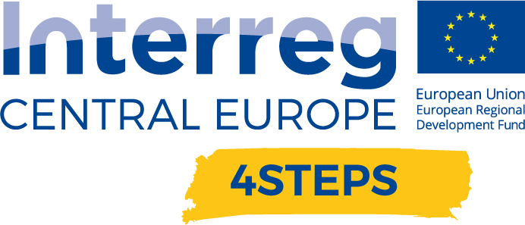
D.C. 5.1 Local focus groups events year 1

D.C. 4.2 Report –Local focus groups events year 1 – VDC Fellbach | Version 1  06 2020

- Name of the event, implementing date and place

XR Expo, 25th and 26th June, online

- Number and types of participants/target groups
The event had 430 participants. Including SMEs, big companies, policy makers, universities and research facilities, private attendants and press representatives.

- Topics tackled and links to deliverables, outputs
- Explaining RIS3 strategy and its regional context.
- Informing regional stakeholders about the activities and services carried out and planned by VDC
- Raise Awareness for the DIH especially regarding regional workshops and planned services
- Discuss the needs and expectations of regional stakeholders in the area of digital transformation
- Share information about the capabilities of the DIH and consider cooperation

- Expected effects and follow up

Sensibilization for upcoming events related to the project. Participants will get information as soon as a date for the events will be fixed.
Dissemination of the information regarding the planned new services, which will also be send to the participants when they will be defined.

- Annexes: e.g. agenda of the event, pictures, media coverage web-links etc

https://www.vdc-fellbach.de/nachrichten/2020/06/29/experiment-xr-expo-virtual-ueberzeugt-fachpublikum/

https://xr-expo.com/

