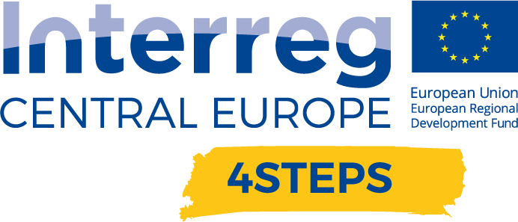
D.C. 5.2 Local focus groups events year 2

D.C.5.2 Report – Local focus groups events year 2 – Partner PP07 CCIS | Version 1  01 2022

- Name of the event, implementing date and place

Meeting of Slovenian DIH’s
23.06.2021, Orehov gaj, Ljubljana, Slovenia, from 13.00−18.00

- Number and types of participants/target groups
- representatives of 11 DIH’s established in Slovenia
- representatives of Ministry of Public Administration
- representatives of development centres (Development centre Novo Mesto)
- representatives of Institutes (Institute Jozef Stefan)
- representatives of SMEs

The total number of representatives at the event was 29.

- Topics tackled and links to deliverables, outputs
The event was mainly connected to the deliverable D.C.5.2. Local focus groups events year 2 - focused on guidelines for TAP local implementation.

The main basic of this deliverable was to discuss how to implement the TAP at regional level and according to RIS3. At the event, the priorities have been openly discussed with local stakeholders. The results will be included in the Guidelines.

A workshop was organized in the first part of the event. Representatives of DIHs were answering different questions regarding the future and the implementation of TAP. At the end of the workshop the most common envisions and visions were presented. In the second part of the event, individual participants presented themselves and their work.

- Expected effects and follow up
Mainly achieved effects were networking among DIHs and envision of future scenarios that will affect all of them. Also, the representatives of DIHs discussed the implementation of TAP, which will result in a more reflective and broader integration.

- Annexes: e.g. agenda of the event, pictures, media coverage web- links etc

