Digital Innovation Hub development - template

Deliverable D.T2.3.2  Digital Innovation Hub development | Draft VERISON  01/2022

Project Number | CE1492
Project Name | Towards the application of Industry 4.0 in SMEs
Project Acronym | 4STEPS
Work package | WPT2 - From catalogue to action: local implementation of an intervention plan
Activity | Activity 2.3 - Digital Innovation Hub development
Deliverable | Deliverable D.T2.3.2 Digital innovation Hub development
WP responsible partner | DEX Innovation Centre
Dissemination Level | Public
Date of Preparation | - Template in word: 01.2022 prepared by DEX IC  - Final version: With the contributions of all PPs: …
This document must be referred to as | DIH development
Author | Template: prepared by DEX IC
Contributors | ALL PPs

Table of contents

1. Structure of DIH 3
1.1. Strategic Board 3
1.2. Scientific Board 3
1.3. Stakeholder’s Board 3
2. Main services of the DIH 3

- Structure of DIH
Digital Innovation Hubs (DIHs) are one-stop-shops that help companies to become more competitive with regard to their business/production processes, products or services using digital technologies. They are based upon technology infrastructure and provide access to the latest knowledge, expertise and technology to support their customers with piloting, testing and experimenting with digital innovations. DIHs also provide business and financing support to implement these innovations, if needed across the value chain.

DIH’s, facilitated in framework of 4Steps project are composed of 3 boards with specific tasks: 1) Strategic Board, 2) Scientific Board and 3) Stakeholder’s Board.

  - Strategic Board
Strategic board is focused on DIH’s governance. The board's key roles include strategic direction, oversight, policy setting, and fund-raising.

Please explain how the Strategic board of your DIH is structured (who are the strategic board members, how often does it meet, what are its main competences, etc).

The Strategic Board consists of five members. The chairman of the board, a secretary, a deputy, a person responsible for finance and one additional board member.

- Chairman of the board (CEO): OB Gabriele Zull, Mayor of Fellbach
- Secretary: Prof. Dr. O. Riedel, Fraunhofer IAO
- First deputy: Daniel Banek, VDC Member
- Finance: Martin Zimmermann, Imsimity GmbH
- Member of the Board: Bernd Kußmaul, Bernd Kußmaul GmbH

It meets at least three times a year but if required or requested can meet more often. The Strategic Board is responsible for all matters of the Association, unless they are assigned to another body by the Statutes. Its tasks include, in particular, the preparation and convening of the General Assembly of Members and the drawing up of the agenda, the implementation of resolutions of the General Assembly of Members, the drafting of the budget, bookkeeping, the preparation of the annual financial statements and the management report, the presentation of the financial plan, the passing of resolutions on applications for membership and the exclusion of members.

  - Scientific Board
Scientific board is focused on the scientific and research activities of DIH.

Please explain how the Scientific board of your DIH is structured (who are the board members, how often or on what occasion does it meet, what are its main competences, etc).

The Scientific board consists of at least 10 members from different organisations, universities and colleges. These organizations are namely Hochschule Anhalt, Hochschule Karlsruhe, Hochschule Heilbronn, VIS Uni Stuttgart, Fraunhofer-Institut für Arbeitswirtschaft und Organisation IAO, Duale Hochschule Baden-Württemberg Stuttgart, Hochschule Mannheim - Kompetenzzentrum Virtuelles Engineering Rhein-Neckar (KVE), Hochschule Albstadt-Sigmaringen, Universität zu Köln, Hochschule Heilbronn – UniTyLab, IHK Stuttgart, Hochschule Reutlingen, Universität Stuttgart Höchstleistungsrechenzentrum (HLRS) and the HfT Stuttgart.

They usually meet at least 3 times a year. But they can also meet more often which depends on whether there are important topics that requires decisions or elaborations. The board looks at specific topics that are submitted or identified. These are analysed and if necessary, worked out in detail. The requirements are then derived from this. They are carried out and formulated for the hub, the industry, public sectors or politics. It has an advisory function and helps the hub to pick up the right topics and needs.

  - Stakeholder’s Board
Main aim of the Stakeholder’s board is to disseminate the latest knowledge among the key stakeholders and also it is a platform for communication between DIH and companies.

Please explain how the Stakeholder’s board of your DIH is structured (who are the board members (SMEs, public administration actores, UNIs, etc..), how it operates, etc

The Stakeholder’s board consists of all members of the VDC hub, they are all part of the board. It includes Companies from the following sectors.
- Hardware and software developers
- Technology service providers
- Universities and research institutions
- Personal members

The ordinary meeting shall be held at least once a year. Extraordinary meetings shall be held upon resolution of the scientific board if the interests of the association so require, or if at least two fifths of the members request this in writing, stating the purpose. The general assembly shall be convened in writing by the executive committee / or by the management with at least four weeks' notice. Invitations by e-mail shall also be considered valid. In this case, the agenda shall be announced and the required information shall be made available. The invitation letter shall be deemed to have been received by the members if it was addressed to the last address made known to the Association.

The agenda shall be supplemented if a member requests this in writing at least two weeks before the scheduled date. The addition shall be announced at the beginning of the meeting. Motions on the deselection of the strategic board, on the amendment of the statutes including the amendment of the purpose of the association and on the dissolution of the association, which have not already been sent to the members with the invitation to the general assembly, can only be decided at the next general assembly.

The general assembly shall be chaired by a member of the strategic board or by a chairperson elected by majority vote. Any general assembly duly convened shall constitute a quorum irrespective of the number of members present. Resolutions shall be passed by a simple majority of votes. Each member shall have one vote. The vote may be transferred in writing to another member. For amendments to the Statutes and the Rules of Procedure, a majority of 2/3 of the votes of those present is required. Legal entities must appoint a voting representative in writing. At the request of a member, voting shall be by secret ballot.

Meeting Minutes shall be taken of the resolutions of the general meeting. The minutes shall be made available to all members without delay and approved at the next general meeting.

Subjects and decisions:
- the approval of the budget and the financial planning,
- the adoption of the annual financial statements and the management report, discharge of the Executive Board,
- the election of the members of the Executive Board
- the appointment of financial auditors,
- amendments to the Statutes,
- the approval of the subscription regulations,
- the policy on the reimbursement of travel costs and expenses,
- motions of the Executive Committee and the members,
- the appointment of honorary members
- and the dissolution of the Association.

- Main services of the DIH
The services from 2.3.1 should be briefly summarized. Feel free to add some pictures!

Services of the Virtual Dimension Center.
Transparent competencies, faster flow of information and easier business contacts: the Virtual Dimension Center is the compass for 3D innovations. The VDC offers specialist knowledge in the dynamic field of virtual engineering, project development, marketing, contact mediation, technology transfer, digitization and industry 4.0.

Virtual Dimension Center Services:
- Organization and participation expert working groups
- Project development and funding management (tender screening, application, consortium formation, project management)
- Organisation of specialist events with speakers from member companies
- Internal knowledge database (market studies, position papers, analyses)
- Placement of specialists via the job exchange
- Reception of relevant contact enquiries
- Demo centre: technology exhibition and concessions on use, VR, AR & wearables Hardware and Software Demonstrators
- Measurement and evaluation of VR tracking systems
- Hardware Assessment
- XR Start-Up Connect Ecosystem
- XR Consulting

Measurement and evaluation of VR tracking systems:
The VDC offers hardware including a programmable six axis robotic arm and software to measure and evaluate the accuracy of VR tracking systems. The concept provides standardized measurement with defined processes, but it can be flexibly expanded and adapted to a wide variety of uses.
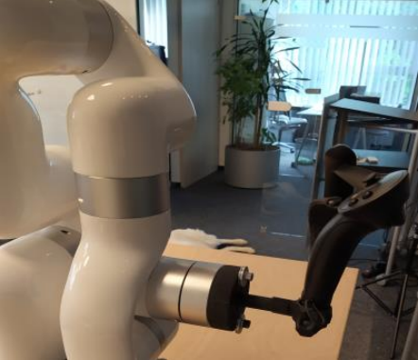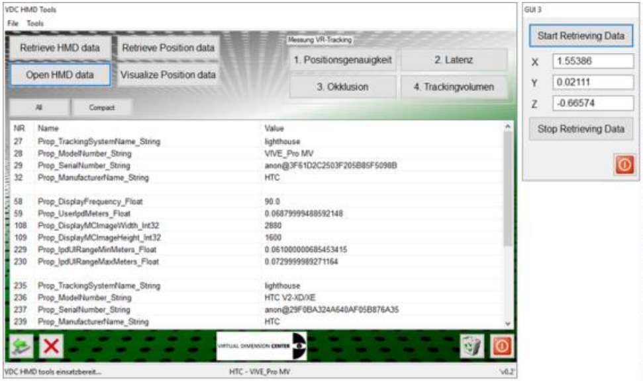
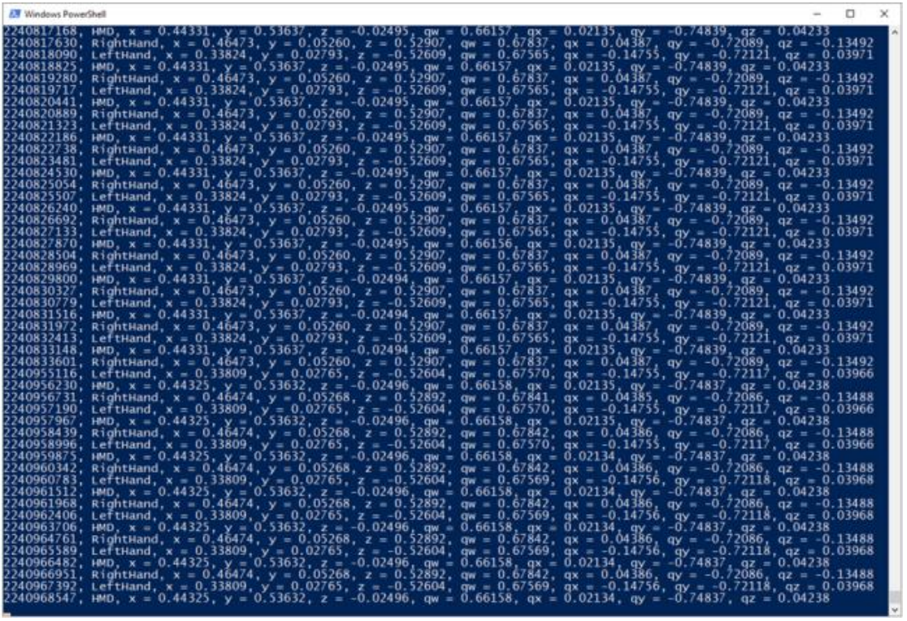
Source: DIO: 10.6084/m9.figshare.14784828, DIO: 10.6084/m9.figshare.14784861

VR Software, Production Planning:
The VDC provides the possibility to use Virtual Reality (VR) in production planning as a possibility to add value to the production planning and assembly process. Consulting and support is provided together with the needed hardware, tools and equipment to simulate a wide range of operation scenarios.
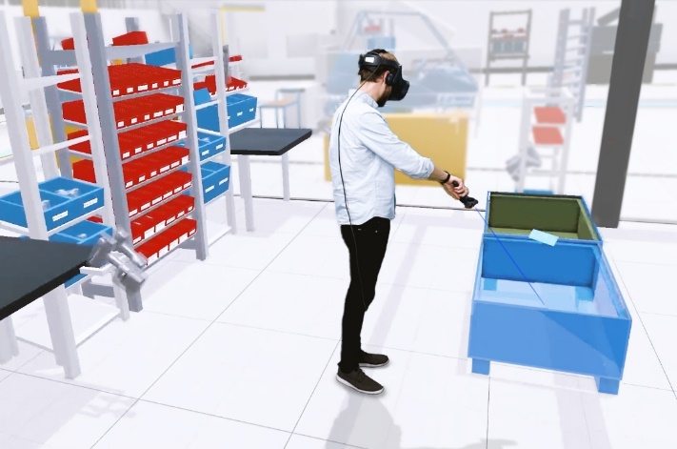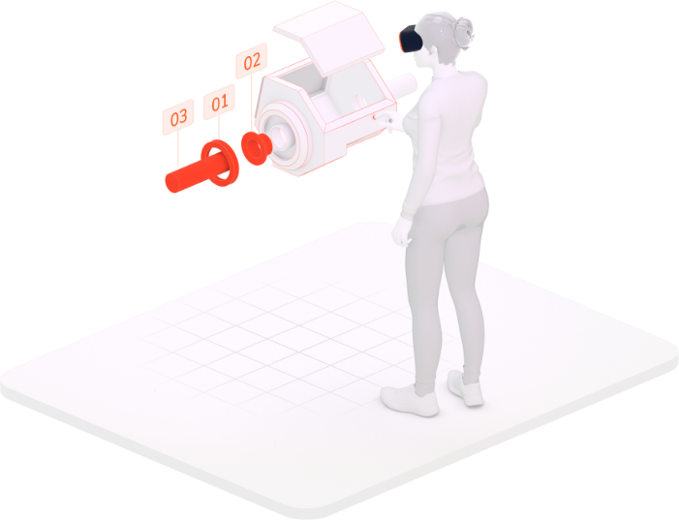
Source: https://halocline.io/

Hardware Assessment:
VDC also provides a hardware assessment for VR HMD's and tracking systems. Equipment is available for measuring the field of view, stereoscopic range, image sharpness, white & black luminance, readability of writing, image contrast, colour range, refresh rate, weight distribution, torque, precision and working rage of the tracking systems. The availability of the qualitative assessment means that the different devices can be assigned to the requirements of the industry and recommended and selected in a targeted manner.

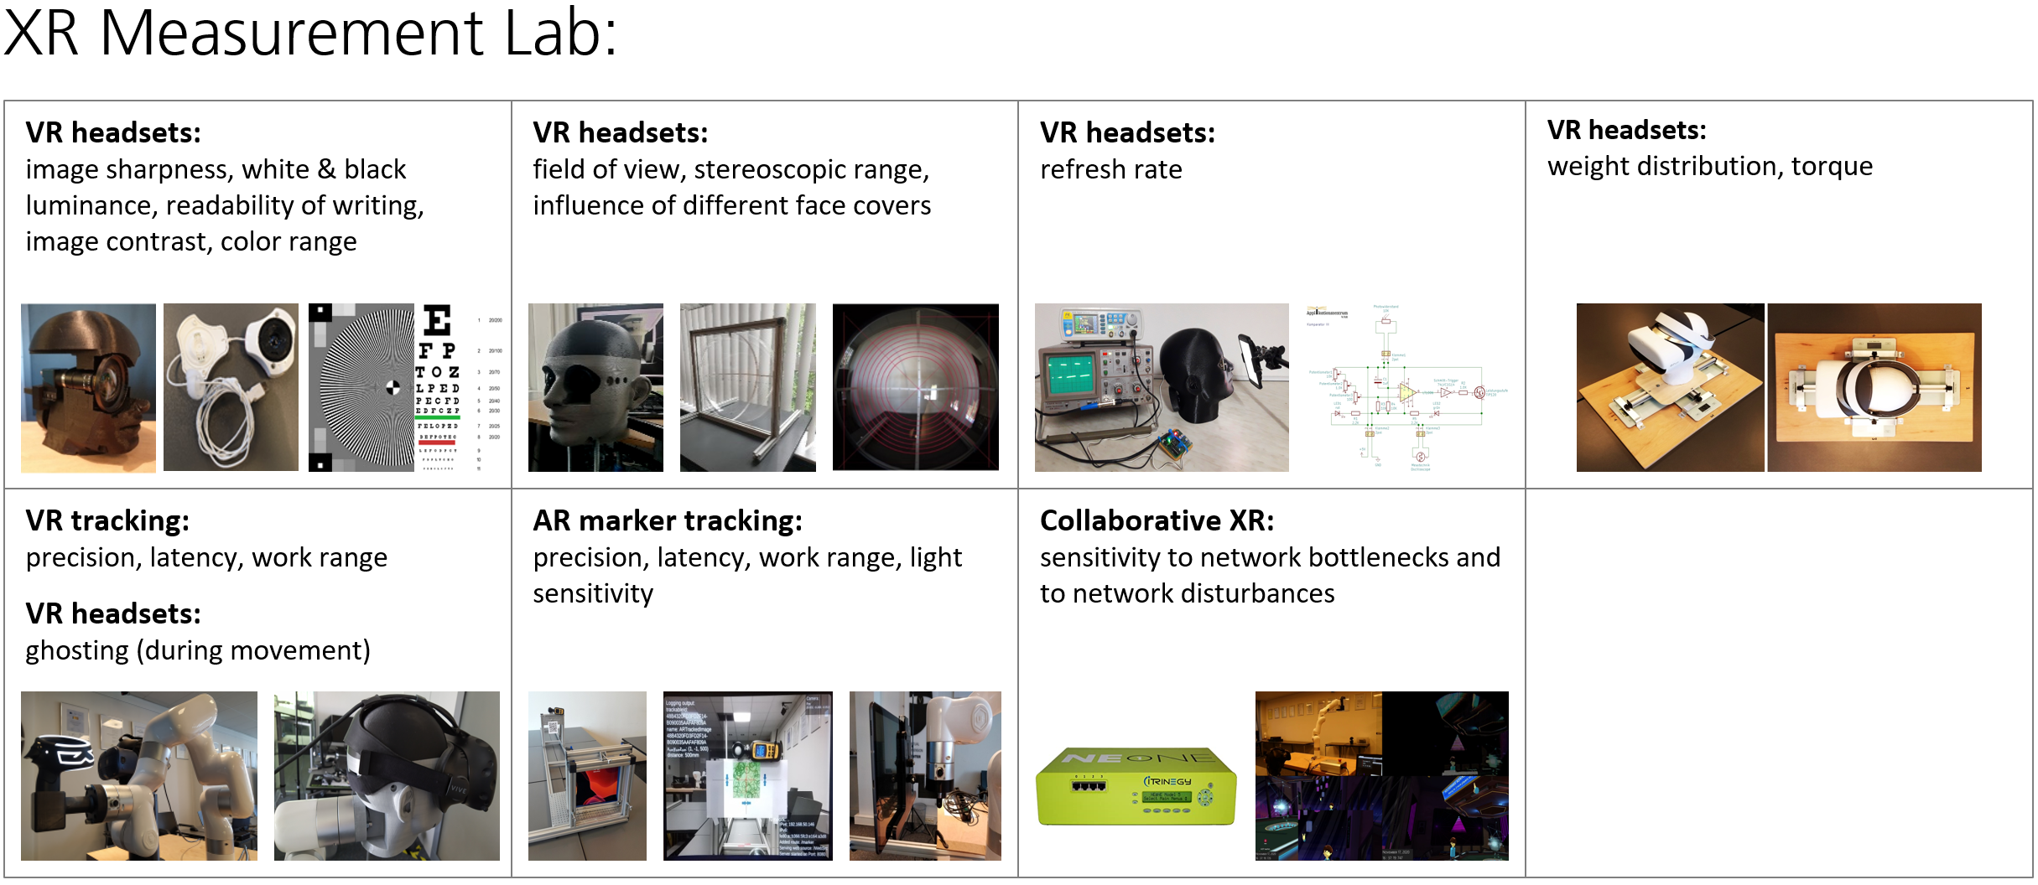
Source: www.vdc-fellbach.de

Demo Center:
The Virtual and Augmented Reality Demonstration Center is one of the tools for our technology transfer. Various hardware and software demonstrators are on our site and permanently accessible. In addition, it is possible to arrange dates for special demonstrations in our rooms. Available Hardware includes wearables and glasses like the Google Glass 2 enterprise edition, Meta 2, HoloLens 2 and Lynx R1 MR Headset.
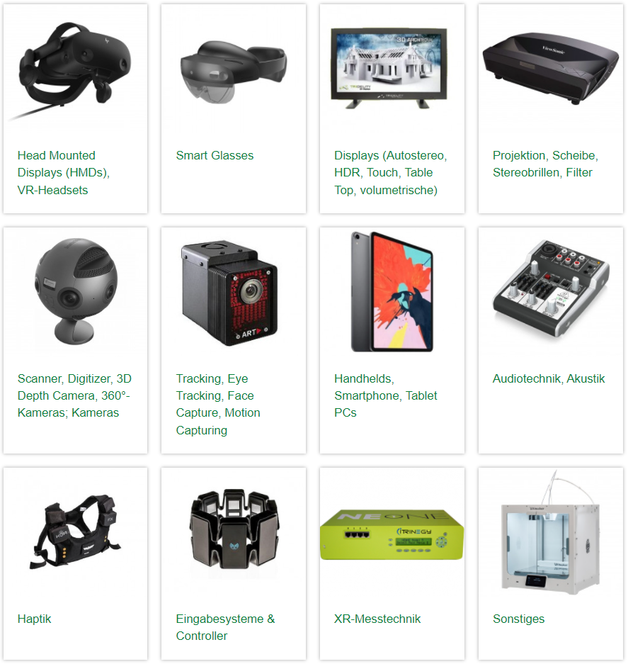
Source: https://www.vdc-fellbach.de/leistungen/technikbewertung-var/

XR Start-Up Connect Ecosystem:
XR Start-Up Connect is an innovation service, the platform is relevant for all Start-Ups, Investors and Corporates in the field of virtual & augmented reality, as well as virtual engineering. It is intended to be a contact, exchange and networking platform for all players explicitly in the XR Start-up environment, inviting them to get to know each other, implement joint projects or plans, or simply ask for advice.
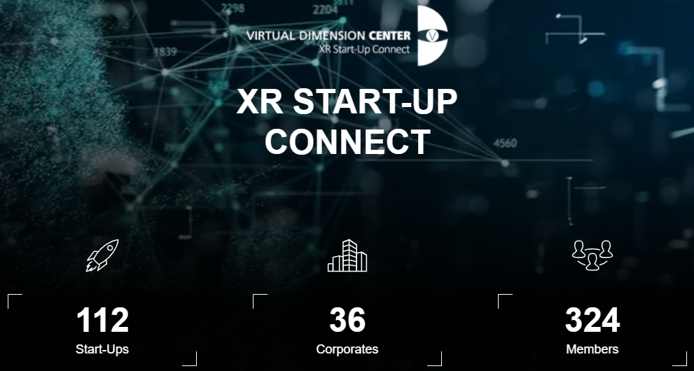
Source: https://xrconnect.vdc-fellbach.de
XR Consulting:
The VDC offers online and on-site consulting. It includes entry-level consulting and more detailed further consulting that can be booked on the website. The consulting includes topics such as networking, cooperation’s, presentation of the VDC, XR technologies, XR applications and XR industries. The site also offers the possibility of an interactive and geographical search for specialized XR consultants throughout Germany.

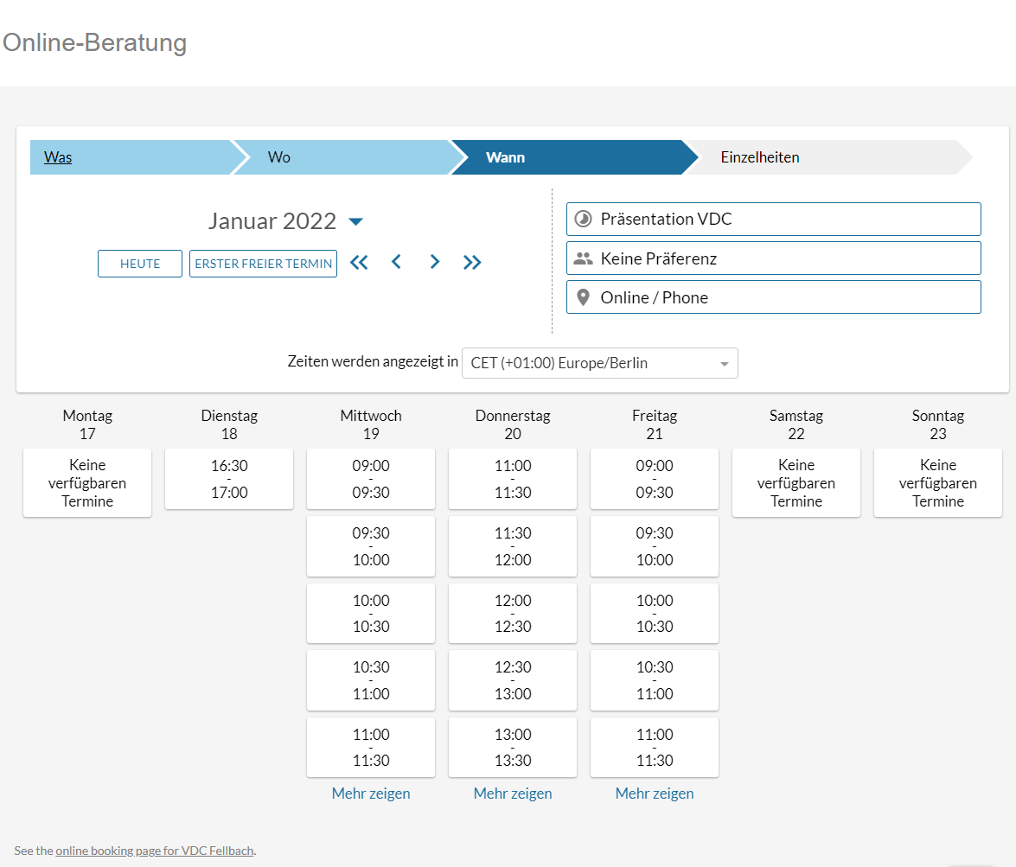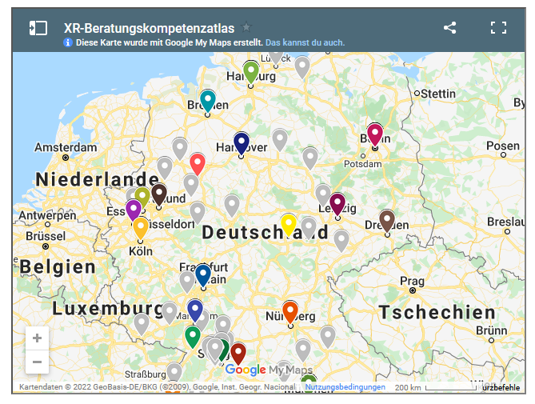

Source: https://www.vdc-fellbach.de/, https://www.vdc-fellbach.de/wissen/xr-beratungen/

