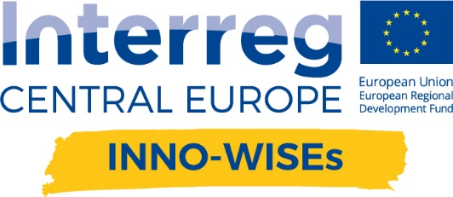
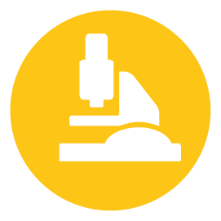

8° Project team meeting

Agenda  BARKA | Version 1  20-21 January 2019

MONDAY 20 JANUARY
14 – 14,15 | Welcoming and partners arrival
14,15 – 16 | Project additional indicators  - Feedback and direction form JS on the project  - Thematic results indicators: institution to reach and supporting documentation  - Position paper (D.C.3.5) and format of letter of support  Guided by FPM
16 – 16,15 coffee break
16,15 – 18 | Steering Committee  - Platform responsibility after the project  - Partners’ protocol (D.T3.3.3) and Partnership agreement (D.T3.3.4)  - Looking at the project end, last steps and decisions  Guided by FPM and ENSIE
dinner together at 19,30

TUESDAY 21 JANUary
9 – 10,45 | Project implementation, WP.C  - Final event of the project  - Target reached  Guided by CGM and ENSIE
10,45 – 11 coffee break
11 – 13 | Looking at the project end (6 months at the end)  - Financial progress and budget shifts  - Project progress and achievement (deliverables, outputs…)  - Deliverables to be completed  Guided by FPM and comments by partners
13 – 14 lunch
14 – 15,30 | Project implementation, WP.T3 – WP.T4  - Final steps  - Activities to the end of the project  Guided by ITC and ACT

LOCATION OF THE MEETING
BARKA headquarter: sw. Wincentego 6/9 street, 61 - 003 Poznan

LOCATION FOR DINNER:
To be defined

The lunches, coffee breaks and dinner are offered by BARKA as hosting partner.

