

D.T.4.3.1 “GUIDELINES FOR THE MONITORING AND COMPILATION OF TEMPLATES”

GUIDELINES FOR ALL SCHOOLS

Period reported: December 2017

|  |  |
| --- | --- |
| Versione 01  31.12.2017 |  |

Edited by PP6 UNIBO

|  |
| --- |
| D.T. 4.3.1 “GUIDELINES FOR THE EXECUTION OF MONITORING AND COMPILATION OF TEMPLATES”  Version 01  31.12.2017 |

Edited by PP6 UNIBO

INDEX

|  |  |
| --- | --- |
| **1. ABSTRACT** | **5** |
| **2. HOW TO USE THE TRAINING EXCERCISE?AND WHY?**  **3. THE SETTING PHASES OF THE TRAINING EXCERCISE** | **6**  **6** |
| **a. INVENTORY: “Template to identify the school energy situation”** | **6** |
| **b. ELABORATION** | **8** |
| **c. ORGANIZATION: “Maps of the Schools and rooms”** | **8** |
| **d. EXECUTIVE** | **11** |
| **e. COMPLEMENTARY** | **15** |
| **f. FINAL** | **16** |
| **4. INTRODUCTION TO TEMPLATES** | **19** |
| **5. EXAMPLE OF COMPILING TEMPLATES** | **22** |

1. Abstract

The following document addresses the attention of SEG's and JEG's of the various European schools involved in the Energy@School Project.

This document aims to prepare a training exercise focused on the energy culture in order to develop the Energy Culture Action Plan of the JEGs. The structure of the document was created to assist SEGs through simple or more technical notions during the different phases of the training exercise from January 2018 to May 2018:

**a – INVENTORY** – JEG’ s have to make the inventory of all the energy consumptions of the equipment (lamps, computer, printers,…..) into the classrooms and common rooms using the specific templates attached to this document;

**b - ELABORATION** – the data from inventory will be elaborated and discussed between SEGs and JEGs in order to select the classrooms and common rooms having the highest energy consumptions. The energy consumptions in the classrooms or common rooms are strictly linked to the presence of persons and to the temperature for a right comfort. JEG’ s have to organize the monitoring of the school using the specific templates in order to realize the basic energy consumption profile;

**c -** **ORGANIZATION** –. JEGs will elaborate a specific map of the entire school complex in which will be evidenced the individual classrooms chosen to be monitored;

**d -** **EXECUTIVE** – this is an operative phase for the data collection for the monitoring of specific consumption (See paragraph **“d”**);

**e - COMPLEMENTARY** – each week the filled templates will be sent to the Joint NOC at the UNIBO research group. Periodically Joint NOC will send back to the school an update of the energy consumption profile for a discussion between SEGs and JEGs in order to implement, if it is necessary, the monitoring management (See paragraph **“e”)**;

**f – FINAL** – the training exercise will get the basic energy consumption profile of the school and a monitoring management of the highest energy consumption classrooms and common rooms. On the basis JEGs have to elaborate their Energy Action Plan scoped to increase the energy efficiency of the school.



TIME TABLE – Time phases of the training exercise

1. How to use the training exercise? And why?

The installed smart meter in each school takes electricity and gas data at regular intervals on switchboard and displays the data via online portal or display device.

Daily monitoring allows schools to immediately measure the results of energy efficiency programs put in evidence any unexpected increases in electricity o gas use.

However, the data from the smart meter are not generally open data and thus it is difficult takes directly the data from each device to be sent via online portal to the control cabin at UNIBO. Furthermore, specific sensors to be interconnected online do not generally recover the indicators of the presence of people into the rooms as well as of the temperature into the working places and then they have to be collected by a manual procedure. Once the sensors have been installed in the various classrooms and workplaces, JEG's will have to monitor electricity and heat consumption and, if necessary, the presence of students or members of the school staff within the identified spaces.

Once the sensors have been installed in the various classrooms and workplaces, JEG's will have to monitor electricity and heat consumption and, if necessary, the presence of students or members of the school staff within the identified spaces.

The JEG’ s will then have to submit weekly, all data generated and organized in a standard table, to the UNIBO research group.

This operation will allow the UNIBO team to engage in the collection, reprocessing and analysis of all data received, in order to identify a consumption profile and subsequently a sustainable behaviour for each school identified by a performance score.

The ultimate purpose of this document is to re-elaborate such monitoring data for computer software programming, which will also be available via smartphones, allowing the development of E @ S game and the final competition between the schools.

E @ S game is a tool to compare a performance score of energy efficiency to the baseline performance score. Once the Energy Guardians have determined the results, they can use this information to evaluate the effectiveness of the action plans both of the Senior and Junior.

3.THE SETTING PHASES OF THE TRAINING EXCERCISE

a. INVENTORY: Template to identify the school energy situation

Knowing where your school’s energy comes from and how you use it is a crucial first step to understanding what changes can be made.

Equipment and appliances typically account for approximately 20% of a school’s energy use. Much of this energy use occurs when the equipment is not in use (in standby mode). Standby loads look small but because they are running continuously they can amount to a large energy use. Reviewing your power bills and checking off -peak energy use, and by using an electronic power usage tool can measure this.

In each classroom and common space the JEGs should make the inventory of the equipment energy use. In fact, to become more energy efficient, it is important to know how energy is currently being used. The template 1 assists schools to determine their energy use and type. It will provide the base information for improving both energy efficiency and energy sustainability. Ideally, students use the template as part of their learning. Improving energy efficiency is a gradual process. Once you have identified what energy you use and where, choosing two or three priority areas may best does making change. The JEGs should try to reproduce the energy profile in each classroom and common space.

[ENERGY CONSUMPTION (Wh) vs TIME (hours) for each day of the week]

In order to establish the thermal comfort, in general the vertical distribution of the temperature in the room should be 23°C at the level of the head and 17°C at the level of the feet with a difference of no more than 3°C.

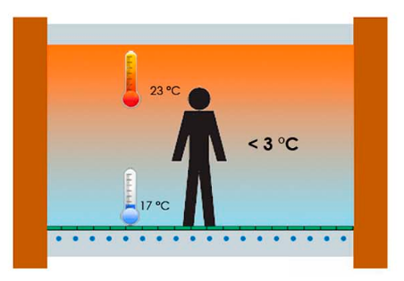

FIGURE 1: Distribution of the room temperature for an optimization of a thermal comfort.

The thermal comfort depends on the specific activities which are carried out into the room (i.e.: lesson, sport, eating, break-time,…).

b. ELABORATION

Once all the inventories of the different classes of the school have been carried out, it will be necessary to proceed with the evaluation of the consumption expected for each of them. Will follow a comparison a comparison of all estimated total consumption in order to identify which, among the classes studied, results to have a greater consumption and therefore results to be an interesting class to be monitored in order to eventually reduce consumption, once implemented energy action plan in the final phase.

c. ORGANIZATION: Maps of the Schools and rooms

This step is necessary for a better understanding and possible verification of the consumptions detected, known that the structures detected and the impianstistic components therein present.

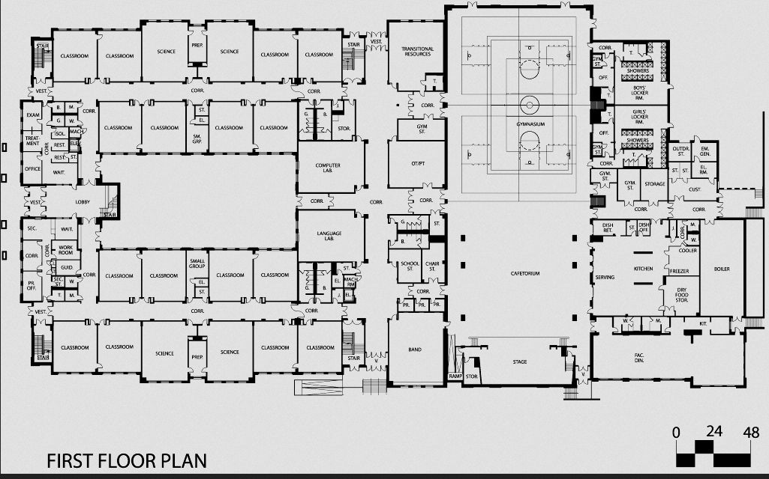Therefore, the maps of the entire school structure are requested and the classes actually chosen for monitoring are highlighted. It is important to report the name or the identification of these spaces.

FIGURE 2: Example of hypothetical school structure

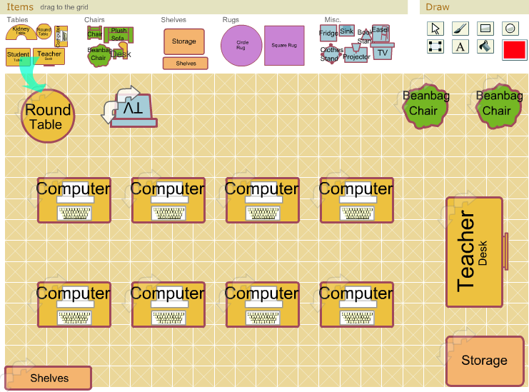

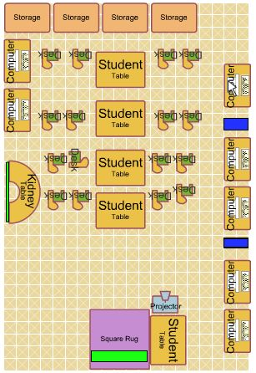

FIGURE 3: Example map of free classroom planner for teacher

FIGURE 4: Example map for study classroom

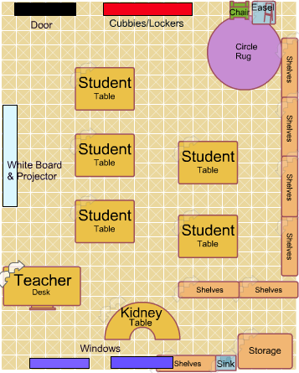

FIGURE 5: Example map of general classroom

d. EXECUTIVE

On the basis of the energy consumption theoretical profile in each space of the school, JEGs have to organize the collection of the real data using the installed smart meter and manual detection of the temperature as well as the presence of persons into the selected spaces. Theoretical profiles are necessary in order to determine the spaces having the highest energy consumptions. Controlling these points will allow to develop an energy action plan which will be able to reduce the wasted energy.

In order to collect the data of the energy usage, the schools, involved in the Energy@School project, have installed online systems or devices to monitor daily electricity and thermal consumptions.

In order to evaluate the waste energy, it is necessary introduce two more indicators such as the presence of persons into the school and the indoor temperature; in fact, the energy consumption is directly connected to the presence of student or staff school into the building while the temperature is a simple well-being indicator.

On the basis, the Joint NOC can evaluate the energy performance of each school developing a performance score, if the following types of measurements will be periodically sent at the joint unit:

1- electrical consumption (kWh);

2- thermal consumption (kWh)

3- presence of persons (0 = no, 1 = yes)

4- Temperature (° C)

HOW TO MONITOR

The installed smart meter in each school takes electricity and gas data at regular intervals on switchboard and display the data via online portal or display device. However, the data from the smart meter are not generally open data and thus it is difficult takes directly the data from each device to be sent by an online portal to the control cabin at UNIBO. Furthermore, the indicators of the presence of people into the rooms as well as of the temperature into the working places are not generally recovered by specific sensors to be interconnected online and then they have to be collected by a manual procedure.

Smart meter for the collection of general electrical and gas and/or thermal energy data – the smart meter should make an up-date each one hour and the data should be reported on a digital display to be easily checked-out by the Junior Energy Guardians. The data to be collected and transformed in kWh when reported with different unit of measurments in a specific template.

Meter of consumption of electricity for devices in working and stan-by phase - For the compilation of the first table it is also requested to insert the energy absorption of the various devices, which may vary according to their mode of operation. In this regard we can use a small object, very easy to use, known as the meter of consumption of electricity, very easy to find, available in the electricity department of supermarkets or hardware stores, or even online.

It is an electronic device with a display, which is inserted between the socket of our appliance and the electrical outlet in the wall. As soon as it is connected, the device will measure the current flow, then calculate how much electricity is consumed during the use of the appliance in question.

**How does it work?**

The display shows the consumption in real time in Watt, in Ampere, the power peaks: the data are automatically saved to review them calmly. On some devices, it is possible to set the cost related to its range of use to directly view consumption expressed in Euros.

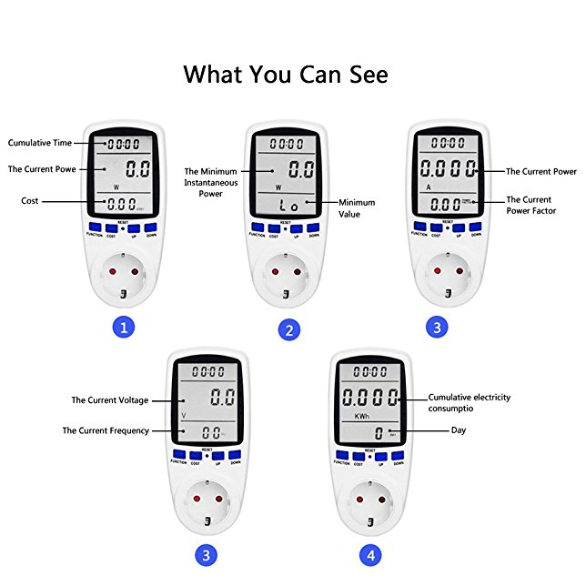

FIGURE 6: Representative image of a meter of electrical consumption.

**Presence of people in rooms** – this data collection should be organized with a manual reporting using presence or not presence of persons during the working time into the school. The presence of people will be periodically checked by the Junior Energy Guardians and reported in a specific template.

**Temperature in the working class** - this data collection should be organized with a manual reporting using digital thermometer or a fixed one during the working time into the school. Temperature will be periodically checked by the Junior Energy Guardians and reported in a specific template. WARNING: do not detect the temperature by placing the thermometer near heat sources (radiators, pc, refrigerators and similar), near windows and doors, because they could alter the actual consumption result, being areas characterized by a strong excursion and / or thermal dispersion .

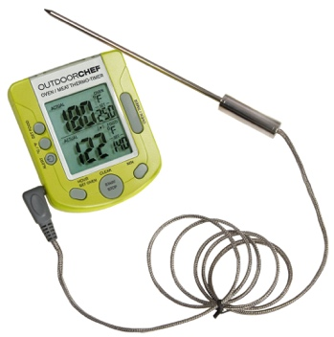.

FIGURE 7: Example of a digital thermometer to be used for the manual monitoring of temperature in the chosen classroom.

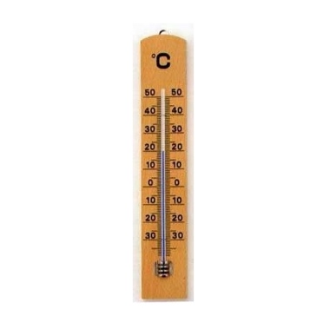

FIGURE 8: Example of classic thermometer to be used for the manual monitoring of temperature in the chosen classroom.

The training exercise will permit to normalize a method to collect the data using different smart meter and in the absence of electronic sensors for the presence of people and for the temperature.

WHEN TO PERFORM THE RELIEFS

Electricity and gas consumptions provide a variety of information if they are periodically collected that can assist schools to understand their energy usage during the working days and all the detailed analyzes that follow. JEG's are asked to carry out surveys, every day, and more precisely:

**1 - in the morning as soon as you before to go into the classroom;**

**2 – halfway through the day;**

**3 – in the afternoon before to leave the school.**

Therefore, three surveys are requested per day, for four different consumption details, for each of the selected classes!



FIGURE 9: Monitoring plan of the energy consumption during the day.

e. COMPLEMENTARY – Format for sending data to the centralized system

At minimum weekly intervals, the school complex will load the sensor values into the data supply interface, with significant intervals between each measurement.

The sending format can be in the following types:

1) Upload from Excel file or CSV file

2) Manual loading on the web frontend

3) Manual upload from mobile device with access to the responsive web interface

4) Loading data via API exposed by the frontend

**Upload from Excel / CSV file**

The sending format can be an xls sheet or a csv file with the specified structure, the system will load only the measurements with date after the last measurement loaded for each sensor, avoiding double insertions.

**Manual upload from the Frontend Web**

A web page will be made available which, following a login from an Energy Guardian, will propose a list of the sensors assigned to the plexus in which the Energy Guardian is registered.

The interface will allow you to enter data by presenting a layout similar to a table with the predefined time intervals and the possibility to add columns for each sensor and the related data.

**Manual upload from Frontend Web via mobile device**

The same page used for the Frontend by Browser is made of Responsive technology to be used also by mobile devices. Internet access is required during data collection.

**Loading data via API exposed by the frontend**

The data load frontend can also be used for automatic feeding via REST protocol calls. The API specifications will be made public to allow greater automation in the data supply process.

f. FINAL

The training exercise will get the basic energy consumption profile of the school and a monitoring management of the highest energy consumption classrooms and common rooms. On the basis JEG’ s have to elaborate their Energy Action Plan scoped to increase the energy efficiency of the school. They will have to decide for some strategies of use, of the various equipment present in the different classes monitored, in order to reduce their impact on the overall consumption of the school, for example, through the meter of electricity consumption it is possible to save on consumption, being able to highlight the different consumption, for example, of an old device with one of the latest generation, which being in class A ++, consumes very little.

**Why is it important to measure the consumption of our appliances?**

Over time, the appliances lose efficiency; they fail, causing, without our knowledge, a power loss, resulting in an increase in our energy expenditure. At other times, we tend to underestimate certain consumption that apparently may seem harmless, such as the stand-by light. This type of evaluation could be an example of sustainable strategy.

A good solution for energy saving, could be the replacement of an old fridge, which shows on average a daily consumption of 2 kWh, with one of the latest generation, class A +++, which consumes only about 0.35.

This is an important example of sustainable strategy, because the fridge is one of the most impactful appliances on energy consumption, remaining in operation 24 hours a day.

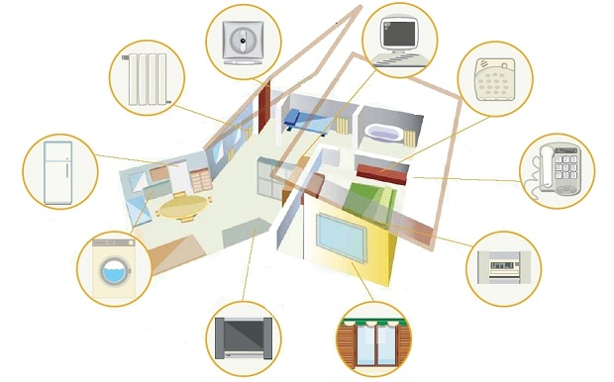

FIGURE 10: Example of some devices to be monitored in schools and in their own homes.

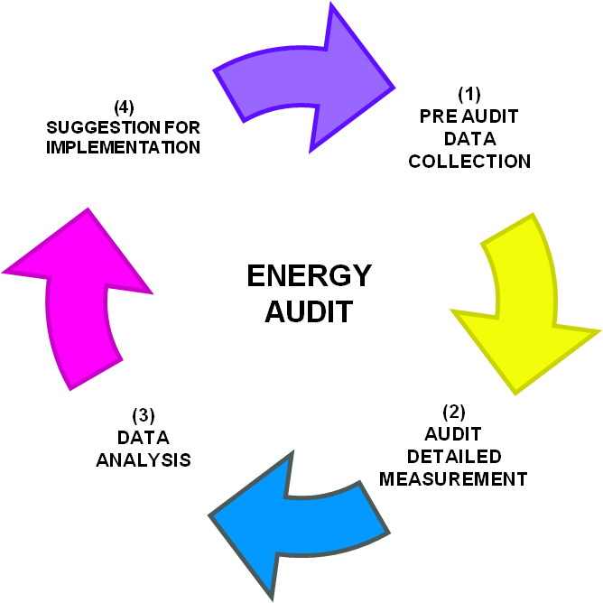

FIGURE 11: Possible operational scheme of an energy-sustainable strategy.

4. INTRODUCTION TO TEMPLATES

Each school will be presented with two templates, cards necessary to collect all the data collected daily, therefore, even weekly. The first template is an inventory, in which it is required to specify the devices present in each of the chosen classrooms, their power and duration of hourly operation per day; for the compilation of the second one, instead, it is required to report the numerical details, for four different types of consumption (See paragraph d).

Each card must contain the name of the JEG's which will carry out the survey, the date and the execution time, together with some specific consumption data and the ID name of the sensor consulted.

Each card must be completed for each of the classrooms chosen for monitoring, and for each school day of the week; sending the completed forms, however, only at the end of the school week just ended.

All the completed files must be sent weekly, and not daily, to the UNIBO research group.

Each school will be presented with an EXCEL file containing seven different sheets, each of which will contain the template dedicated to the daily collection of consumption data detected from time to time.

In the first sheet the template 1 has been prepared, dedicated to the inventory of each class chosen for monitoring; to follow, in the remaining six sheets, template 2 was added, one for each day of the school week, from Monday to Saturday.

The JEGs will have to compile a file every week with the monitoring and then send it to UNIBO at the beginning of the next week when they will begin to compile the new file.

Each file must be named with "school name, class and / or room, week detection number".

TEMPLATE 1

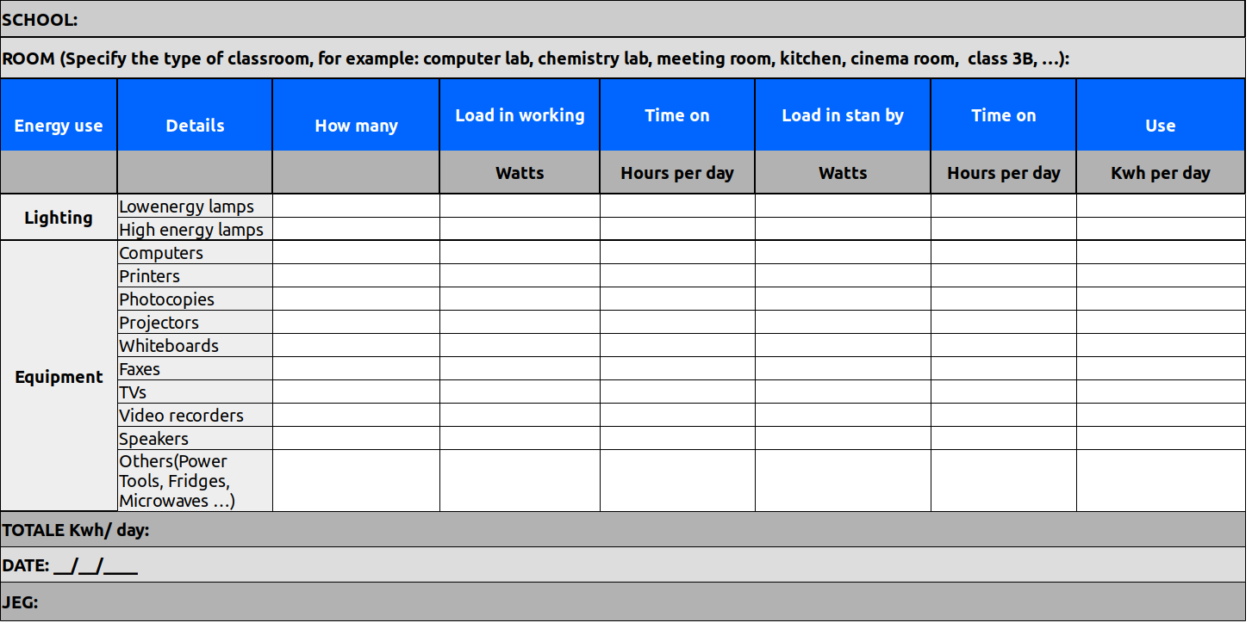

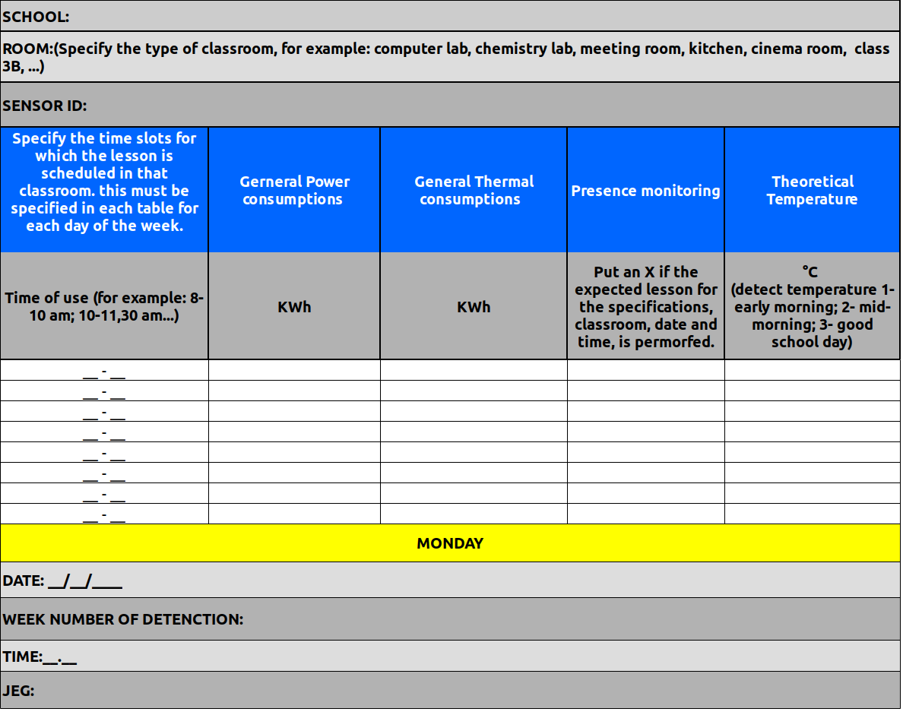

TEMPLATE 2

5. Example of compiling templates

With the aim of facilitating the comprehension of the guidelines for filling the tables for monitoring, we propose the following example, which sees as a reference the class shown in, **Figure 4 - Paragraph c,** of this document. The class in question is a simple and common study room, open to all students, according to the rules laid down by their school structure. We have hypothesized, for the school day on **Monday**, the following timetable, for which, “the study room” is expected to be open to the public:

|  |  |  |  |  |  |  |
| --- | --- | --- | --- | --- | --- | --- |
| **CLASSROOM “15“ - “STUDY ROOM of Scientific High School, Vitruvio Pollione – Avezzano (AQ) ITALY“** | | | | | | |
| **TIME** | **MONDAY** | **TUESDAY** | **WEDNESDAY** | **THURSDAY** | **FRIDAY** | **SUNDAY** |
| 08-09 |  | ... | ... | ... | ... | ... |
| 09-10 | **X** | ... | ... | ... | ... | ... |
| 10-11 | **X** | ... | ... | ... | ... | ... |
| 11-12 | **X** | ... | ... | ... | ... | ... |
| 12-13 | **X** | ... | ... | ... | ... | ... |
| 13-14 | **X** | ... | ... | ... | ... | ... |
| 14-15 | **X** | ... | ... | ... | ... | ... |
| 15-16 | **X** | ... | ... | ... | ... | ... |
| 16-17 | **X** | ... | ... | ... | ... | ... |
| 17-18 |  | ... | ... | ... | ... | ... |
| 18-19 |  | ... | ... | ... | ... | ... |

TABLE 1: Example of the school timetable foreseen for the “classroom 15 - study room - on Monday”. The “X” value, indicate, the state of openness of the classroom.

Referring to Figure 12, below, it is possible to notice the devices present in the classroom, such as: a projector and seven computers. Moreover, the presence of a low-consumption LED technology, for the interior lighting of the classroom (SmartForm LED BCS460 / BPS460 - PHILIPS) has been hypothesized.



FIGURE 12: Example classroom for compilation simulation.

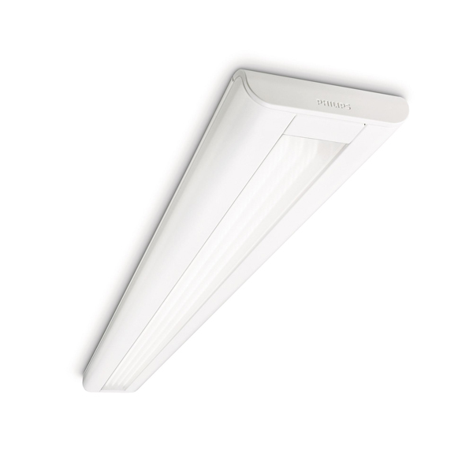

FIGURE 13: Example of Led technology for the interior lightning of the classroom.

The following specific consumption of the above devices is assumed:

|  |  |  |  |
| --- | --- | --- | --- |
| **EQUIPMENT** | **HOW MANY** | **LOAD IN WORING** | **LOAD IN STAND-BY** |
|  |  | **Wh** | **Wh** |
| **COMPUTER** | **7** | **300** | **30** |
| **PROJECTOR** | **1** | **353** | **<0,5** |
| **LOW ENERGY LAMP** | **9** | **(7,25 W * 9)= 65,25** |  |

TABLE 2: Example for devices consumption.

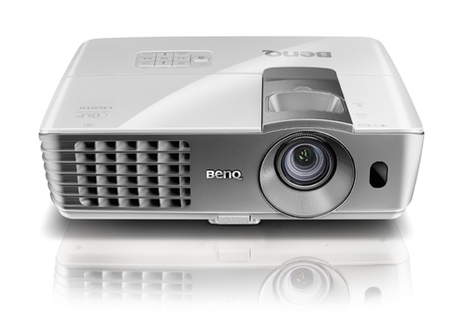

FIGURE 14: BenQ W1070 Projector 1080p Full HD 3D - Example of a high energy saving projector and environmental protection with sustainable technology. Some features: SmartEco Mode automatically determines the optimal brightness, depending on the input source. This special mode intelligently adjusts the light resource to bring maximum energy savings - providing the best contrast and brightness in performance; Eco Blank Mode obscures the projection screen automatically when the projector is not in use. This feature reduces energy consumption by over 70%.

**These can be considered as suggestions for the final evaluation and drafting of the Energy action plans for the final phase (See paragraph f).**

Stationary computers are those that consume more energy. Considering a mid-range computer it is possible to assume an hourly consumption that goes from 65-70 Watt at rest up to 200-250 Watt when it works at full capacity. To this must be added the consumption of the monitor, which will be greater as the screen is larger. In general, a normal LCD screen can consume 15 to 70 watts per hour, a little less in the case of LED screens.

One of the most energivorous components is the video card, which alone can take up to 30 watts per hour at rest and up to 100 watts in operation, which can then increase up to 250 watts in the case of extreme configurations from online gaming .

When the computer goes into stand-by, however, the consumption of electricity is very minimal: for this reason it is important to verify that all the computers have the setting for automatic stand-by after a total of inactivity time.

it is important, for the final phase and the elaboration of the energy action plan, to consider the introduction in the technological market of products more and more oriented towards energy saving; if, therefore, a fixed computer with cathode ray tube screen can get to consume 200 w, a desktop computer with an LCD screen only about 125, dropping up to 30 watts consumed by a laptop computer, it might be useful to evaluate the current state of the devices and evaluate their replacement if they are too old.

Finally, with reference to the average statistical data, a mean temperature of 20 ° C was assumed in the intermediate time slot of classroom use, 17 ° C, instead, at the entrance and exit from the school.

Template 1 – Filling Simulation



TABLE 3: Filling simulation for Template 1; it was assumed that the computers were working at full capacity, equal to half of the total opening hours foreseen for that classroom on Monday, and their operation in stand-by mode for the remaining four hours; operation of the floodlight at full power, for two hours of the total expected lighting of the device and for the remaining 6 hours, a stand-by operation; finally, we hypothesized the lighting of the LED lamps for the total hours foreseen for the operation of the classroom in an example, therefore 8 hours on Monday.

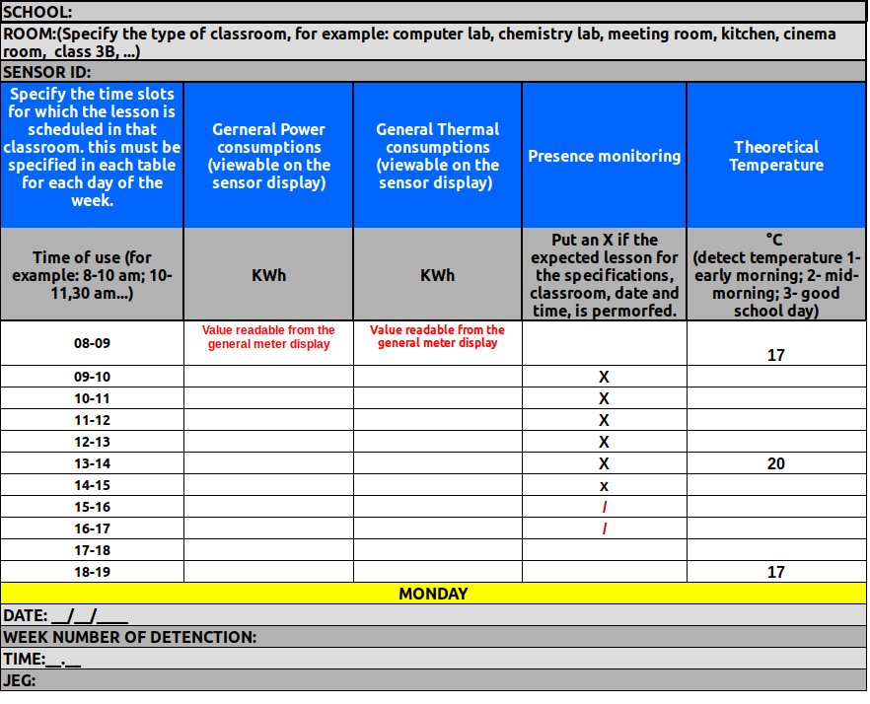Template 2 – Filling Simulation

TABLE 4: Filling simulation for Template 2; on Monday, the opening of the classroom is scheduled until 5 pm. It has been hypothesized that the classroom will not be used, for example from 3 to 5 pm, in this case the JEG in charge of the inspection will have to note the total absence of people in the classroom, to be able to then verify that consumption is also at the minimum basal, if not so, and should turn out lights and computers in operation, this would be a waste of energy, which will be identified thanks to these surveys.