D.T 4.3.2 “SIMULATION GAME DEVELOPED TO TRAIN JUNIOR EG’S ON HOW TO REACH GOALS OF ENERGY SAVING ACTION PLANS”

Edited by PP6 UNIBO + FINMATICA

Version 01

07.2018

D.T. 4.3.2 “SIMULATION GAME DEVELOPED TO TRAIN JUNIOR EGs ON HOW TO REACH GOALS OF ENERGY SAVING ACTION PLANS”

Version 01

07.2018

Edited by PP6 UNIBO + FINMATICA

CONTENTS
1. INTRODUCTION 3
2. MANAGEMENT OF A GHOST BY JEG‘S 3
3.GHOST SUMMARY 4
4. EXAMPLE GHOST MANAGEMENT AND SCHOOL SCORE 6
5. EXAMPLE OF POSSIBLE GHOST SOLUTIONS 9

- INTRODUCTION
The simulation game will have the form of a training exercise to develop junior egs skills in meeting challenges of reducing energy consumption in everyday life (starting from schools and later on extended in the community).
Most of the energy sources we use are not renewable and, in addition, they are also harmful to the environment and the health of living beings because they pollute. Thanks to small gestures, however, we can save energy without giving up comfort. And give our small but fundamental contribution to the health of the planet Earth. E @ S teaches us that energy saving is in fact the result of many responsible mini-actions, which each of us should put into practice taking care of the environment in which we live and behaving every day to consume and pollute less.
E @ S allows even the youngest to become ambassadors of sustainability, adopting an eco-friendly lifestyle and to commit to their future!

- MANAGEMENT OF A GHOST BY JEG’S
GHOST is the anomaly generated by an increase and / or a reduction in consumption compared to the average of the monitored time band.
The JEG will take care of the investigation, trying to understand what was the room that generated greater consumption or behaviour (lights in the hallway, projection of a movie) that increased electricity consumption.
In case of high consume, a generic ghost is shown, the JEG signals the consumption anomaly to the SEG and will manage together the identified waste, analyzing all the possible determinants of that day; for example, if a high-grade ghost is often reported. The JEG evaluates with the classmates and the SEG the level of comfort of the school and discusses how to reduce energy consumption by reducing the temperatures in the classrooms without reducing comfort.
If the ghost is a warm ghost type, the JEG can evaluate together with the SEG whether to carry out corrective actions such as acting on the convectors if present or on the radiator valves; for example, two ghosts are reported, a warm ghost in class 1B and a frozen ghost in class 3A. Class 1B is aimed at SOUTH while 3A is NORTH. Together with the SEG there are considerations on how the arrangement of the classes with respect to the sun changes the temperature and how the radiators should be regulated accordingly, if possible. (For example, by means of thermostatic valves).
If the ghost is of the frozen ghost type, in addition to corrective actions on the convectors the JEG can signal the problem to the SEG for a possible action on the isolation of the room; for example, a frozen ghost is always reported in the chemistry lab. However, the laboratory is only used a few hours a week, so it is not necessary to heat it even when not in use, thus reducing energy consumption.
Each ghost, identified by daily time slot, constitutes the loss of a point while, in the same way, any accrued savings will constitute the purchase of a point if it has not neglected the state of well-being.

- GHOSTS SUMMARY
All the ghosts are summarized in this screen, which in addition to offering the details of the various ghosts (both open and closed) gives the possibility to solve them by realigning the score.
In fact, for each ghost created 10 points will be subtracted, while for each "closed" ghost 10 points will be returned to the school.
By clicking on the ghost you will have access to all the data necessary to understand the causes and possible methods of resolution; once the data of the current day have been entered, you can try to delete the ghost, clicking on "Solve" there will be a check of the correctness of the data and if the answer is positive you can close the ghost adding an optional message.
For all special occasions (such as a school party or a screening of a movie) you can close the ghosts without any control by pressing "Special Day".
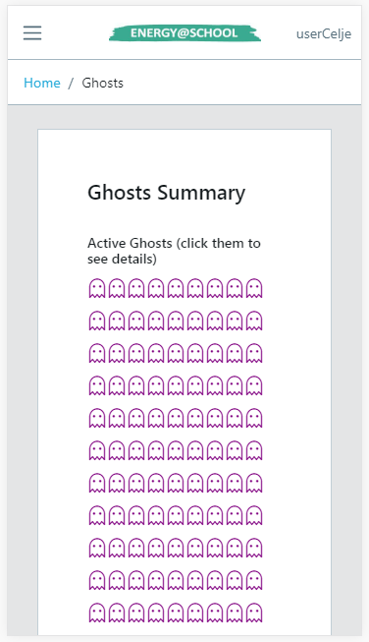
SCREEN 1: Detailed screen of the active ghosts.

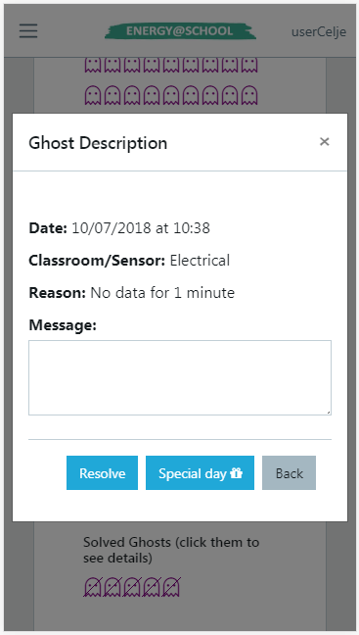
SCREEN 2: Detailed screen about open ghosts’ s details.

4. EXAMPLE GHOST MANAGEMENT AND SCHOOL SCORE
To earn points the JEGs will have to check the ghosts that have been generated and arrange to resolve them. To perform this task the JEGs will have to use the Ghost Summary, in which they can control the situation of the ghosts still open and those already resolved.

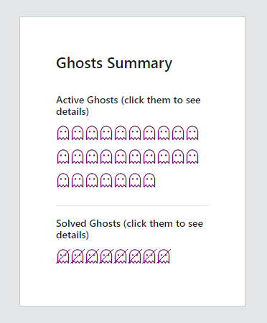
SCREEN 3: Detailed screen about Ghosts summary.

Suppose that a JEG intends to solve a thermal ghost like the one in the previous example where the temperature exceeded the zone of well-being (See: D.T.2.2.4, Paragraph 6, Screen 10 and 11). The JEG will have to open the ghost detail and write in the "MESSAGE" section what action has been taken to solve it.
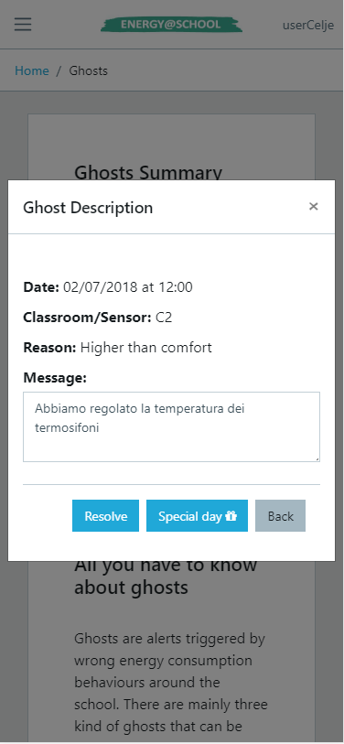
SCREEN 4: Detailed screen about open ghosts’ s details.

The ghost will be inserted among those resolved only if no other ghost of the same type has been presented on the current date. The resolution of the ghost will bring a positive score of 10 points.

The current score of the single school can be seen in the Score Summary, while the comparison between the scores will be present on the main page:
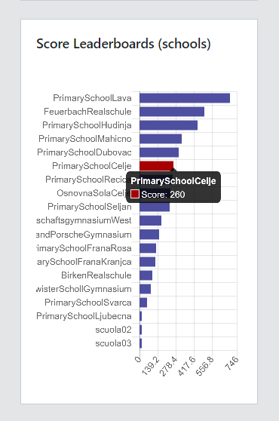
SCREEN 5: Detailed screen about Score Leaderboards.

In the event that the JEG wants to solve a ghost but the measurement values ​​have not been entered for the current day, then a warning message will be generated to warn that it is not possible to resolve the ghost:
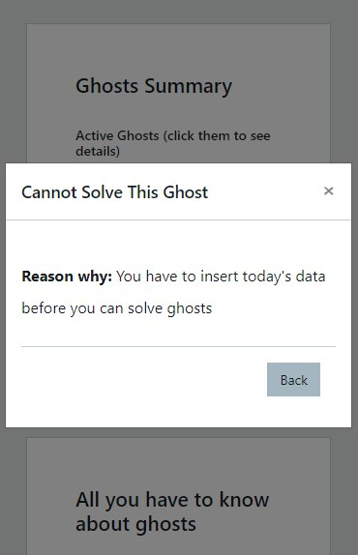
SCREEN 6: Warning message that you see if you have not entered the daily consumption data.

5. EXAMPLES OF POSSIBLE GHOSTS SOLUTIONS
For a more in-depth understanding, refer to the reading of the documents D.T.2.2.2, Paragraph 5 and 9, and the study of the document D.T.4.3.1 - JEG'S ENERGY ACTION PLAN.
Reduction of Thermal consumption
To make efficient, the school decides to lower the ° C of the established internal night temperature and also reduce the night time ignition of the radiators, since there are no people inside, programming the ignition three hours before the start of the morning lessons, so as to have an adequate index of well-being at the entrance of the boys to school.
Furthermore, during the afternoon, it is decided to switch off the radiators three hours before the actual closure of the school structure, letting the temperature and the mc of gas required for the production of heat decrease progressively, this will allow a good saving, maintaining an excellent index of well-being, if you pay attention to keep doors and windows tightly closed during the last activities.
Reduction of Electrical consumption
Monday afternoon, for example from 15 to 17, in class 1B, a movie is shown with the use of a particularly energivorous (not LED) projector.
The JEG that manages the area covered by the electric sensor will have the indication of an Energy Ghost in the rooms covered by the sensor of its competence.
Analyzing the events of the same day will note that a projector was used to view a movie, will evaluate, if necessary, any possibility of intervention and modification, both for the methods and frequency of use and for the quality of the device itself.

