online survey
Awareness on risk and prevention measures in participating cities and regions

Dr. Ludwig Scharmann¹, Peter Just¹, Dirk Dreßler¹
Anna Goris², Stefanie Weiner², Dr. Peter Heiland²
¹⁾ Saxon State Ministry for Regional Development, ²⁾ INFRASTRUKTUR & UMWELT Professor Böhm und Partner

ONLINE SURVEY “Awareness on risk and prevention measures in participating cities and regions” (D.T4.4.1)
Version 1 | 26.06.2020
Authors | Dr. Ludwig Scharmann¹, Peter Just¹, Dirk Dreßler¹, Anna Goris², Stefanie Weiner², Dr. Peter Heiland²
 | ¹⁾ Saxon State Ministry for Regional Development, ²⁾ INFRASTRUKTUR & UMWELT Professor Böhm und Partner

Acknowledgements
This document contains the results of the online survey “Awareness on risk and prevention measures in participating cities and regions”. The outcome is a result of the effort of all RAINMAN partners to develop and distribute the online survey. We would like to thank all respondents of the survey for supporting the RAINMAN project by participating in the online survey.

Contents

1. About this study 4
2. General description of the online survey 4
2.1. Summary of the ex-ante online survey 4
2.2. Structure of the ex-post survey 5
3. Results and conclusions of the online survey 6
3.1. Results and conclusions of part “personal information” 6
3.2. Results and conclusions of Part A: Evaluation of involvement in the project 7
3.3. Results and conclusions of Part B: Evaluation of RAINMAN contents 12
3.4. Results and conclusions of Part C: Outlook and exploitation 16
4. Conclusions 18
5. Annex 19
RAINMAN Key Facts 25

- About this study
Heavy rain events are a major environmental risk in Europe: they can hit any location with only very short warning time. Every year people die, thousands lose their homes, and environmental damages like water pollution occur.
The risks of heavy rain events are increasing all over Europe. In the project RAINMAN, partners from 6 countries have joined to develop and test innovative methods and tools for the integrated management of heavy rain risks by local, regional & national public authorities. These are included in the RAINMAN-Toolbox (https://rainman-toolbox.eu), a set of transferable tools and methods for municipalities and regional stakeholders. The RAINMAN-Toolbox builds on an extensive theoretical knowledge base from all six Central European countries: in exchange with stakeholders from municipalities and regional authorities, the tools and methods were tested and implemented in pilot locations.
An online survey has jointly been developed by the project partners to evaluate
- the pilot activities and the involvement of the stakeholders and
- the contribution the developed tools and methods can have to better manage heavy rain risks.
This report summarizes and evaluates the findings of the RAINMAN online survey. The results are presented as follows: In chapter 2 we present the set-up and structure of the online survey. The report then focuses on the analysis of the overall results of the survey, see chapter 3. In this chapter key findings are summarized for each part of the survey. Chapter 4 then focuses on the conclusions that can be drawn. Answers to the open questions are listed in the annex.
- General description of the online survey
During the RAINMAN project, two online surveys were carried out. The first survey was conducted as a basis for the toolbox design to assess experiences with heavy rain events and to define the requirements of the relevant actors for the improvement of heavy rain risk management. This concluding survey was only provided to a limited number of participants in the pilot location to evaluate the involvement of the stakeholders.
  - Summary of the ex-ante online survey
The aim of the online survey was to gather information regarding experiences with heavy rain in general and heavy rain risk management in different regions as well as regarding wishes and demands to improve heavy rain risk management.
With the analysis of the survey results the approach of the RAINMAN project and the toolbox has been confirmed. Stakeholders dealing with heavy rain risks do not only need information on details (for example on a single method, a single measure etc.) or information about specific fields (for example the individual tools, the catalogue of measures etc.) but guidance in the different activities (for example guidance on how to select measures) and the overall integrated management process. The results of the online survey confirmed to further promote the approach of the RAINMAN-Toolbox. With the RAINMAN-Toolbox the project partners aim to develop an easy accessible online tool that gives guidance for the integrated management of heavy rain risks and that comprises the whole process: from assessment and mapping of heavy rain risks though the selection of risk reduction measures and risk communication to governance.
The results of the online survey have been implemented in the concept of the RAINMAN-Toolbox and its comprising methods and tools.
The whole analysis of the online survey on the subject of heavy rain risk management is published on the RAINMAN website (see “Publications”) and is available for download on the RAINMAN website.
  - Structure of the ex-post survey
Pilot activities in all participating partner regions of the project have been implemented to test and improve the feasibility and applicability of developed methods and tools for the RAINMAN-Toolbox. In addition, the pilot actions deliver show cases for implementations. The online survey was jointly developed by the project partners to evaluate these pilot activities and the awareness on heavy rain risks and prevention measures (see activity T4.4.1). It was an integrated part of the pilot activities in WP 3, see activities in Saxony (T3.1.2), South Bohemia (T3.2.2), Styria (T3.3.2), Jasz-Nagykun-Szolnok (T3.4.2), Zagreb / Istria (T3.5.2), Lower Silesia (T3.6.2) and Upper Austria (T3.7.2).
The development of the survey questions was coordinated by the Saxon State Ministry for Regional Development. The local project partners translated the content into the local languages. The translated questions were then implemented in the online survey tool LimeSurvey.
The survey was distributed between January 2020 and April 2020 by the project partners. They provided information about the survey to the stakeholders, associated partners and other persons involved in the seven pilot activities.
The survey is structured in different thematic parts. The structure looks as follows.
- Personal information
- Part A: Evaluation of involvement in the project
- Part B: Evaluation of RAINMAN contents
- Part C: Outlook and exploitation
The survey closed with the option to provide contact information to stay in touch with the project and register for the RAINMAN newsletter.

- Results and conclusions of the online survey
In 2020 the return of 123 questionnaires from seven RAINMAN pilot regions were evaluated. The main findings from the different parts of the online survey are presented in this chapter.
  - Results and conclusions of part “personal information”
The survey started with some personal information to get a clear picture about the respondents of the survey.
Results
The following figures summarize the results of part “personal information” of the online survey. Comments and observations regarding the figure are added below the respective figure:
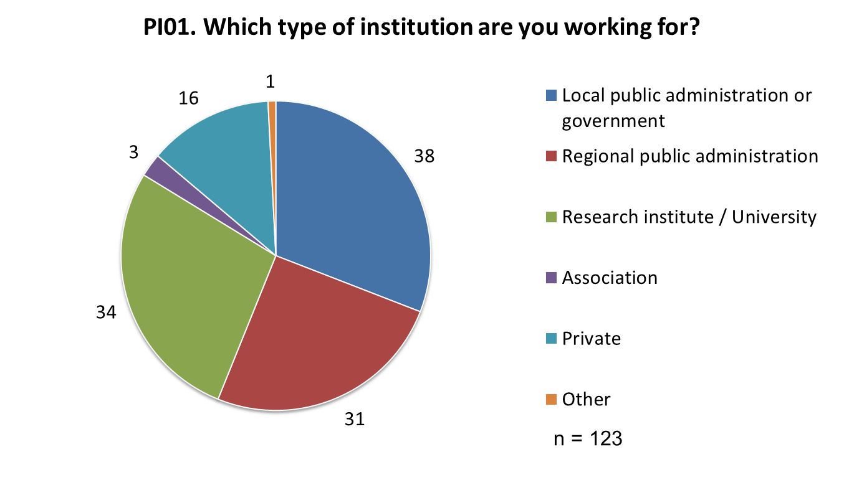
- In total we received 123 completed questionnaires.
- Main target groups were reached: around 56 % of the respondents are working in local public administration or local government and regional public administration.
- The share of the main target groups within the partner regions differs between 21 % and 94 %. This can be explained by the different focuses of the pilot projects. While some PPs worked mainly with local administrations, others had a close cooperation with universities and research institutes.
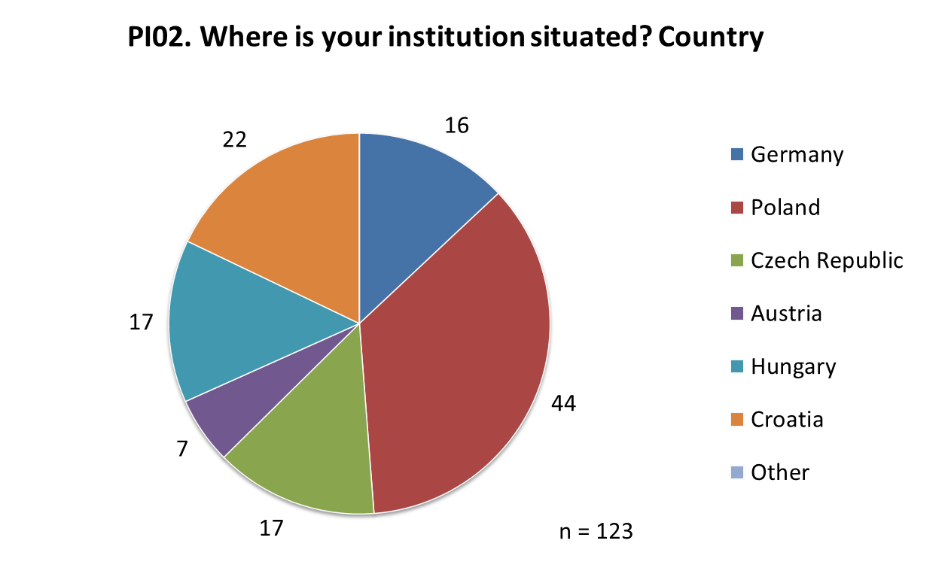
- The sample size varies from one partner country to the next.
- The sample size as well as composition of the sample (type of institution) needs to be considered when drawing conclusions.
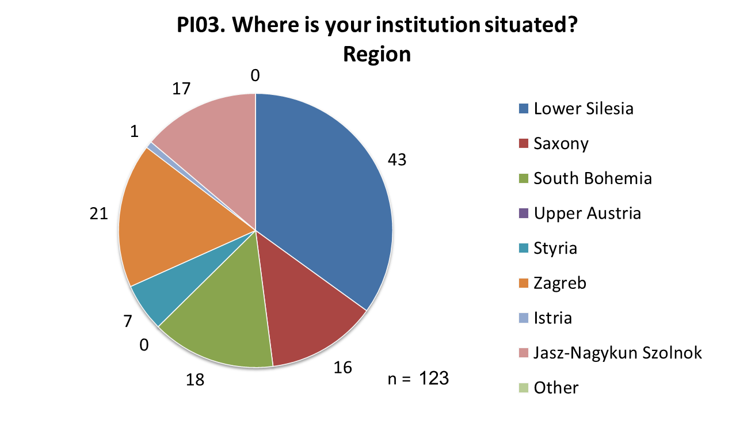
- Main target regions were reached: All answers came are from the pilot regions, the highest numbers were reached in Lower Silesia and Croatia (Zagreb and Istria).
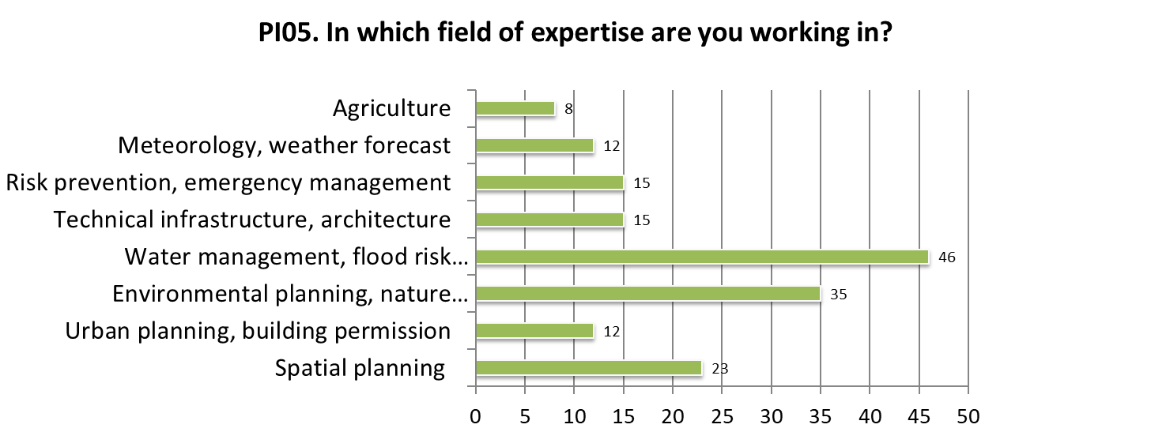
- A high proportion of the respondents are experts from water management.
- Another important share are working in planning disciplines like environmental planning and nature preservation and spatial planning.
- Only few participants are stakeholders in the field of meteorology / weather forecast and agriculture. These areas of activities are therefore underrepresented in the results and conclusions of the survey compared to their practical relevance with regard to heavy rain risks. The relatively small number of respondents from these disciplines reflects that both are not a focus of the RAINMAN project and its activities. Nevertheless, the practical relevance should not be underestimated.
  - Results and conclusions of Part A: Evaluation of involvement in the project
Pilot actions in all participating partner regions have been implemented to test methods and tools that have been developed to support municipalities and regions to reduce the risks of heavy rain. There are 7 pilot actions with different characteristics to proof the practicability of the methods and tools under different application conditions. The experiences gathered in the pilots activities are incorporated into the further development of the methods and tools. In addition, the pilot activities deliver show cases for implementations.
Within this part of the survey, we want to evaluate how satisfied stakeholders of the pilot activities are regarding their involvement in the RAINMAN project.
The evaluation includes three sections:
- Evaluation of the organisational aspects of the pilot actions: How satisfied were you with the format through which you were involved in the project / the way of being involved in the project (e-mails, meetings, workshops, public hearings, etc.)?
- Evaluation of the contents of the pilot activities during your involvement in the project: How satisfied were you with the contents provided? Did these contents help you to improve heavy rain risk management skills?
- Overall evaluation of the pilot activity: In this section we ask you to evaluate your overall satisfaction with your involvement during the project.
Results
The following figures summarize the results of part “Evaluation of involvement in the project” of the online survey. Comments and observations regarding the figure are added below the respective figure:
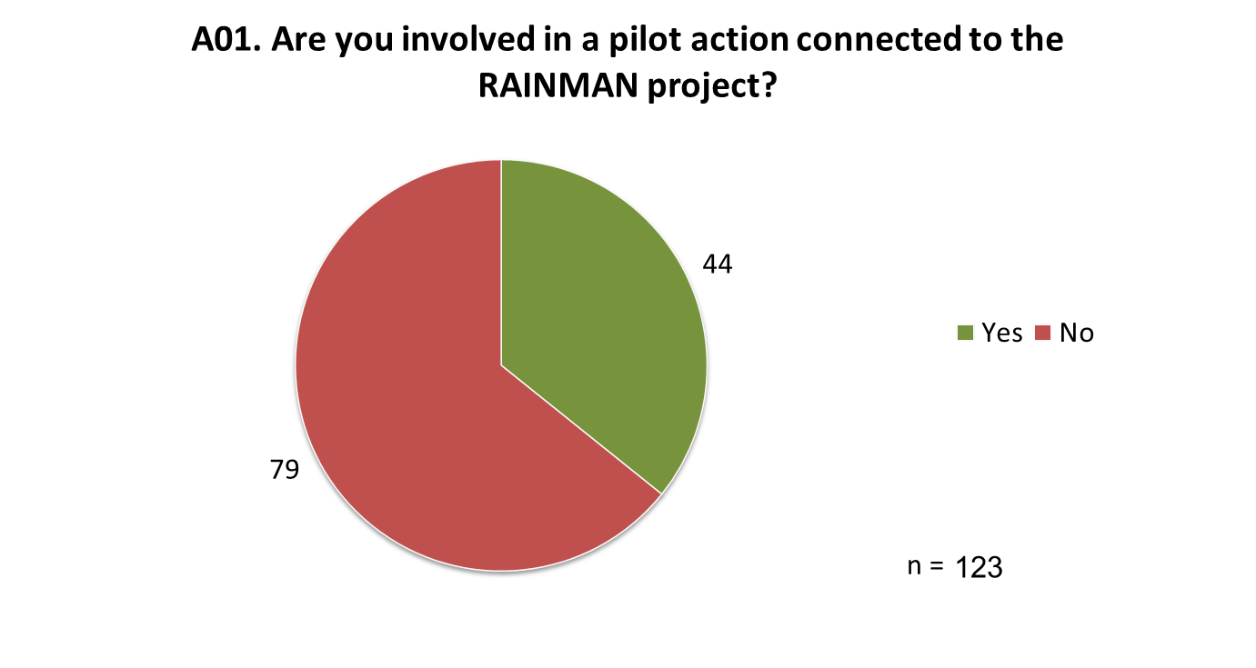
- Less than half of the respondents (34 %) were involved in a pilot action connected to the RAINMAN project. As a consequence the following results of this part are just answered by this part of the respondents.
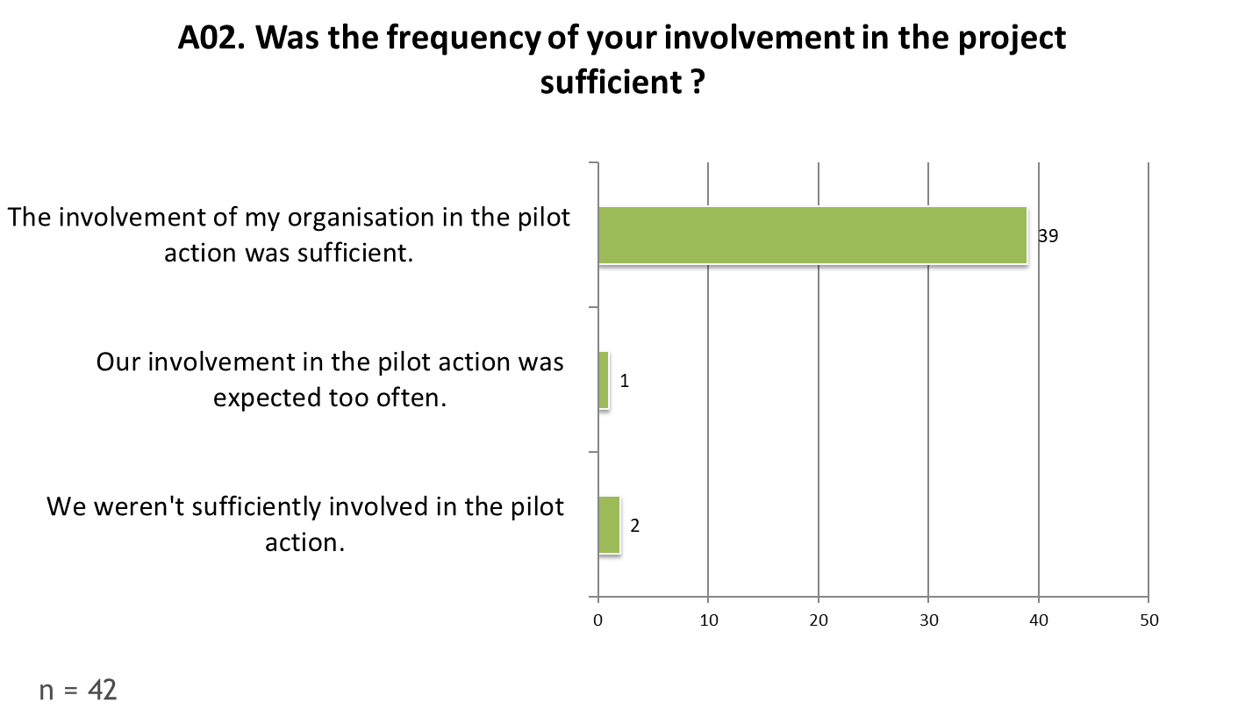
- Most respondents and their organisations answered that they were sufficiently involved in the pilot actions connected to the RAINMAN project.
- Few respondents thought that they haven’t been sufficiently involved. Only one person responded that the involvement was expected too often.
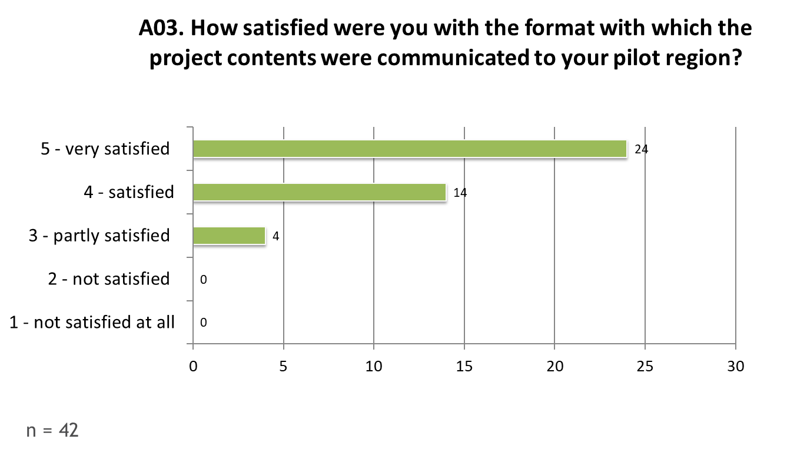
- Most of the respondents were very satisfied with the organisational aspects/format in which the project contents were communicated to the pilot regions. Another big part of the respondents was satisfied with the communication format.
- Only few respondents were only partly satisfied. No one was “not satisfied”
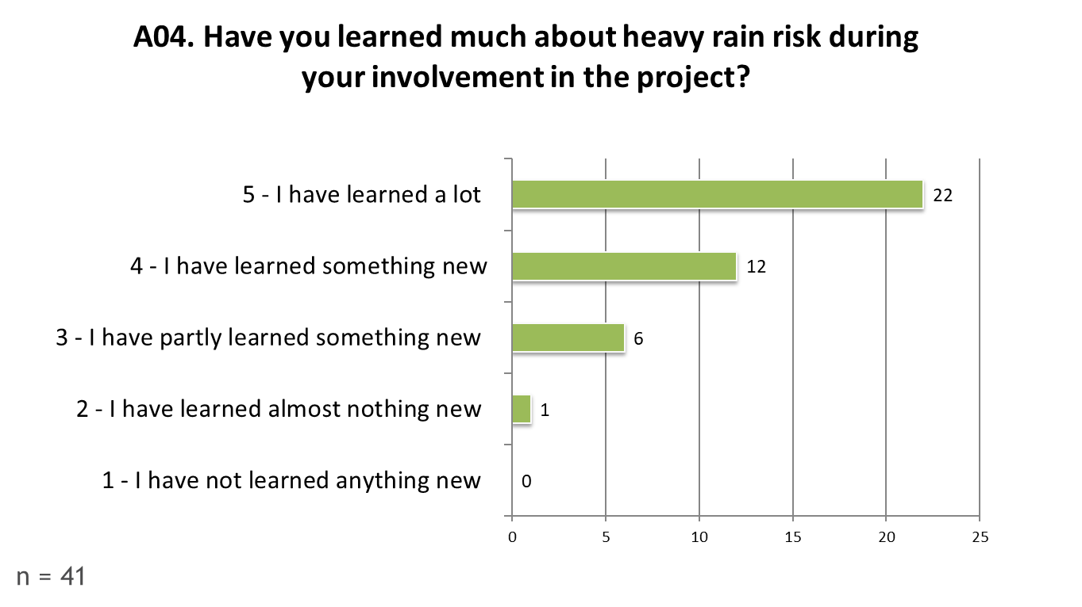
- Most of the respondents learned a lot about heavy rain risk during their involvement in the RAINMAN project. Another remarkable part of respondents answered, that they learned at least some new things about heavy rain risk.
- A small part of respondents did only learn few new things and only one respondent learned almost nothing new about heavy rain risk during the involvement in the RAINMAN project. These persons may already have had a high level of knowledge before being involved in the pilot action and / or were involved as experts (e.g. from Universities or research institutes).
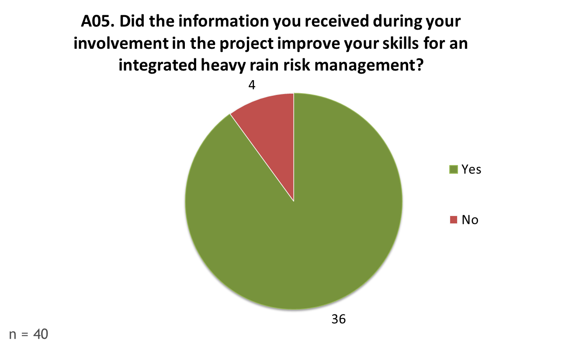
- Most of the respondents indicated that their involvement in the RAINMAN project improved their skills to work on the integrated heavy rain risk management.
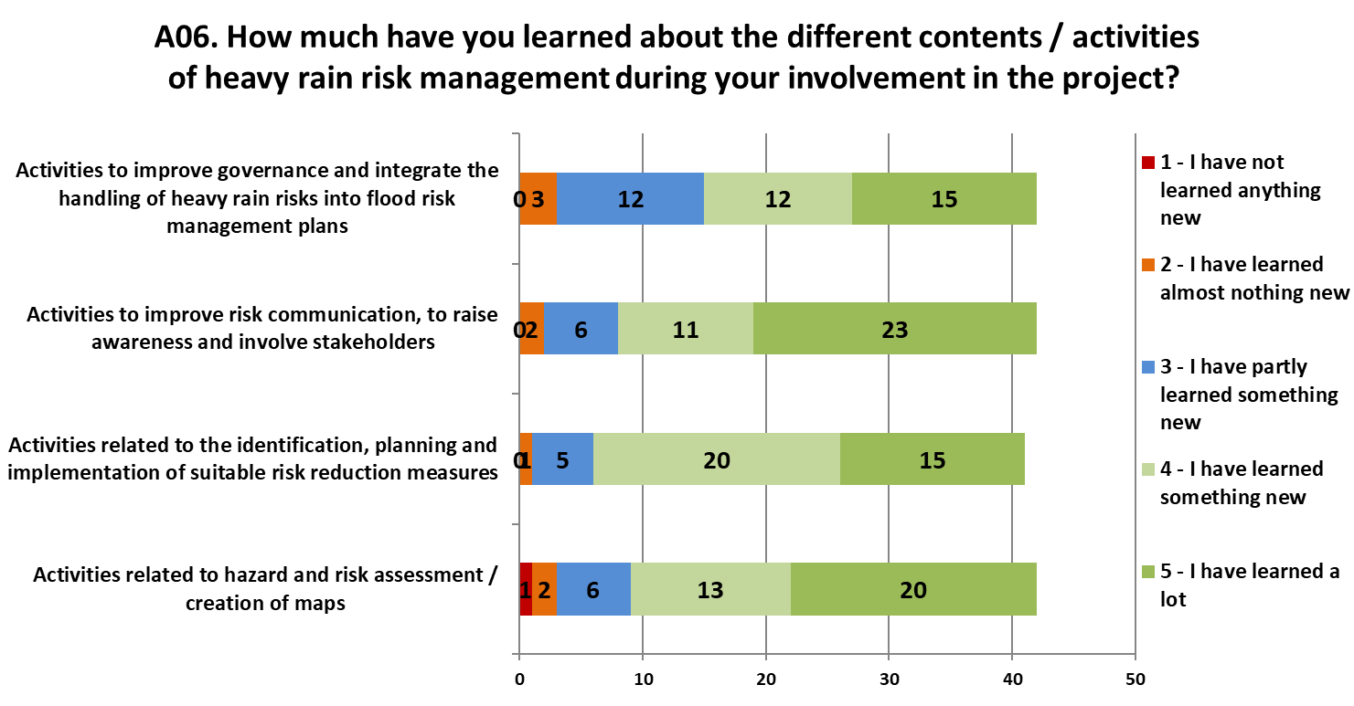
- The RAINMAN project develops a toolbox to support local and regional authorities in managing heavy rain risks. The toolbox provides guidance on various aspects of integrated management of heavy rain risks. The contents of the toolbox will include four different aspects to reduce fatalities and damages caused by heavy rain. These contents have been addressed during the stakeholders’ involvement in the project.
- The largest number of respondents indicated to have learned a lot about all four activity groups.
- Another remarkable number of respondents learned something new about the topics.
- Only few respondents indicated to only have learned partly new things about the topics.
- Few respondents gained almost no or no new knowledge during their involvement in the project.
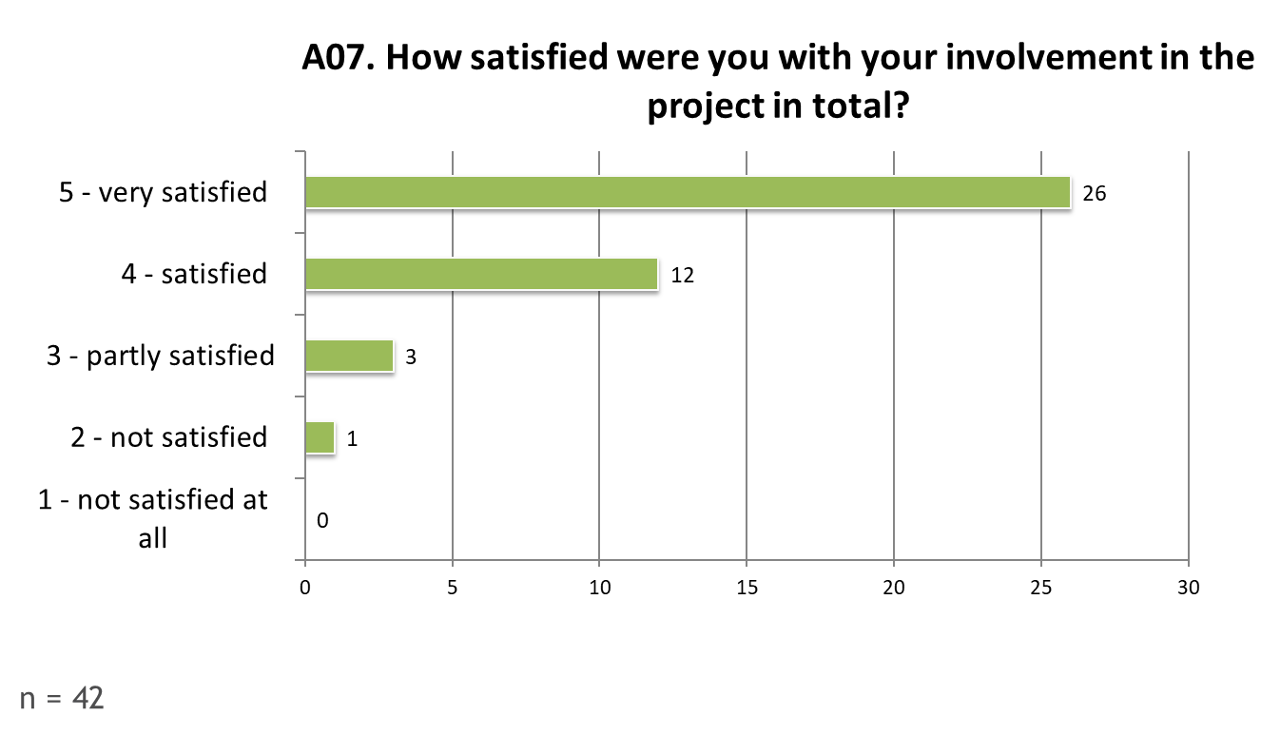
- The largest number of respondents was very satisfied or satisfied with their involvement in the RAINMAN project.
- Few respondents were only partly satisfied and just one person was not satisfied with the involvement in the project. This corresponds well to the answers of the previous questions, especially to A04 “…”.
  - Results and conclusions of Part B: Evaluation of RAINMAN contents
The results of the RAINMAN project will support local and regional authorities in adapting their regional and local development to the existing risks of heavy rain induced floods and support the integrated management of heavy rain related risks.
Within this part of the survey, we evaluated
- the importance of heavy rain risk management in your community and
- the contribution RAINMAN can have to improve heavy rain risk management.
Results
The following figures summarize the results of part “Evaluation of RAINMAN contents” of the online survey. Comments and observations regarding the figure are added below the respective figure:
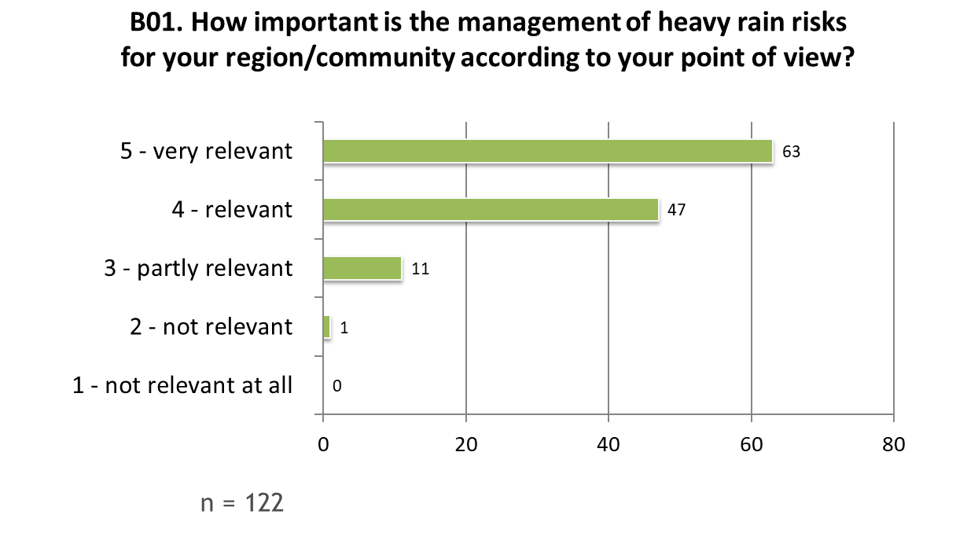
- More than 90 % of the respondents think that the management of heavy rain risk is very relevant or relevant for their region/community.
- Only 9 % of the respondents think that the topic is only partly relevant in their region/community and just one person thinks that it is not relevant.
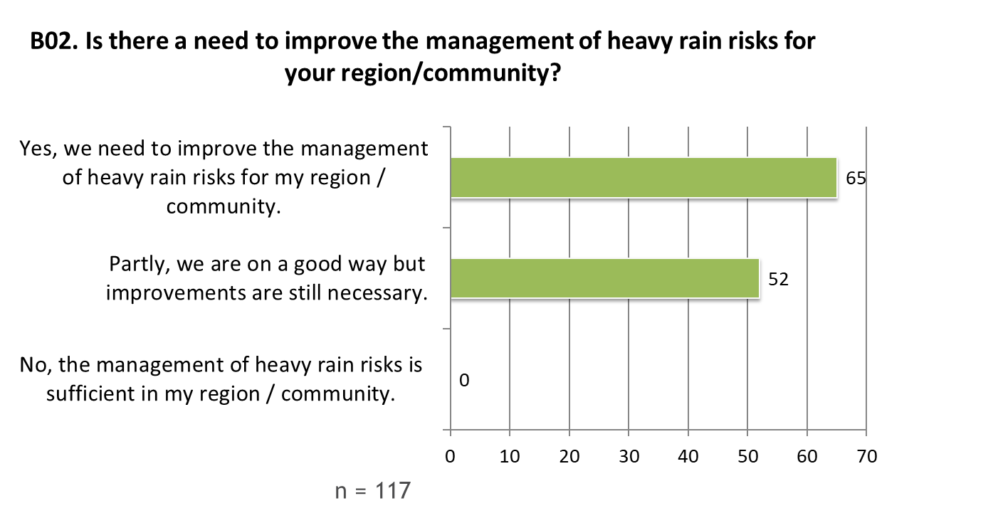
- All respondents think that there is a need to improve the management of heavy rain risks for their region / community.
- More than half of the respondents indicate that there is an absolute need to improve their management of heavy rain risks. The other part of the respondents thinks that their management is on a good way but improvements are still necessary.
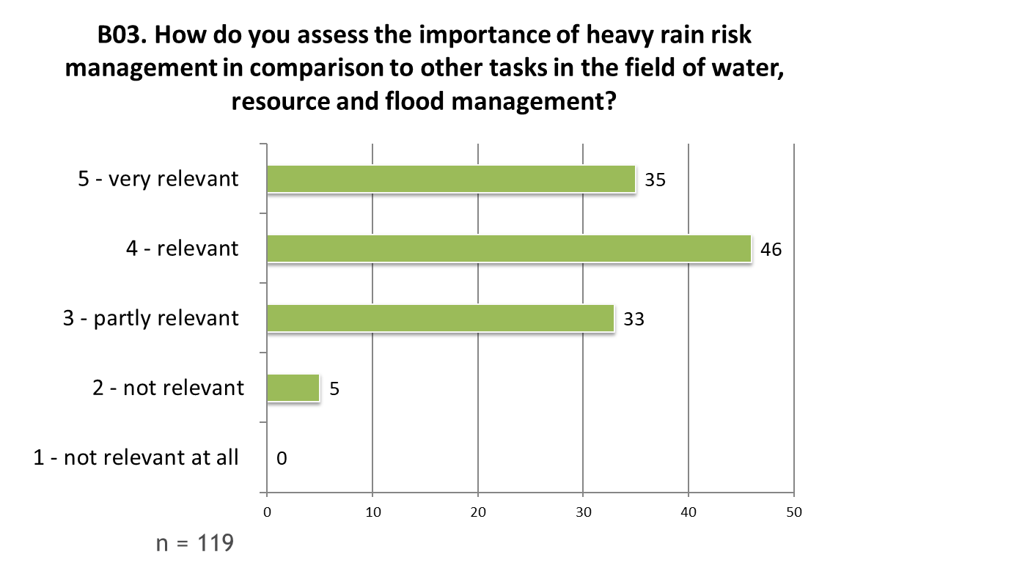
- In comparison to other tasks in the field of water, resource and flood management, most respondents assess heavy rain risk management as very relevant or relevant.
- Only very few respondents think that the topic is not important in the named field.
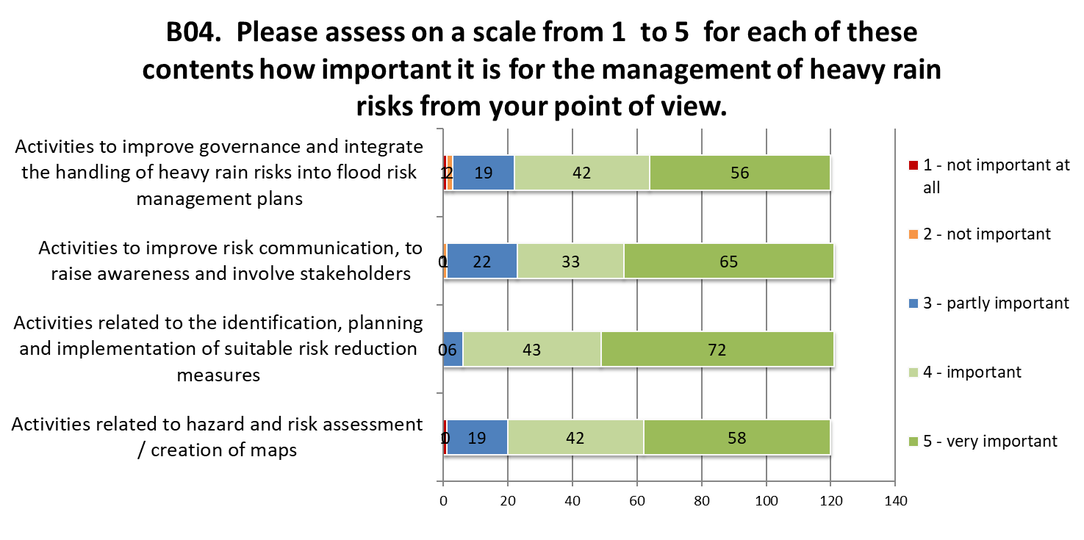
- The contents of the toolbox include four different aspects to reduce fatalities and damages caused by heavy rain. The respondents assessed for each of these contents how important it is for the management of heavy rain risks.
- Activities related to the identification, planning and implementation of suitable risk reduction measures are seen as the most important contents for heavy rain risk management.
- All contents are assessed as partly important, important or very important by nearly all of the respondents. This confirms the focus of the RAINMAN-Toolbox.
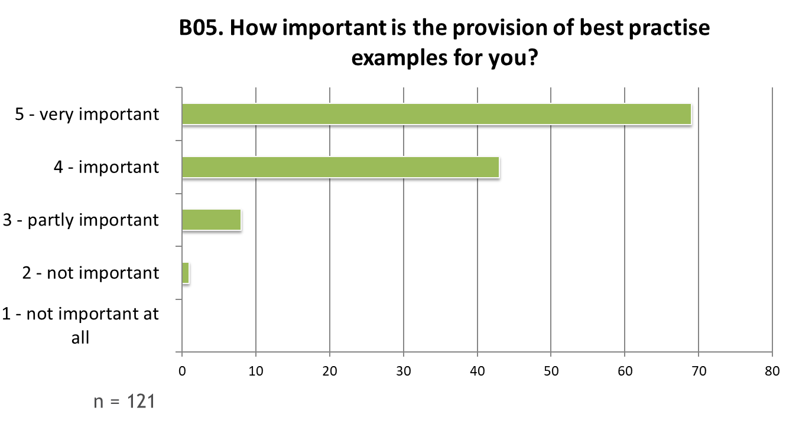
- The provision of best practise examples is very important or important to around 93 % of the respondents.
- Only few /very few respondents value the provision of best practise examples as only partly or even not important.
- Best practice examples are included in the RAINMAN-Toolbox in the section “Our stories”.
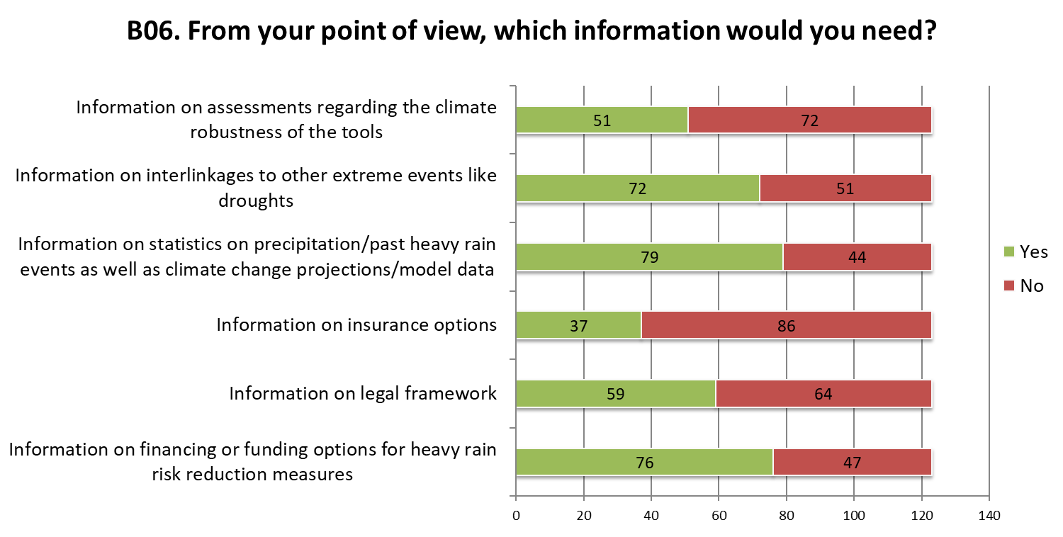
- Information on interlinkages to other extreme events like droughts, information on statistics of precipitation / part heavy rain events as well as climate change projections / model data and information on financing or funding potions for heavy rain risk reduction measures were mainly valued as important information that are needed by the respondents.
- Information on insurance options is mainly valued as not to be important. Also information on assessments regarding the climate robustness of the tools is not important for more than half of the respondents.

  - Results and conclusions of Part C: Outlook and exploitation
The RAINMAN project aims to reduce the damages caused by heavy rain. Therefore we developed a toolbox that provides guidance on various aspects of integrated management of heavy rain risks. The toolbox is designed as a web-based application. To improve risk management processes, the toolbox offers contents on different levels of varying information depth, from a rough overview of in-depth information and transferable recommendations to good practical implementation examples mainly related to the pilot activities in the project. The main contents of the toolbox are presented in the six languages: English, German, Czech, Polish, Hungarian and Croatian. We asked the respondents for their ideas for the exploitation of the toolbox.
Results
The following figures summarize the results of part “Outlook and exploitation” of the online survey. Comments and observations regarding the figure are added below the respective figure:
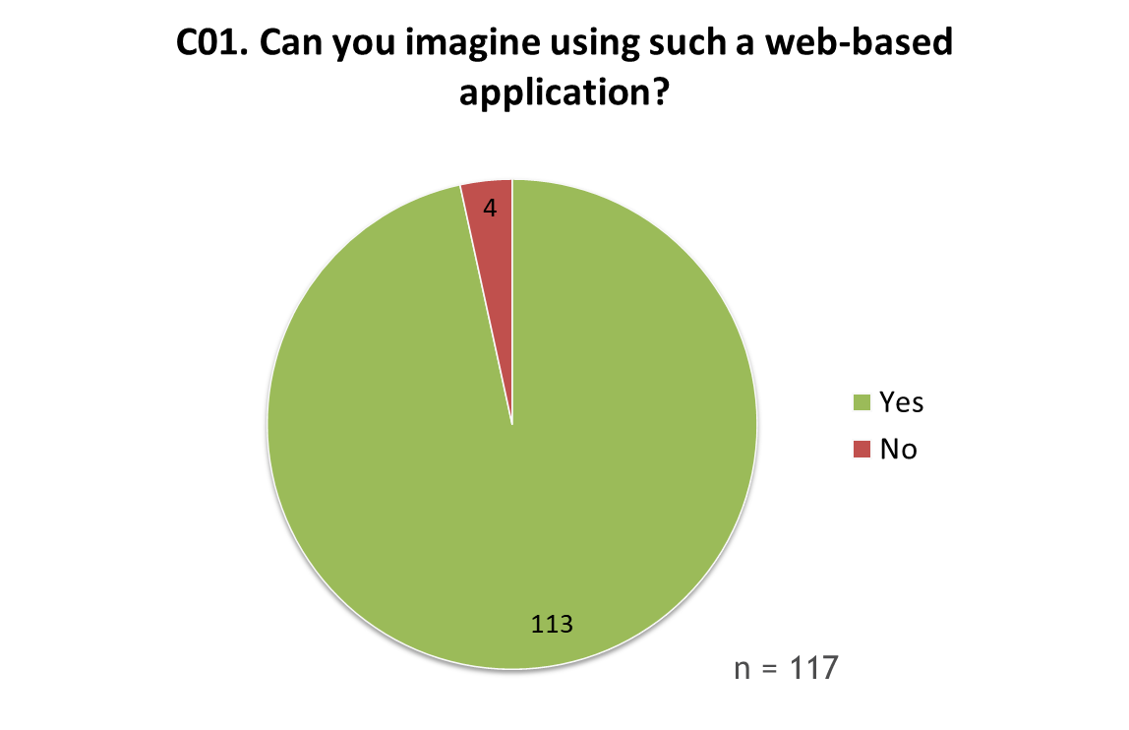

- Almost all of the respondents can imagine using such a web-based application.
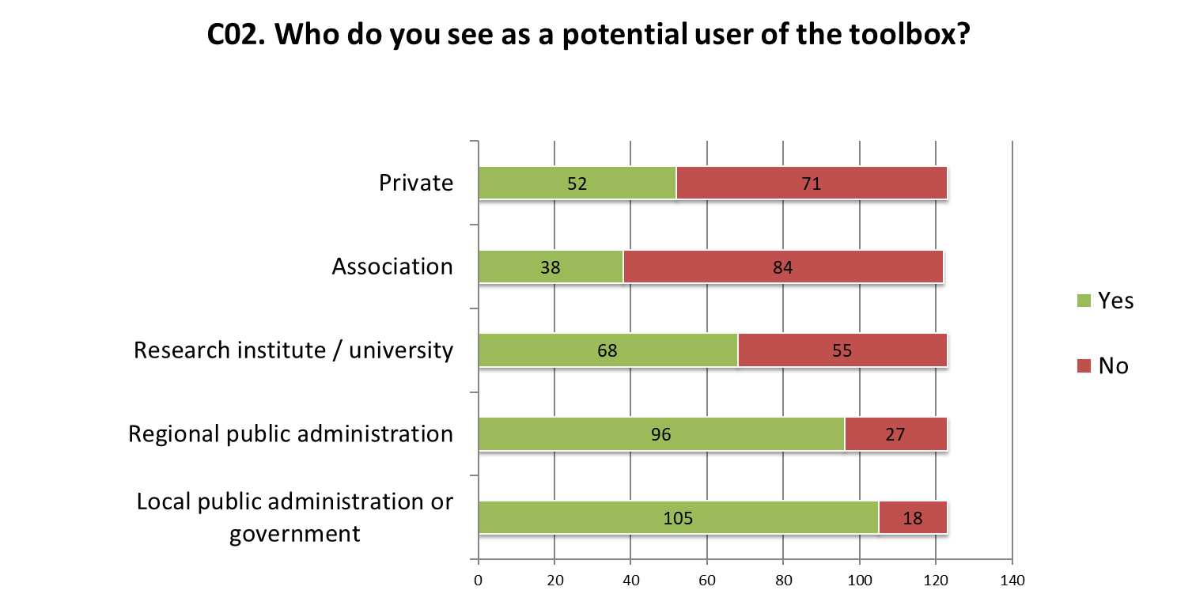
- Most of the respondents see local public administration or government or regional public administration as user of the toolbox.
- Another remarkable number of respondents think that research institutes / universities are potential users of the RAINMAN toolbox.
- Private persons and associations are mainly not valued to be potential users of the toolbox.

- Conclusions
The aim of the online survey was to evaluate the pilot activities and the involvement of the stakeholders and the contribution the developed tools and methods can have to better manage heavy rain risks.
The involvement of the participating cities and regions in the development process of the toolbox can be seen as success. Most stakeholders were very satisfied or satisfied with this process, with the communication within these pilot projects and with their involvement. 83% have learned a lot/something new regarding heavy rain risk management. Looking at the overall goal of the RAINMAN project, to improve integrated management capacities of public authorities to mitigate heavy rain risks, the survey results can be seen as confirmation for the achievement of the goal.
The analysis of the survey results also confirmed the approach of the RAINMAN project and the toolbox. The RAINMAN-Toolbox gives guidance for the integrated management of heavy rain risks and that comprises the whole process: from assessment and mapping of heavy rain risks (tool 1) through risk communication (tool 2) to the selection of risk reduction measures (tool 3). Furthermore, best practice examples are included in the toolbox. All these contents have been assessed by most of the respondents as being important or very important.
The results of the online survey were discussed within the RAINMAN partnership will be valuable for future projects.

- Annex
The following table summarizes the answers of the participants to the open questions of the survey. Answers were given in national language. The overview differentiates the answers from the respective countries.

Country | Entry
- A|02. Was the frequency of your involvement in the project sufficient (e.g. number of meetings)?
AT | - Ich wurde durch meine Abteilung relativ spät in das Projekt eingebunden, dahingehend beziehen sich meine Bewertungen nur auf die Projektendphase.
HR | - Održali dva sastanka, ispunili traženu dokumentaciju, predali statističke podatke o intervencijama i lokacijama (xls, shp) unazad 10 godina...  - 3 8  - Sudjelovali smo u početnim fazama izrade projekta, te bili pozivani na više radionica i skupova.
A|03. How satisfied were you with the format (presentation, workshop, etc.) with which the project contents were communicated to your pilot region?
HR | - Sve dobro objašnjeno i prilikom ispunjavanja potrebne dokumantacije pružena potrebna pomoć i objašnjenja...  - Nije nam moguće ocjenjivati zbog naše neposredne uključenosti u ono što bi trebali ocjenjivati
HU | - A konferencia, amin részt vettem teljeskörű információval látott el.  - Konferenciák, tájékoztató anyagok megfelelőek. Az érdekeltek bevonása szintén. Esetleg több magyarországi előadás az érdekeltekenk, hatásviselőknek.
A|04. Evaluation of the content of the pilot activities during your involvement in the project Have you learned much about heavy rain risk during your involvement in the project? Please evaluate how much you have learned on a scale from 1 (I have not learned anything new) to 5 (I have learned a lot).
AT | - bereits vorab Grundwissen und Erfahrungswerte vorhanden
HR | - Nisam imao mogućnost detaljno proučavati svaki apekt dokumantacije ali je na vrlo pregledan i prihvatljiv način prikazano način i razmišljanje u kojem smjeru ide projekt i koji su planirani rezultati projekta...  - Dovoljno  - Nije nam moguće ocjenjivati zbog naše neposredne uključenosti u ono što bi trebali ocjenjivati
HU | - Csatornázási Üzemvezetőként munkám során már tettem szert ismeretekre és tapasztalatra ezen a területen.
A|07. How satisfied were you with your involvement in the project in total?
HR | - Dovoljno  - Iznimno smo zadovoljni jer smo imali prilike napraviti obrade kakve smo dugo planirali, ali za to nije bilo raspoloživih mogućnosti
A|08. What could have been better? Do you have any comments?
DE | - Ich bin sehr zufrieden mit der Arbeit und den Ergebnissen von RAINMAN, vielen Dank am das kompetente & engagierte Team
HR | - Dovoljno  - Bilo bi korisno da se po završetku projekta publicira monografija s najvažnijim rezultatima po pojedinim pilot područjima
B|01. How important is the management of heavy rain risks for your region / community according to your point of view?
AT | - Die Starkregenereignisse häufen sich, Flächenversiegelung ist enorm, Problembewusstsein ausbaufähig
CZ | - V rámci regionu jsou nejproblematičtější místa již podchycena a větší nutnost spatřuji v efektivním hospodaření s dešťovou vodou.  - V roce 2002 byla obec Předmíř, resp. její místní část Metly zasažena katastrofální povodní, kdy 1 člověk zahynul a 13 domů bylo postiženo přímo nebo muselo býát strženo.
DE | - Kerbtallage der Kernstadt und einiger Stadtteile im Zusammenspiel mit teilweise verbauten Gewässern erzeugt hohes Schadensrisiko.  - Elbehochwasser
HR | - Zbog ugrožavanja grada od obilnih padalina prije nekoliko godina.  - Loše upravljanje rizicima od oborina izaziva štete na gradskoj infrastrukturi, imovini, zastoj u prometu, ekonomske gubitke, a moguće su i posljedice na život i zdravlje ljudi.  - Dovoljno  - Ima i drugih rizika pa sve treba obuhvatiti  - Nije bilo većih problema vezano za oborine u posljednje vrijeme  - Częste występowanie miejskich powodzi wywołanych intesywnymi opadami deszczu  - Pilot područje Istru karakteriziraju pojave vrlo intenzivnih oborina, te je nužno implementirati odgovarajuća rješenja zaštite od njih.
HU | - Azért csak közepesen, mert kicsi a szilárd burkolattal rendelkező, viszont nagy az elszivárgásra lehetőséget adó sik terület.  - A régióban (síkvidék) jellemzően az urbán táj esetén van jelentősebb kockázat.
PL | - Inensywne opady deszczu powodują duże zagrożenie w miastach, o dużej powierzchni uszczelnionej  - Praca  - Jest to podstawa do działania  - Problemem jest jak zarządzać takim ryzykiem i na ile jest to możliwe!  - Brak obecnych działań zarządzania ryzykiem intensywnych opadów, wpływ tego elementu na wiele aspektów życia społecznego i administracyjnego  - Częste występowanie miejskich powodzi wywołanych intesywnymi opadami deszczu  - W kontekście miast oraz terenów górskich bardzo ważne  - Powódź w 2007roku  - Zarządzanie ryzykiem związanym z intensywnymi opadami deszczu ma bardzo istotne znaczenie z perspektywy bezpieczeństwa mieszkańców regionu. Wprowadzenie rozwiązań zwiększających bezpieczeństwo ma również wymiar ekonomiczny. Skuteczny system bezpieczeństwa jest zawsze tańszy niż naprawa szkód związanych z intensywnymi opadami deszczu.  - Brak zarządzania ryzykiem intensywnych opadów może prowadzić do występowania zjawisk powodziowych  - Nie 5, bo na to zjawisko nie mamy wpływu
B|02. From your point of view: Is there a need to improve the management of heavy rain risks for your region / community?
CZ | - Co se týče ohrožení obydlí, tak jsme na dobré cestě. Co se týče ochrany zemědělské půdy, tak tam je potřeba velmi zapracovat
DE | - Bisher nur zaghafte Projektansätze als Reaktion auf aufgetretene Schadensereignisse, was zu 'Schnellschüssen' führt. Keine Maßnahmen zur Vorbeugung.
HU | - A klimatikus anomáliák kényszert jelentenek a kockázatkezelés tekintetében. A helyi szabályozóknak követnie kell a változásokat, ahogy egyén szintjén is szükséges ennek fontosságának belátása, vagy beláttatása jogi/gazdasági szabályozók által.
HR | - Zbog poplava.  - Zbog klimatskih promjena i sve učestalijih ekstrema, trenutne sposobnosti se moraju stalno nadograđivati  - Potrebno je novelirati sustave oborinske odvodnje i odvojiti ih od sustava fekalne odvodnje  - Dovoljno  - Uvijek treba težiti boljem, no nismo na dnu  - Poboljšanje je uvijek potrebno  - Grad Zagreb ima dobar sustav obrane od obilnih oborina.  - Uz analizu stanja i mogućnosti provedbe primjerenih rješenja, nužno je u daljnjim fazama u većoj mjeri ustrojiti aktivan sustav zaštite, temeljen na monitoringa stanja u realnom vremenu.
PL | - Zawsze należy rozmawiac i zawsze znajdzie się cos do poprawienia  - Ciągle należy poprawiać  - Szkolenie osób za zarządzanie ryzykiem  - Nie orientuję się w poziomie zarządzania tym ryzykiem  - Brak świadomości społeczeństwa, zarówno w kwestii planowania, zabezpieczania oraz zachowania w przyapdku zdarzeń kryzysowych. W przypadku jednostek administracynych brak wiedzy oraz brak uwzględniania zagrożenia w planowanu przestrzennym  - Miasto podejmuje działania w tym zakresie, jednakże nie mają jeszcze one charakteru obligatoryjnego, raczej uznaniowe  - Wg mnie zarządzanie ryzykiem opadów nawalnych nie istnieje  - Brakuje obiektów "małej retencji"  - Postępujące uszczelnianie terenów miejskich wymaga dalszej ulepszania działań w zakresie zarządzania ryzykiem intensywnych opadów, których przybywa również na skutek niekorzystnych zmian klimatycznych  - Budowa zbiorników retencyjnych oraz odpowiednie zabezpieczenie terenów zalewowych
B|03. How do you assess the importance of heavy rain risk management in comparison to other tasks in the field of water resource and flood management (water quality, supply, droughts, ...) on a scale from 1 (not relevant at all) to 5 (very relevant)?
AT | - Ereignishäufigkeit größer, da Hochwasserproblematik in den letzten Jahren sukzessive bearbeitet wurde
CZ | - Aktuálním problémem posledních dvou let je hlavně sucho. Kvalita vody a povodně z přívalových srážek jsou až druhé v pořadí a na stejné úrovni.  - Všechny výše uvedené příklady by měly být v dnešní době diskutovány a hlavně řešeny  - Všechny oblasti považuji za stejně významné
DE | - Es besteht Bedarf einer integrierten Betrachtung des Wassermanagements. Wo weniger wild abfließendes Wasser nährstoff- und schadstoffreiche Sedimente in die Oberflächengewässer spült profitiert auch die Gewässergüte davon. Etc...
HU | - Az előzőek a térségemben fontosabbak ennél.  - Jelentős károkozás állhat fenn az esemény bekövetkezésekor, különösen lakott beépített területeken.
HR | - Pošto smo poljoprivredni kraj upravljanje rizicima od oborina je bitno i za opskrbu vodom, navodnjavanje i sve većim sušama.  - Tijekom 2019 godine već su zabilježena najmanje 2 ektrema obilnih oborina koja su dovela do velikih šteta u urbanim sredinama  - Podjednako kao i ostale prijetnje.  - Područje rizika od obilnih oborina zahvaća manju površinu i lakše je sanirati posljedice  - Dovoljno  - Samo sveobuhvatno vodi dobrom  - Postaje sve relevantnije obzirom na klimatske promjene  - Važno je radi prevencije većih šteta i boljih uvjeta života u ugroženim područjima.  - Obzirom na krški karakter pilot područja Istre, uz pojave velikih voda kao posljedice obilnih oborina, dominantni su problemi vezani u kakvoću voda, kao i sve učestalije pojave iznimno sušnih razdoblja,
PL | - Zarządzanie takie jest istone obecnie w porówaniu z innymi zagrożeniami marginalne lub pomijane  - Powinno być na równi traktowane z innymi zadaniami  - Powinno być na równi traktowane z innymi, w niektórych przypadkach nawet bardziej  - Zarządzanie ryzykiem związanym z deszczami nawalnymi uważam za zadanie istotne, jednak nie dominujące pośród podstawowych potrzeb społeczeństwa np. zaopatrzenie w wodę pitną.  - Kwestie te są ze sobą skorelowane  - Jakość wody, zaopatrzenie, susze - są co najmniej tak samo ważne - to są sprawy ważne na co dzień
B|04. Please assess on a scale from 1 (not important at all) to 5 (very important) for each of these contents how important it is for the management of heavy rain risks from your point of view.
AT | - Karten wichtig, um zu wissen, wo können Probleme auftreten bzw. Schadenspotential hoch ist. Da aber Probleme meist lokal begrenzt und sehr kurzfristig, muss jede/er wissen was ist wann zu tun.
CZ | - Ohledně komunikace o rizicích: je to velmi obtížný problém, protože velkou roli tady hrají jednotlivé obce a města. Problém je v případě malých obcí, kdy je starosta neuvolněn. V takovém případě je vystaven "tlakům" z různých směrů - je potřeba řešit povodně z přívalových dešťů, je potřeba řešit sucho, je potřeba řešit vylidňování vesnice, je potřeba řešit dostupnost veřejné infrastruktury...
HR | - Da se unaprijedi upravljanje rizicima od obilnih oborina potrebno je uključiti sve elemente  - Dovoljno  - Sve je važno i sve treba razvijati  - Svi prostorni podaci moraju biti tako i prikazani, kao prostorni podaci i kartografski prikazi, to je najjasnije.  - Sve je važno, ali implementacija mjera za koje se nesumnjivo zna da pridonose smanjivanju poplavnih rizika sigurno najvažnija
PL | - Intensywane opady atmosferyczne mają bezposrednio i pośredni wpływ na wiele dzidzin życia oraz na inne zagrożenia w tym morfologiczne i hydrologiczne oraz podtopienia, dlatego też konieczne jest zarówno zwiększenie lokalnego rozpoznania zjawiska (montaż dokładniejszej i zagęszczonej sieci pomiarowej, wykorzystanie nowych technologii oraz określenie obszaów zagrożonych)  - Każde z tych zagadnień uważam za istotne, a ich współdziałanie za niezbędne do osiągnięcia skuteczności
B|05. How important is the provision of best practise examples for you?
AT | - Gute Beispiele inspirieren immer
CZ | - Pro mě osobně je to dobré - rád se podívám, jak to jinde zvládají
DE | - Ideenvorschläge werden geliefert
HU | - Hatékony megoldások alkalmazása. Döntés egyszerűsítése.
HR | - Dovoljno  - Najlakše se nešto shvati na primjerima  - Lakše je razumjeti ako vidiš primjer dobre prakse.  - Iznimno su važni baš primejri dobre prakse, da se što veći broj osoba koje su i neposredno zadužene za rješavanje problema odvodnje, uvjere u učinkovitost nekih od za sada rijeđe korištenih rješenja.
PL | - Najlepiej człowiek uczy się na przykładach  - Przykłady są najważniejsze  - W ramach udziału w konferencjach dotyczącyh opadów atmosferycznych i zagospodarowania wód z nim związanych takie praktyki są opracowywane przez różne jednostki, niestety jest ich w dalszym ciągu za mało i i zgłaszane są także z jednostek administracyjnych głosy o konieczności opracowania takich wytycznych.  - Przykłady dobrych praktyk będą "mówić same za siebie". Odpowiednio zobrazowany przykład odpowiednio przedstawi odbiorcy zasadę działania danego rozwiązania, nawet jeśli jest skomplikowane.  - Stanowią inspirację do podobnych działań
C|01. Can you imagine using such a web-based application?
CZ | - Velmi záleží na způsobu zpracování webové aplikace.
HR | - Dovoljno  - Svašta si mogu zamisliti, ali nisam baš lud za takvim aktivnostima  - Lako ih je ažurirati sa svježim podacima pa su uvijek aktualne. Analogni format po malo zastarjeva za ovako aktualne teme.  - Naravno
PL | - Liczy sie najnowsza technologia  - Wykorzystanie o charakterze informacji/ostrzezenia  - Brak obecnie internetowych zbiorczych informacji na tema opadów w POlsce jedynym rozwiązanie obecnym jest opracowany atlas klimatycnzy CARPATCLIM oraz mapy na stronie IMGW oraz pogodynka.pl  - Jestem ciekaw.
C|04. What would be important for the marketing of such a toolbox and the distribution of information regarding the toolbox?
CZ | - Kromě toho, že se udělá klasická zveřejňovací akce - tedy tisková zpráva pro noviny, rozhlas, televizi, zpráva na webu a facebooku, tak je možné dostat se i k odborné veřejnosti mimo "vodohospodářský" obor - např. pokud se v rámci projektu využije GIS, tak proč to nezveřejnit např. na facebooku GISportál. Pokud se v rámci GIS využijí produkty ESRI, tak je možné udělat poster na ESRI konferenci (setkání uživatelů ESRI - cca 1500 lidí) apod.  A samozřejmě klasický low-cost marketing: jde udělat soutěž na Instagramu nebo středních školách apod.  - Srozumitelnost, jednoduché a intuitivní ovládání
DE | - Förderung anpassen.  - Übersichtlichkeit; Start mit Übersicht zu Themenbereichen mit Beispielen, Detailfülle dann bei Vertiefung zunehmend  - Mediale Information über die Existenz und die Nutzung des Tools  - Regelmäßige Informationsveranstaltungen Vorort in den Städten und Gemeinden
HR | - Da je aplikacija besplatna  - Dijeljenje informacija na pristupačan način (brošure, letci, plakati,..)  - Informiranje zainteresiranih i strukom povezanih osoba i institucija o postojanju alata i načinu korištenja alata - radionica, videozapisi (npr. YouTube)  Predstaviti široj javnosti rezultate alata  - Ukazati na njegovu korisnost na primjerima iz prakse  - Objava na društvenim mrežama i informacija kroz oglašavanje na tv-u i sl.  - Posebno važno da se uz takav alat osigura i mogućnost korištenja za to nužnih podlog.
PL | - Nagłośnienie w lokalnej prasie oraz TV, radiu  - Zaangażowanie lokalnej prasy, radia, TV, spotkania w Domach Kultury lub innych miejscach ogólnodostepnych  - Szeroko pojęte akcje uświadamiające i szkolenia na poziomie profesjonalnym i publikacje internetowe  - Podobne do RCB  - Aktywna akcja informacyjna  Rozesłanie informacji do jednostek samorządowych  Współpraca w ramach instytutów Naukowych, np. IMGW z grupami eksperckimi opracowującymi ekspertyzy i opracowania oraz kontaktującymi się bezpośrednio z jednostkami w kwestii możliwości informowania o istnieniu takich narzędzi oraz prowadzenie szkoleń.  - Strona internetowa, kampania w social media, szkolenia, darmowa możliwość korzystania z aplikacji przez jednostki naukowe  www, szkolenia, kampania promocyjna, open source, integracja z innymi systemami

RAINMAN Key Facts
Project duration: 07.2017 − 06.2020
Project budget: 3,045,287 €
ERDF funding: 2,488,510 €
RAINMAN website &
newsletter registration: www.interreg-central.eu/rainman

Lead Partner
Saxon State Office for Environment,
Agriculture and Geology
rainman.lfulg@smul.sachsen.de

Project Partner

T. G. Masaryk Water
Research Institute, p.r.i.
Leibniz Institute
of Ecological Urban
and Regional Development
Croatian Waters
Institute of Meteorology and Water
Management National Research Institute
Environment Agency Austria
Project support
INFRASTRUKTUR & UMWELT
Professor Böhm und Partner
RAINMAN@iu-info.de

