template

Output factsheet: Pilot actions

Version 1

Project index number and acronym | CE111 Focus in CD
Lead partner | Maribor
Output number and title | Output O.T3.1.1 Development and implementation of  10 pilot projects  Evaluation and follow up of family members
Responsible partner (PP name and number) | Heim Pál National Paediatric Institute - PP10
Project website
Delivery date | 24.0.5 2019

Summary description of the pilot action explaining its experimental nature and demonstration character
PP10’s pilot action targets further undiagnosed groups of patients with subtle or subclinical manifestations in addition to diagnosing CD patients with clinical symptoms who spontaneously visit health care facilities. Since CD has a genetic background, first degree family members have elevated risk, but they often do not seek medical advice, or children are not tested by gastroenterologists if an adult patient is diagnosed or vice versa. In this pilot action, we established an open-access family evaluation regardless of age limits. The only criterion for enrolment was an already ongoing gluten consumption in case of testing serology markers (transglutaminase and endomysial antibodies) in young children, but even without that even newborns were evaluated for the presence HLA-DQ2 and HLA-DQ8 genetic allele variants which confer susceptibility for developing CD. Workshops were organized for stakeholders (eight in total) where the index patient and his/her family were informed about risks, possible clinical signs and the screening procedure. If consent was given, venous blood (or cord blood) was collected and processed. Serum antibodies against transglutaminase 2 (TG2) were measured by a capture ELISA using human red blood cell TG2. Endomysial antibodies were detected and titrated by indirect immunofluorescent method using human umbilical cord and appendix substrates. Genomic DNA was extracted from EDTA-treated venous blood samples by the Flexigene (Qiagen) kit. HLA-DQ risk alleles were detected by SNP-based Taqman probes using PCR amplification. A simple fluorescent method was developed and optimized during WP1 (diagnostic evaluation of new diagnoses) that could be read by fluorescent ELISA already available in the hospital. This worked well for the alleles DQ2.5 and DQ8. However, allele DQ2.2 needs 3 reactions and amplification is more difficult to detect. Therefore, for larger scale testing, a LightCycler automated real-time PCR machine was needed (rented). The organized workshops had 366 participants. During the pilot project 1486 newly enrolled family members were tested and 235 positives found (15.8%). In most cases the diagnosis of CD was confirmed by small bowel biopsy.

NUTS region(s) concerned by the pilot action (relevant NUTS level)
HU, HU101, HU321

Expected impact and benefits of the pilot action for the concerned territory and target groups
Subclinical CD has late health consequences and clinical symptoms can be prevented or if mild, reversed more easily when diagnosis and therapy are introduced early. Almost 90% of CD cases are asymptomatic during childhood but when a close relative is diagnosed with CD, these subjects can be relatively easily detected by serological screening. This is important, as families often adopt gluten reduction in their general eating habits and without screening, other affected members may go long unnoticed. During our pilot project, serology showed disease activity in 15.8% of family members. As a result, family screening added 23% more persons to the newly diagnosed CD cohort in our institution during the interval of the pilot. It can be expected that systematic family screening by serology also in other settings and countries will increases clinical diagnoses in general by at least 20%. Regular screening for HLA-DQ2 and DQ8 above the age of 6 years is not cost-effective, because the overwhelming majority of even DQ2 and/or DQ8 positive subjects still negative for serology at this age will remain unaffected also later on. However, a negative DQ2 and DQ8 result in very young children may alleviate the need for repeated serology screening. In fact, no disease features were detected in the pilot in persons negative for both DQ2 and DQ8. This test can be performed independently from gluten intake (even at newborn age), but only 15% of the children of known patients and 15-25% of other first-degree family members (sibs, parents) are DQ2 and DQ8 negative.

Sustainability of the pilot action results and transferability to other territories and stakeholders
With appropriate organization, regular screening for all first-degree relatives of newly diagnosed CD patients can be established and the practice maintained. Since screening is part of internationally recommended case-finding strategy already incorporated into international guidelines, official referral from family doctors can be obtained for each person. For this practice, medical education will be needed in broader sense. When referral is available, the testing can be accommodated into outpatient evaluations and supported by health insurance. Technical advance in antibody detection, rapid tests and simplification of the genetic testing strategy and methods applied in this project will make the evaluation cheaper and more accessible also in smaller centers. However, transferability may be of variable degree to countries with very different health systems and referral rules. Transfer will be easier in pediatric care, partly because parents are more concerned about their children’s health, but it might prove to be difficult to convince adult family members to collaborate.

Lessons learned from the implementation of the pilot action and added value of transnational cooperation
We experienced that families were very open to listen to provided information and a high percentage of them volunteered for the screening involving all first-degree relatives. In some family’s parents gave consent to screen their children, but they did not participate although mothers were often collaborating more than did fathers. We learned that nowadays it is quite easy to start a gluten-free diet just in anyone and this may compromise screening results. Therefore, advice for the family screening should be communicated as early as possible and prior to reducing gluten intake. We further learned that genetic results must be always personally discussed to avoid misinterpretation and anxiety. A positive HLA-DQ result, in fact, does not prove any disease. It is only a normal variant in 30% of the normal population making gluten presentation possible to the immune system, but most of these people remains healthy. Thus, persons with positive result should not be regarded as diseased. However, if they are still young and relatives of CD patients, they should be carefully followed and retested.

References to relevant deliverables and web-links
If applicable, pictures or images to be provided as annex
Deliverable D.T3.2.10 Evaluation and follow up of family members
Workshop and equipment pictures

All deliverables and the output can be found here:
https://www.interreg-central.eu/Content.Node/Evaluation-and-follow-up-of-family-members.html

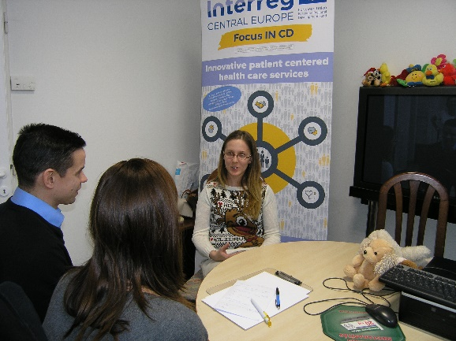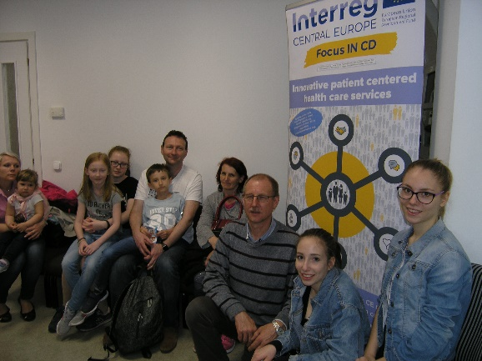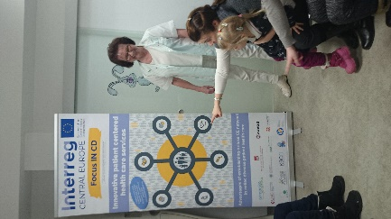
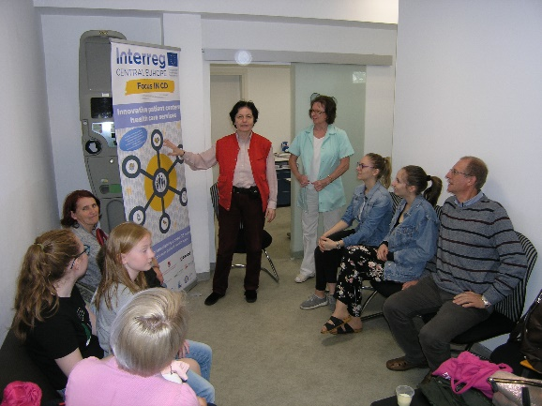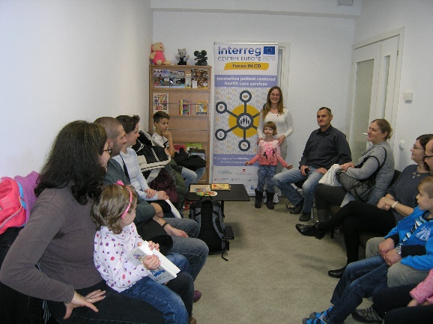
Stakeholder workshops at Heim Pál Hospital
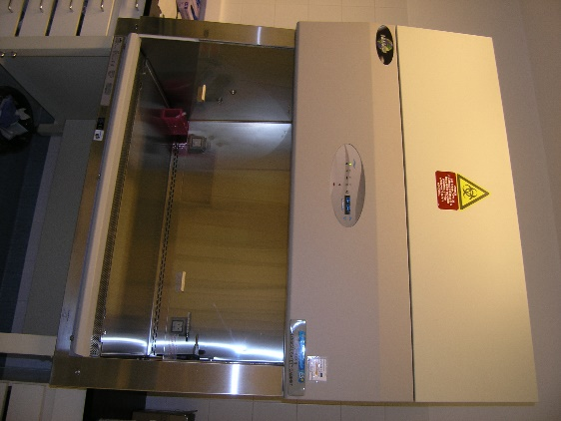
Class II laminar box purchased for proper preparation of DNA

