Output factsheet: Pilot actions

Project index number and acronym | Focus IN CD 111
Lead partner | Municipality of Maribor
Output number and title | Output O.T3.1.1 (T3.2.4)  Development and implementation of 10 pilot projects
Responsible partner (PP name and number) | University Medical Centre Maribor - PP2
Project website | https://www.interreg-central.eu/Content.Node/Focus-IN-CD.html
Delivery date | 5/2019

Summary description of the pilot action explaining its experimental nature and demonstration character
»Improvement of early diagnostics, testing method 'IgA t-Tg deposits in tissue sample'«

Pilot activity was developed and tested by the University Medical Centre Maribor with the strong cooperation and support of partners IRCCS Burlo Garofolo (PP-7) and University of Trieste (PP-5). Main aim of the activity was to improve current diagnostic capacity in Slovenia with transfer of novel diagnostic methods into practice. It is known that diagnosis of celiac disease is suboptimal in many regions, which can partially be attributed to insufficient use of existing diagnostic methods. This can yield to long delays and high level of misdiagnosis. However even in regions where all diagnostic methods are available, some patients exist in which a firm diagnosis cannot be made due to the discrepancy of the results of “classical” diagnostic tests. In these cases, novel immunodiagnostic procedures can prove to be of a great value to clinicians and to patients. One of these methods that is only used in few centres in the World is the detection of initial immunological deterioration within the intestinal tissue of patients. It has been shown that pathological immunological reaction can precede systemic reaction and this can be proven by special immunohistopathological methods.
In order to introduce and test the method in Slovenia, samples of celiac disease patients were stored in liquid nitrogen. To do this efficiently liquid nitrogen containers as well as transport freezers were purchased in initial stage of the project. Samples of patients were stored and were alter transported to laboratory of PP7 in Trieste. Members of the PP7 project group tested some of the samples for their viability, and later one of the members of the PP2 project group spent one month at the PP7 diagnostic laboratory, where she learnt the method using samples of patients diagnosed at PP2. After that, the method was introduced on site of PP2 where samples were continued to be collected and tested.
The method enabled to establish the diagnosis in several of very challenging cases with discrepant results of initial diagnostic tests.
Introduction of new method and testing of the samples improved the quality of service provided by healthcare in Slovenia.

NUTS region(s) concerned by the pilot action (relevant NUTS level)
Method was introduced in University Medical Centre; however, partners involved come from other partner regions. All of the partners were presented with the results of the transfer of new method to Slovenia.
NUTS regions:
HR03-Primorska Hrvatska
HR04-Kontinentalna Hrvatska
HU11-Budapest
HU31-Northern Hungary
ITD4-Friuli-Veneza Giulia
SI03-Vzhodna Slovenija
SI04-Zahona Slovenija

Expected impact and benefits of the pilot action for the concerned territory and target groups
Pilot activity Improvement of early diagnostics, testing method 'IgA t-Tg deposits in tissue sample’ will have an important impact on diagnostic capacity of healthcare institutions in Slovenia. With introduction of this method, challenging cases of celiac disease from Slovenia will be diagnosed with greater certainty without the risk of unnecessary delaying the diagnosis and without the risk of misdiagnosis. Improved diagnostic capacity will also improve the quality of life of patients with unclear diagnosis or with subtle changes, which cannot be detected by traditional tests. Improved diagnostic capacity will also indirectly influence management of other immune diseases where diagnosis can be as challenging as in celiac disease.
The end net effect will be better healthcare service for all citizens in the region.

Sustainability of the pilot action results and transferability to other territories and stakeholders

Sustainability: equipment purchased within the project will remain to be used at the University Medical Centre Maribor after the project end. Diagnostic method of detecting tissue samples of tissue transglutaminase in intestinal biopsies will continue to be used in challenging cases of celiac disease. Method will be presented at annual professional events and will be offered to diagnostic centres from other regions. Equipment will be regularly updated.

Transferability: upon exchange of the experience with partners and stakeholders the service will be provided to end users from other regions, where this diagnostic method has not been introduced yet. Based on our experience we will be able to help in introduction of this method to these centres or will provide them with diagnostic possibility at our institution. Several institutions have provided positive feedback and interest in new methodology. Pilot activities and achievements were also transferred to other regions and countries through our participation at transnational events: AOECS (EU patient society), ESPGHAN, UEG (EU professionals societies) and through project communication channels. We will continue to promote new developed service through our networks.

Lessons learned from the implementation of the pilot action and added value of transnational cooperation
During the initial state of the development of the service, a literature search was done that enabled partners to get better insight into the current diagnostic methods. Major help was provided by one of the partners with extensive experience in the field of celiac disease autoimmunity. This step proved to be crucial in further development of the service.
Important step that proved valuable to partners was purchase of equipment early during the project, which enabled storage of samples before the implementation of new method.
Close co-operation with partner with extensive knowledge and diagnostic capacities proved to be very valuable.
On-site training of one of the members of the partner group was very important step, which enabled the efficient exchange of knowledge. Training with real samples and providing patients with challenging diagnosis with appropriate feedback was also very rewarding.
Without co-operation of partners at regular meetings, and especially without the close collaboration of partners PP2, PP7 and PP5, the development of service would not be possible. Transnational partnership enabled us to get the information of local practices and expertise in center with extensive knowledge and diagnostic capacities. This enabled the development of the service, which can in future be transferred to other settings without the need of major modifications.

References to relevant deliverables and web-links
If applicable, pictures or images to be provided as annex
D.T3.1.1 Report about pilot project ideas and established stakeholders’ groups
D.T3.2.1 Preparation of common pilot methodology
D.T3.2.4 Improvement of early diagnostics, testing method 'IgA t-Tg deposits in tissue sample' (PP2 UKC MB)

All deliverables and the output can be found here:
https://www.interreg-central.eu/Content.Node/Improvement-of-early-diagnostics--testing-method--IgA-t-T.html

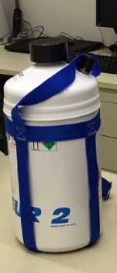

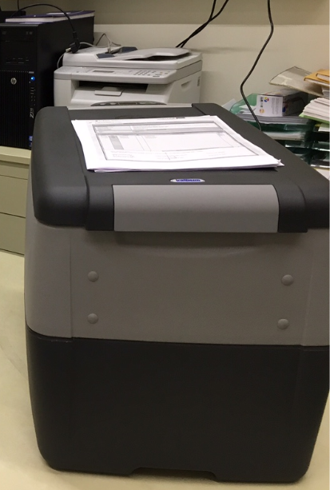
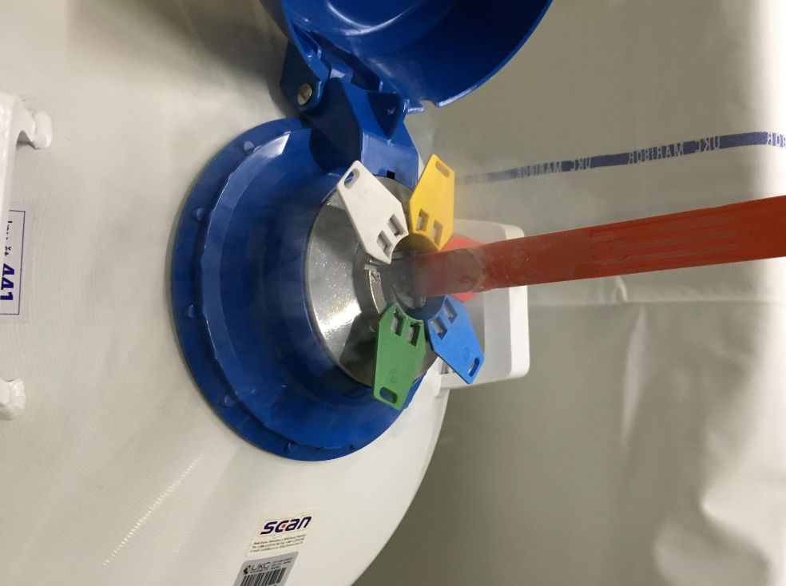
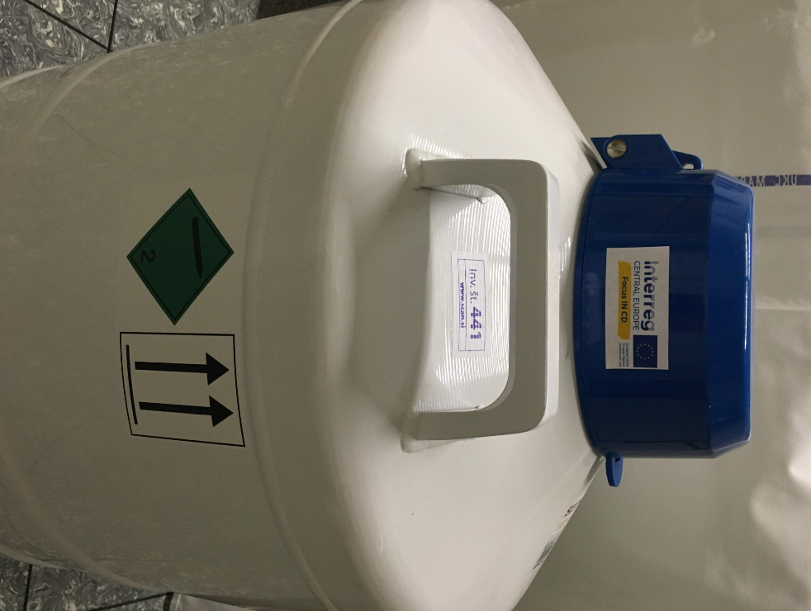

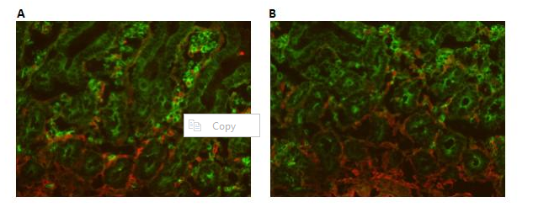
Negative sample of one of the patients

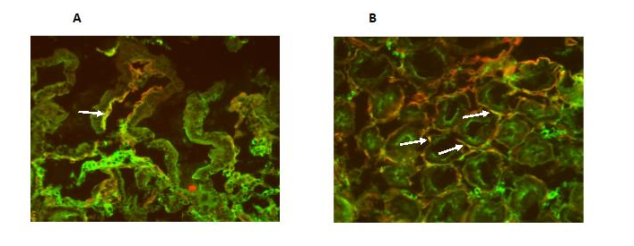
Positive sample of one of the patients.

