SENTINEL Project

Activity A.T3.4 Policy Recommendations Targeted at EU Level
Deliverable D.T3.4.2

Working Paper on Policy Recommendations

Coordinated by
Central European Initiative – Executive Secretariat
With the contribution of:
Social Impact gGmbH

May 2020

Table of contents

EXECUTIVE SUMMARY 3

1. Social Enterprises in Disadvantaged Regions within Europe 4

2. SENTINEL: Activities and Impact 5

3. Challenges and operational proposals for Social Enterprises in Disadvantaged Regions 7

4. Learnings from SENTINEL: Key Elements for a Social Enterprise Strategy in Disadvantaged Regions 8

5. Policy Recommendations 10

EXECUTIVE SUMMARY

This document offers a thorough overview of the SENTINEL Project accomplishments over the past three years, giving a coherent picture from the conceptual and normative background to the main activities and impact. Sentinel - a transnational project funded by the Interreg Central Europe Programme 2014-2020 - aimed at improving and strengthening the role of social enterprises (SEs) in marginal areas.
The Policy Recommendations stand as a tool both for comprehending the inherent value of SEs in areas that are currently lagging behind and for leveraging their potential in future scenarios.
The Policy Recommendations encompass 11 key points, focussing on social, economic and operational challenges. The document provides a handout about how SEs work in marginal areas in Central Europe countries and the 11 points are the result of an accurate analysis of both the needs and the opportunities of the regions involved, in the broadest meaning of territorial capital resources, i.e. physical, human, and economic.
The value of the analysis relies on the fact that SENTINEL involved areas which vary considerably as to economic capacity and development of SEs. The pilot actions implemented in the project gave evidence of these differences, helping to organize them according to key domains, i.e. existing legislation, socio-economic background, business development and local impact.
In particular, the Recommendations target some strategic stakeholders such as decision-makers, EU level bodies and transnational bodies/organizations, providing the vision of the inclusive approach to growth and development policies. The distinctive feature of SEs is that they combine three specific dimensions: the entrepreneurial dimension, the social dimension and the governance dimension. SENTINEL gained evidence that SEs should endeavour to develop further their capacity to adapt and evolve, taking all these three aspects in the due account. Indeed, a lesson that appears to be of the highest relevance for the times we are experiencing is that the balance of these three dimensions holds its validity.
Concerning marginal areas, the Recommendations draw attention to the mutual relation between SEs and their specific context and provide suggestions for enhancing this two-way correlation.
Decision-makers, at all level, are encouraged to be more aware of the unique role of SEs in promoting social cohesion and economic value on a territorial basis.
Similarly, it is also crucial to include SEs when planning investments in research, innovation, improvement of governance and training. This model is highly reliable, as it has anticipated a system of values that today are widely adopted and continue to be a source of inspiration for corporate responsibility, local development and territorial sustainability policies.
The Policy Recommendations of the SENTINEL Project stem from an evidence-based analysis that embraced the very multidimensional speciality of SEs. The document comprises measures that may be readily applied within different geographic contexts to promote knowledge about SEs and to strengthen their role.

Social Enterprises in Disadvantaged Regions within Europe

Following its Social Business Initiative (SBI, 2011) the European Commission has defined social enterprises by referring to three key dimensions:

- Social enterprises (SEs) run continuous economic activity (entrepreneurial dimension) - which distinguishes social enterprises from traditional non-profit organisations / social economy entities
- In order to achieve primarily and explicitly a social purpose (social dimension) - which distinguishes social enterprises from mainstream (for-profit) enterprises -
- and, have an inclusive and transparent organisation and / or ownership system (governance dimension).

The EU Commission’s definition is based on principles shared by the majority of Member States while respecting their diversity of political, economic and social contexts as well as the capacity for innovation of social entrepreneurs. As a consequence, different EU Member States adopted new legislation and/or created strategies and/or policies to support SEs’ development.

This led to a diverse SE landscape across the European Union, where SEs provide useful, and potentially disruptive, tools and actions to enhance inclusive socio-economic development and promote employment and competitiveness through the mobilisation of civil society actors and the wider population. The capacity of social enterprises to directly benefit local development and correct major socio-economic imbalances while benefiting local communities has been demonstrated within structurally disadvantaged regions in Europe and beyond, and it remains a crucial asset to hamper detrimental depopulation tendencies in regions plagued by population aging, an accelerating loss of (basic) infrastructure, fiscally strapped municipalities etc.
In particular, marginal regions are frequently characterised by an ever expanding lack of public and private support networks and services, longer distances and financial scarcity, while local communities simultaneously fall prey to less mobility, quality of life as well as enhanced social and political fatigue and distrust. In such social and political cleavages and underserved communities social entrepreneurs can represent local changemakers, eager to turn the pages and rejuvenate and capitalize on regions’ resources and virtues.
To foster the development and longevity of such SEs, it is frequently those instruments provided to and tailored for start-up and growth processes of regular, profit-oriented businesses, which are, too, open to SEs. Like other companies, social enterprises have consulting, coaching and financing needs. However, SEs also have specific features which distinguish them from ordinary commercial companies and which must be taken into account when designing conducive policy measures to support those local changemakers.

In this policy brief the INTERREG CE SENTINEL project seeks to discuss the potential SEs bring to disadvantaged regions within CE and the challenges as well as necessary political measures to address these idiosyncratic thresholds. In what follows the paper defines “disadvantaged regions” (or marginal regions) as territories in the CE area that are plagued by adverse consequence of transformation processes such as (peripheral) rural areas experiencing steady population declines and/or territories undergoing adverse economic transformation processes.

SENTINEL: Activities and Impact

The INTERREG CE project “SENTINEL - Advancing and Strengthening Social Enterprises to Maximize their Impact in the Economic and Social Sector of Central European Countries” is a transnational project, which aims to support and develop social enterprises in marginal areas.

Ten partner organisations from six Central European countries are involved in the project (see graph).

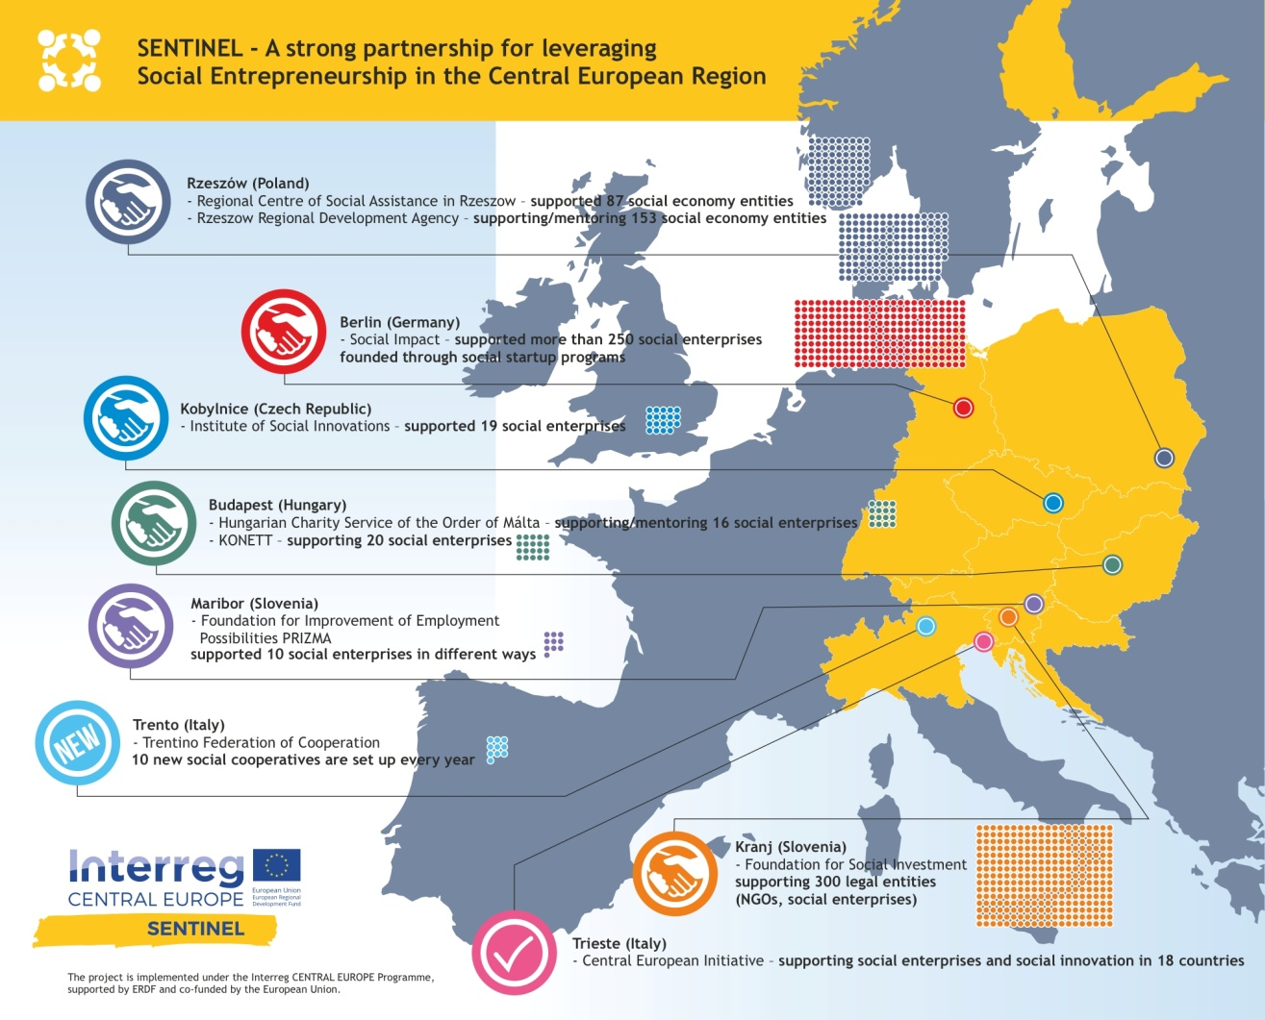

The main objective of SENTINEL was to reduce regional inequalities and improve economic performance of disadvantaged regions of Central Europe. The project set out to achieve this by enabling social enterprises to effectively contribute to the local economy, job creation and better capitalise on their role in elevating social innovations and the CE regions’ quality of life.

While there are numerous different definitions of social enterprises being applied in the European member states (see discussion above), the INTERREG CE SENTINEL project has not adopted a unique definition for social enterprises – the SE landscapes (and understandings) in the partner regions are simply too diverse. Instead the project relied on an open approach that embraced the various understandings of SE governing the partner regions in Eastern Europe. This allowed regions to exchange experiences and knowledge, while also supporting their regional SEs during the project.

The project focused on three areas:

Following this focus, the project’s main results were captured in two outputs:

- Handbook on Managed Networks: Managed Networks are innovative ecosystems, where exchange of knowledge, co-working and mutual business support promotes the growth & sustainability of enterprises. The Handbook will be a tool helping to set up and operate such collaborations.

- Toolbox on Social Business Mentoring Services: Locally available & flexible SE support mechanisms exist only in some countries. SENTINEL provides a model for Social Business Mentoring Services to be used by support organisations working in marginal regions.

Both the Handbook on Managed Networks and the Toolbox on Social Business Mentoring were elaborated taking into consideration the project’s experience and learnings from regional pilot projects supporting regional SE networks and social initiatives.
The pilot actions addressed a variety of needs in the respective regions as they tested different approaches to help SEs foster their business models and spur impact. Consequently, the project draws conclusions about effective support methods for SEs operating in particularly challenged environments.
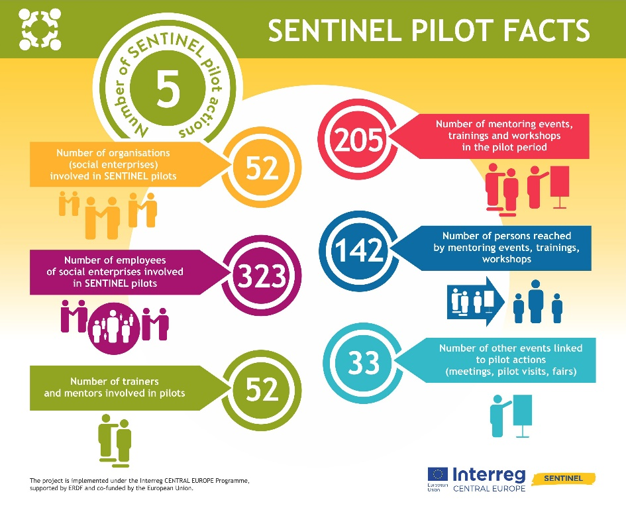

SENTINEL promoted pilot actions with the aim of testing and implementing these innovative tools. Pilot actions aimed at improving the support to potential and existing social enterprises especially in rural areas and were designed based on particular findings from needs analysis conducted in previous phases of the project. Different country contexts and identified needs led to differences in approaches to design and implementation of the pilot actions.
Existing social enterprises (Hungary, Slovenia and Italy), potential social entrepreneurs (Czech Republic and Poland) as well as mentors, coaches, advisors, SE experts who participated as direct or indirect target group (Czech Republic, Poland, Slovenia, Hungary) and local community actors (Italy) were at primary focus of the pilot actions.

Although working in different (regional) contexts and with various target groups, the analysis of the pilot actions showed that pilot projects followed similar key steps:

In total, 323 employees of social enterprises were involved in the pilots, 52 trainers and mentors organised 205 events in which 142 persons were reached. A range of tools were developed and used, which will be collected in the common toolbox for further use.
In testing of the developed models, the partners faced several challenges deriving from external and internal factors (e.g. legislative changes, low response from potential participants, keeping participants engaged through a longer period of time), which had to be addressed and should be taken into account in future activities and in the building of the social economy support ecosystems.

Challenges and operational proposals for Social Enterprises in Disadvantaged Regions

In the course of the SENTINEL pilot actions a needs analysis was carried out to gather an understanding of SE’s status quo in the participating project regions. As a result, the project was able to map the most common challenges experienced by SE actors prior to the inception of the project’s support measures.

The main common thresholds can be synthesised as follows:

Operational Challenges  - Lack of managerial capacities, strategic planning skills and competencies necessary for scaling up;  - Lack of viable business models;  - Risk of burn out for the staff in coping with daily activities. | Financing  - Weak capacity to access to funding;  - Public sector as only resource of revenue;  - Difficulties in accessing markets also due the competition with big size companies (profit and not for profit);
SE Ecosystem Support Infrastructure  - Lack of specific business development services and support;  - Lack of common evaluation methods/standards to assess social impact. | Political Framework  - Weak or missing legal environment for SEs and specific legal instruments for marginal areas;  - The acknowledgement of the role of social entrepreneurship and the visibility of social enterprises;  - Marginality as an issue for connections (material and immaterial).

Based on the above mentioned challenges and on the results of SENTINEL pilot actions, SEs operating in marginal areas should consider the following practical advices to enhance community support and, thus, elevate the chances for social and economic success:

- SEs should establish a strategic collaboration agreement with local stakeholders in order to boost synergies and support based on the local network potential;

- SEs should contribute or foster multi-level networks and alliances within the realm of their activities to spur social impact, cross-fertilisation with relevant actors and enhance long-term sustainability of SEs in marginal areas.
- SEs should make use of tailored dissemination and communication channels apt to actually reach local stakeholders, e.g. collaborate with local stores and newspapers, use visible platforms within the community to communicate ideas and value proposition of projects.
- Given the increased market complexity for SEs in marginal areas, SEs are advised to seek help and resources with setting up project management and stakeholder involvement strategies due to a frequent lack of competences in these fields.

Learnings from SENTINEL: Key Elements for a Social Enterprise Strategy in Disadvantaged Regions

During the implementation period, pilot results highlighted the value of supporting social innovation projects in marginal areas:

- Trust: With increasingly challenging socio-economic pressures exerted on marginal areas, peoples’ quality of life is more and more threatened, jeopardizing social trust and well-being. Hence, it is crucial to activate social bonds and local networks for community development – which is what social innovation projects do. Through their reliance on and collaboration with local communities, they spur project success and a wide adaptation and acceptance among local communities once the community realises the value of social initiatives. An (inter-) active community, thus, supports the development of social business initiatives, which rely on local collaboration, consumption and dissemination via mouth-to-mouth and trust-based communication channels.
- Locality, market potential and competition: Socio-economic conditions in marginal areas differ from central and populated areas. Smaller communities mean smaller demand, market potential and potential to grow. Social enterprises, thus, must adapt to the specific conditions in marginal areas, without reaping the full benefits of economies of scale, which makes them more vulnerable to market competition from outside. These actors, however, do frequently not exert notable interest in contributing to regional development, e.g. large-scale farmers. Quite the contrary, their effect on regions might have adverse mid- to long-term consequences for sustainable regional development processes. On the other hand, social enterprises operating in marginal areas often address very specific needs not otherwise provided by existing actors. SEs step in and fill voids left by public or private services providers, thus, justifying their value to society. However, to support social innovation actors, regional political stakeholders can pay more attention to social and regional development aspects in, for instance, their public procurement policies and processes;
- Territorial capital and local development: the SENTINEL experiences gained by social enterprises have highlighted the importance of recognizing the territorial values, promoting the role of local actors who know the needs of the territory and who are active in the local communities, and valorizing the different local resources and skills, in order to facilitate forms of local sustainable development. SENTINEL has demonstrated that, in order to face the complex situation of marginal areas – lack of job opportunities, the issue of the ageing population in rural and mountain areas, social marginalization, industrial or environmental decline - it is important to recognize the social and ethical dimensions together with the organizational and economic aspects that characterize social enterprises.
Based on these dimensions, the following considerations can feed strategies to develop social innovation activities in marginal areas:
- Social enterprises should be based - or, at least, should carry out their activities mainly - in the local marginal areas;

- Policies and supporting tools should be compatible with the size – in terms of employees and economic / financial dimensions – of SEs in the marginal areas;
- Governance models should be defined with an important representation of people and stakeholders based in the area;

- Encourage local communities to develop integrated bottom-up approaches addressing the need to respond to territorial and local challenges calling for structural change;

- Support community involvement in regional development processes and stimulate the readiness for innovation (including social innovation);

- Promote community ownership to support demand and awareness for social innovation services and/or products;

- Promote sustainable procurement policies to offset potential market disadvantages social enterprises face due to their very business model.

- Enhance access to social business mentoring and support services to facilitate SEs addressing critical issues on their development and growth path;

- Promote development of local and regional networks and mutually beneficial alliances to further business success and advocate more effectively for a conducive political framework for social enterprises.

Policy Recommendations

Following the dimensions and the criteria already set in the EU documents, the different findings and outcomes of the SENTINEL project can be taken to define the following policy recommendations to address successfully the multiple social, economic and operational challenges:

- To improve the legal environment, defining appropriate European legal forms with criteria that can promote the adoption of common legal forms for social entrepreneurship capable of enhancing the role of social enterprises in the different national context;

- To support promotion, communication and awareness raising on the importance of social economy sector for the regional development and regional economy in order to strengthen the ways of promoting social entrepreneurship as an element of social cohesion and as an actor of local sustainable development processes;

- To include social enterprises as a cross cutting element in the EU regional development policies in order to ensure success and sustainability of SEs and their contribution to the regional, cross-regional economy and employment, with a mix of different measures (i.e. customized support for SEs in ERDF funds and incentives for development, growth and scaling-up of their business; financial support in ESF funds in form of different financial instruments to develop knowledge and skills; cross-border and transnational ERDF support for business cooperation with networking and corporate approach involving public and private organisations);

- To recognize the specificity of social enterprises by contributing to their participatory dimension, supporting governance models that can combine their social dimension with the ability to promote economic development;

- To support the development of social enterprises also through a training strategy and a specific training investment aimed at promoting training programmes for knowledge sharing and capacity building of social enterprises in order to enhance their impact at regional and transnational level;
- To strengthen investments in research and innovation for the social enterprises, promoting their role also in innovation ecosystems EU regions, with a comprehensive approach that can include different sectors (economic, environmental, educational and social dimensions in innovation processes);

- To strengthen the participation of social enterprises in social innovation territorial processes (local, cross-border and transnational) with open innovation methodologies (living labs, co-design and co-planning processes, etc.) capable of enhancing the social impact of social business initiatives in different domains supporting employment and sustainability;

- To define common criteria and promote knowledge sharing among countries to support specific procurement rules (with preferential access to the supply of goods and services of public interest) and state aid rules (recognizing favourable conditions for social enterprises in the state aid framework - de minimis regime for social enterprises);

- To strengthen the promotion of the already existing social financing tools, to update the financing framework rules (i.e facilitated access to funds, loan, included tailored requirements for the accessing funds, updated impact indicators, simplified procedures) and to foster the development of new tools based on form of public-private investment;

- To encourage the aggregation of the existing small SEs in order to foster a long term economic sustainability, especially when they must face emergency situations and crisis, as demonstrated by the emergency caused by the Covid-19 outbreak;

- To strengthen the role of social enterprises including them among key actors in thematic strategies in EU policy development documents, in order to encourage the involvement of social enterprises in new organizational models of management of public services and common goods.

European Commission, Social Business Initiative. Creating a favourable climate for social enterprises, key stakeholders in the social economy and innovation, COM (2011) 628 final, Brussels 25.10.2011
European Commission, A map of social enterprises and their ecosystem in Europe, 2015

