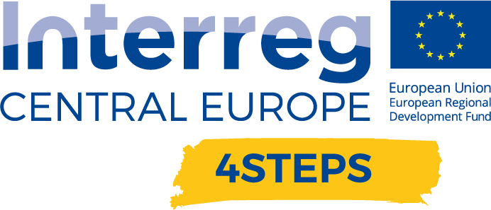
D.C. 5.3 Local focus groups events year 3

D.C.5.3 Report – Local focus groups events year 3 – VDC Fellbach | Version 1  03 2022

- Name of the event, implementing date and place

VDC XR-Meetup, 23rd March, hybrid

- Number and types of participants/target groups
The event had 22 participants. Including SMEs, Start-ups, big companies, universities and research facilities.

- Topics tackled and links to deliverables, outputs
- Presentation of the pilot activities and goals.
- Informing regional stakeholders about the activities and services carried out and implemented at the VDC
- Discuss the needs and expectations of regional stakeholders in the area of digital transformation
- Shared information about the pilot and discussed possible cooperation with potential partners / universities and research facilities.
- Open discussion about needs and expectation

- Expected effects and follow up
Participants will receive information about the pilot and new services available. Increased use and accelerated implementation of new technologies thanks to the opportunity to try them out.

- Annexes: e.g. agenda of the event, pictures, media coverage web-links etc

https://www.vdc-fellbach.de/termine/2022/03/23/vdc-xr-meetup/

