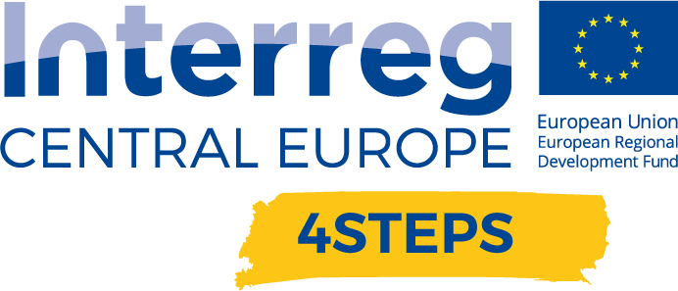
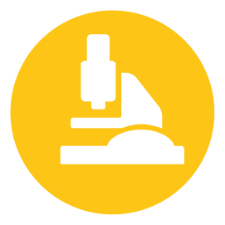

D.T.2.2.1 Regional Workshop

D.T.2.2.1 Report – Regional workshop  VDC Fellbach | Version 1  10 2020

- Name of the event, implementing date and place
VDC Lab Tour, 16th of October 2020 - 4:30pm to 6:30pm, Virtual Dimension Center Fellbach - Auberlenstr. 13, 70736 Fellbach

- Number and types of participants/target groups
The event had 10 participants. In cooperation with the local “Volkshochschule” for targeting the general public. Addressed at citizens to develop a basic understanding of the benefits of V/AR technology and how it is used in practice.

- Topics tackled and links to deliverables, outputs
- Presentation
- Working with a Powerwall
- Using an augmented reality maintenance application
- Questions & answers

- Expected effects and follow up
Develop a basic understanding of the benefits of V/AR technology and how it is used in practice. Participants got an overview of V/AR applications and learned how the technology works and experience use cases themselves.

- Annexes: e.g. agenda of the event, pictures, media coverage web-links etc

https://www.vdc-fellbach.de/termine/2020/10/16/besichtigung-vdc-durch-vhs/

