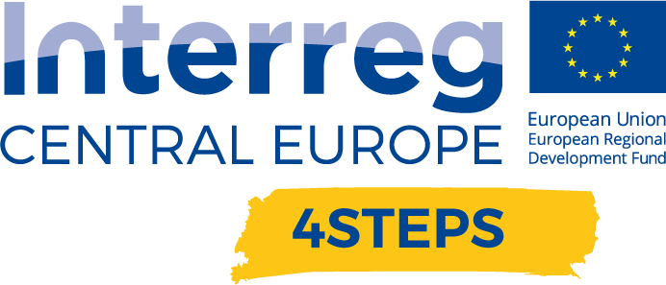

D.T.2.2.3 Regional Workshop

D.T.2.2.3 Report – Regional workshop  VDC Fellbach | Version 1  10 2020

- Name of the event, implementing date and place
"Vermittlung von V/AR-Kompetenzen" (Teaching V/AR skills), 11th of June 2021 - 9:00am to 10:30am, online per MS Teams

- Number and types of participants/target groups
The event had 9 participants. The participants consisted of companies, universities and research institutes.

- Topics tackled and links to deliverables, outputs
- Report from current projects of the participants (projects "compass" and "modal")
- Development of methods for the construction of XR learning modules: Linking learning objectives
- Company survey on knowledge modules
- Joint teaching material collection
- Status report from the working group “Designer in immersive media” of the Federal Institute for Vocational Education and Training

- Expected effects and follow up
We expect that we had successfully raised awareness and sensitized all participants to the topic. In addition, the idea for a curriculum arose as part of this, which we now want to advance as an idea for the future.

- Annexes: e.g. agenda of the event, pictures, media coverage web-links etc

Meeting minutes including agenda and presentation:

https://gzs365-my.sharepoint.com/:b:/r/personal/ziga_lampe_gzs_si/Documents/4STEPS/WP%20T2/D.T2.2.3%20REGIONAL%20WORKSHOP/VDC%20Germany/210611%20-%20AK%20VAR-Lehre%20-%20Protocol%20(Presentation%20included).pdf?csf=1&web=1&e=dMyk7l

Idea / Proposal of a VR Curriculum:

https://gzs365-my.sharepoint.com/:b:/r/personal/ziga_lampe_gzs_si/Documents/4STEPS/WP%20T2/D.T2.2.3%20REGIONAL%20WORKSHOP/VDC%20Germany/210518%20-%20Proposal%20of%20a%20VR%20Curriculum.pdf?csf=1&web=1&e=jV22ha

