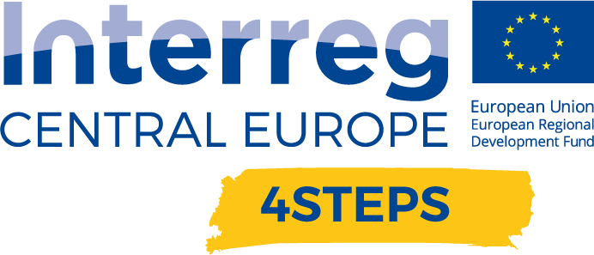

D.T3.4.5 Pilot report

Date: 31.3.2022  Place: DEX Innovation Centre, Liberec | Final version

DEX Innovation Centre – PP5 – Czech Republic

Project Number | CE1492
Project Name | Towards the application of Industry 4.0 in SMEs
Project Acronym | 4STEPS
Work package | WP T3 The Digital Innovation Hubs in action
Activity | Activity 2.2: Preparing the CE citizen towards the  digital future
Deliverable | D.T3.4.5 - Pilot report
Author | Vojtěch Jíra
Contributors | PP5 Michal Štefan

Introduction
The 4STEPS project, which focuses on supporting the digital transformation of SMEs and supporting the RIS3 strategy, has designed and delivered training sessions to help develop the knowledge and skills of companies and their employees through practical workshops and a training seminar to strengthen their knowledge in areas that will help them kick-start their own digital transformation.
Digitalisation is a significant trend that we are facing and have largely injected into our personal and organisational lives. The key to success and "taming" digital trends is building the right capabilities and using the right resources to maintain or enhance competencies to not only stay relevant and eliminate competitive threats in the new digital environment, but also to achieve growth. Digitalisation enables companies and businesses to streamline processes, in fact it is another key to improving performance, especially for us humans.
Digitization transforms an organization's resources into competencies, the application of which brings new sources of revenue, growth and other operational results. These new resources bring value to organizations as they take advantage of the opportunities offered by digital technologies.
This approach enables companies to develop business models, create new products and services, and use the organization's resources more efficiently. These are the magnets that attract the attention of organisations and their managers. All of this is happening through a new combination of information, human capital and the technological assets of the organization.
Digital transformation brings many challenges, so we have created a series of training workshops to help SMEs implement these processes into their own, existing production processes.

Name of the events, implementing date and place
1st workshop - D.T3.4.3 - FabLab workshops for SMEs demonstrating exploitation of rapid prototyping using advanced manufacturing
Name of event: CNC obrábění a gravírování ve výrobě (CNC machining and engraving in production)
Date of realization: 10. 12. 2021
Time: 8:00 – 17:00
Place: DEX Innovation Centre, Rumjancevova 696/3, Liberec

2nd workshop - D.T3.4.3 - FabLab workshops for SMEs demonstrating exploitation of rapid prototyping using advanced manufacturing
Name of event: 3D tisk pro firmy I živnostníky (3D printing for companies and freelancers)
Date of realization: 4. 2. 2022
Time: 8:00 – 17:00
Place: DEX Innovation Centre, Rumjancevova 696/3, Liberec

3rd workshop - D.T3.4.2 - Workshop piloting educational concept for managers of SMEs
Name of event: DIGITÁLNÍ TRANSFORMACE FIREM (DIGITÁLNÍ TRANSFORMATION OF COMPANIES)
Date of realization: 1. 3. 2022
Time: 11:00 – 17:00
Place: online

What have we done?
During the pilot we conducted in the Czech Republic, we met with various people across SMEs and together we addressed the topic of digitalization of SMEs, which is closely related to I4.0. On this trip, we implemented 3 meetings with different participants to develop their knowledge and skills in topics such as 3D printing, CNC, PCBs, but also topics such as risk management or internal processes when introducing digital innovation into production. How did it all work?
1st Workshop
As the first workshop we realized a fablab workshop focused on the work and operation of CNC and plotter. For this workshop, we met on December 10, 2021, kicking off the first workshop of three. We ran the workshop with business representatives and focused on developing their machining and engraving skills. Participants were not only taught how to design products, but we focused on the operation of specific equipment, tried out the possibilities such work offers and measured the mistakes to avoid as working with CNC but also laser (plotter) can be dangerous in some cases. Not if safety precautions are followed, which we also explained to the participants.
We prepared a full-day workshop for the participants, which was divided into several parts, but apart from the initial presentation it was a joint work and the participants were actively involved in the workshop throughout the day.
First, we introduced the participants to the theory of each technology so that they were sufficiently familiar with the basic terminology and the different processes and technologies. This enabled the next part, which is dedicated to working with the equipment - i.e. CNC and Plotter - to be implemented afterwards.
After the introduction to the topic, the participants were introduced to a program that is suitable for the creation of models that can be created on a CNC machine, or Plotter. The two parts were separated as planned, but at times when the topics overlapped, we alternated the two technologies separately or together. Eventually the workshop turned to creating specific models on individual machines. However, these were very simple models that were suitable for testing and learning.
2nd Workshop
The second workshop was held on February 4, 2022 and its main topic was the possibilities of 3D printing and printed circuit board printing. For this workshop we decided to combine topics that are related in terms of being about printing, even though they are distant in many ways.
However, this connection proved to be beneficial, especially from the point of view that these technologies are closely related when a company or startup wants to create a prototype composed of hardware and software. Again, we worked with tools such as fusion 360, slicer or Eagle to create circuit boards.
Under our guidance, each participant tried to design their own design on their own computer while learning the basic functions of the program. After successfully completing the design, the participants were introduced to the SLICER program, which is used to prepare data for 3D printing.
In this workshop, we worked with all types of 3D printers - FDM, SLS and SLA and were shown their differences, advantages and disadvantages. We also looked in detail at questions like: which printer is suitable for which company?
The workshop ended with a final discussion on topics such as the use of printing in a particular company, which printer to choose or why a company should have its own printer.
Printers need to be handled with care, but it is not a technique that is too complicated to use. However, in the case of working with the SLS printer, with which the participants also had the opportunity to try out the working procedures, it is necessary to follow exactly the steps that precede printing, and in this case, as in other cases, we placed great emphasis on explaining the individual steps during the work with each piece of equipment.
3rd Workshop
On 1 March 2022, we held a seminar focused on the digitalization of small and medium-sized companies in the Czech Republic. In this case, the workshop was conducted online, as we had to respond to a reality that has affected the last two years of the 4STEPS project - the coronavirus pandemic. The workshop, which is part of the pilot activities in the Czech Republic and are focused on the development of digital skills of small and medium-sized enterprises, we decided to implement online because in previous workshops we happened to lose a large number of participants at the last minute due to illness associated with the pandemic and now we wanted to avoid this. We conducted the workshop in cooperation with representatives of the Czech Association of Interim Management because the topic is so specialized that it was not possible to implement it only by our own efforts. Therefore, we took the opportunity to involve experts who are dedicated to this area and have direct experience with the implementation of processes leading to digitalization in practice.
We prepared a full-day workshop for the participants, which was divided into several parts, but apart from the initial presentation it was a joint work and the participants were actively involved in the workshop throughout. Although the workshop was originally intended to be a two-day workshop, as it was an online format, it was not possible to deliver the workshop in this way. We didn't want to overburden the participants, as we had a lot of experience across online events where multi-day online events proved to be ineffective for participants.
We first introduced the participants to each other and then presented the 4STEPS project and the activities implemented. We then focused on specific tasks and activities leading to the digitalization of companies. The participants were given an introduction, which was first to explain what the benefits of digitalization are and the types of technologies that are used. They were then taken through the steps a company must go through when implementing technology through specific examples of good practice, with the end being dedicated to specific questions from participants.

Who studied with us?
All workshops were implemented with the aim of developing the knowledge and skills of the participants, which will help them and our region to develop and meet the objectives of the RIS3 strategy for our region. We believe that education is key to any progress and development and this is how we have approached our participants. In order to cover as many participants as possible, we have implemented activities where this was possible online and conversely practical exercises, workshops, have been implemented physically in our fablab and with our equipment.
Both fablab workshops were physically held in Liberec, which was reflected in the composition of our workshop participants. It was a group that was composed of representatives of various companies from the Liberec region, but there were also tradesmen. In most cases they were men, but we also had women at both workshops - one at the CNC workshop and one at the 3D printing workshop. Their knowledge varied, some was general, others none, which had to be taken into account in the activities. On the other hand, the more advanced participants helped those with zero knowledge and the whole group worked much more efficiently.
However, the Fablab aimed at managers was conducted online. We conducted this workshop online primarily to take advantage of the opportunity to attract a larger number of participants who attended. Another reason was that the pandemic situation was again slightly worsening. This strategy was refreshing as we had 24 participants from different companies sign up. These were larger and smaller companies and there was no shortage of men and women. In the end, 15 representatives of small and medium-sized enterprises attended the seminar.
What have we learned?
All the workshops showed us one thing and that is that it is really important to develop the topic of digitalization and support all those who want to improve their society and their surroundings. The digitalization of small and medium-sized enterprises does not only affect them, but also the development of the region as a whole. Industry 4.0 is also a part of improving not only the competitive ability of the region, but also has a positive impact on the climate of the region, because digitalization also affects the environment of the region, but also the whole society.

Our goal is to continue to support companies in their development, to educate them and to look for ways to make positive changes. The workshops have shown us that such change is not easy, but it makes sense and therefore we will continue to pursue it.

Invitations

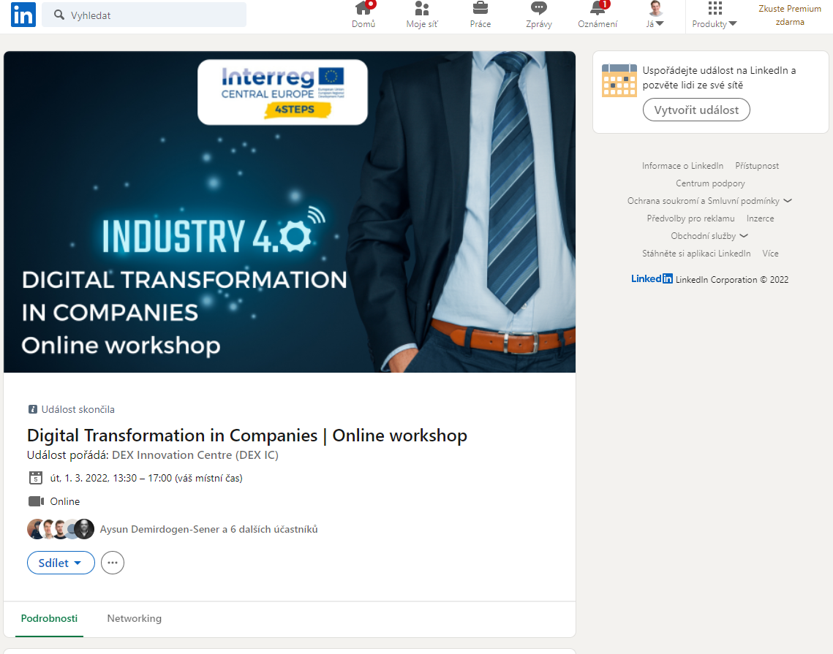

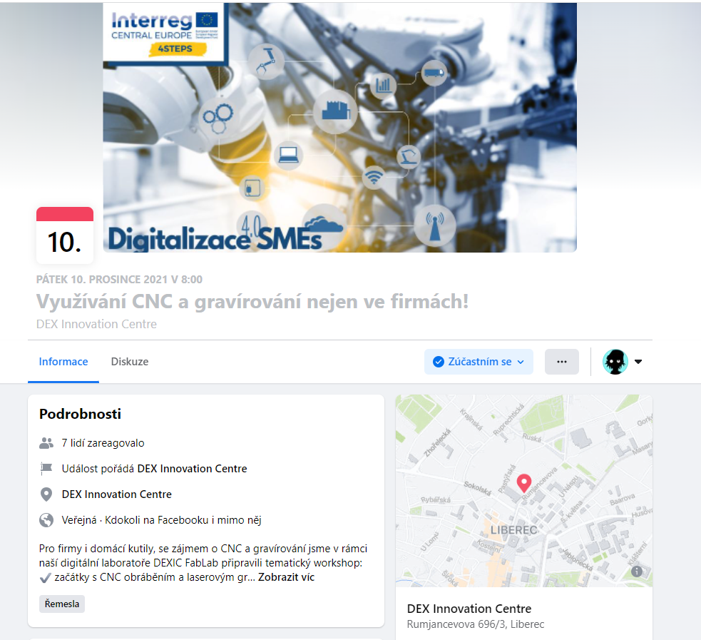
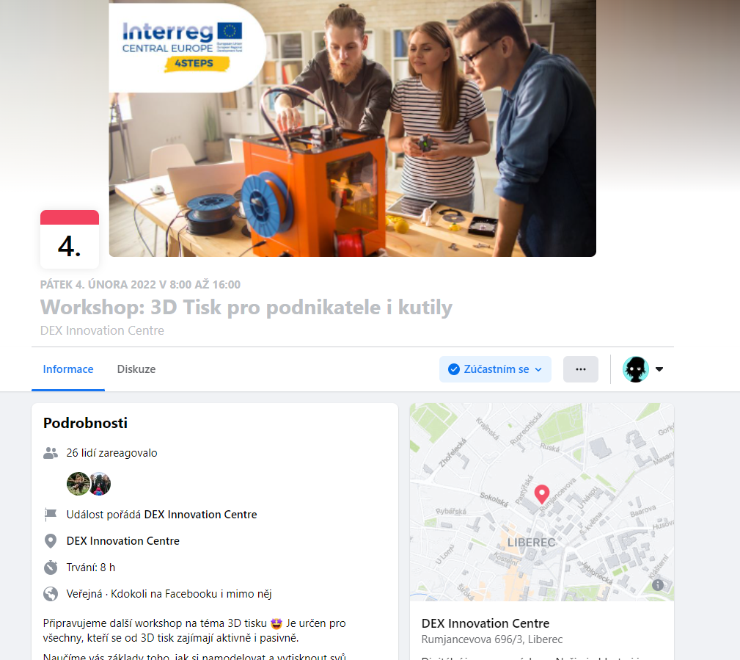

Photos and print screens

