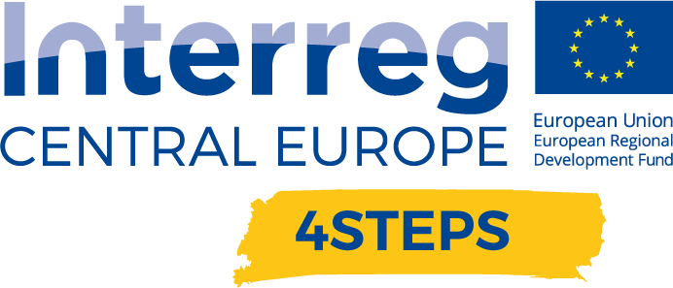
D.C. 5.1 Local focus groups events year 1

D.C. 4.2 Report – Local focus groups events year 1 – Partner CNA Emilia Romagna | Version 1  05 2020

- Name of the event, implementing date and place

NAME OF THE EVENT | DATE | PLACE
The internet of things in intelligent companies: live demonstration of predictive analysis and machine learning | 06/11/2019 | CNA Imola – Via Pola, 3
Artificial intelligence: instructions for use | 10/12/2019 | Portale del Tecnopolo – via Saragat 13 Ferrara

- Number and types of participants/target groups
NAME OF THE EVENT | NUMBER OF PARTICIPANTS | TYPES OF PARTICIPANTS
The internet of things in intelligent companies: live demonstration of predictive analysis and machine learning | 4 | SMEs
Artificial intelligence: instructions for use | 30 | SMEs

- Topics tackled and links to deliverables, outputs
1)The internet of things in intelligent companies: live demonstration of predictive analysis and machine learning (06, November 2019)
This workshop aimed to present, through successful case histories, the advantages that a company can achieve by inserting intelligent technologies such as Machine Learning, IoT, Real Time Traceability and Predictive Analysis into its production processes.
The head of the IT systems of FONDERIE TAZZARI SPA was one of the speakers at the meeting, and he illustrated, in front of an audience of entrepreneurs, how they had been able to improve their production in the foundry with advanced and high-quality industrial technologies, thanks to the ERP integration, a management software integrating all relevant business processes and all company functions. This software is implemented in collaboration with a spin-off from the University of Bologna.
The company ECA Consult presented the opportunity for businesses to use the M1-IoT technology, a cloud infrastructure to connect devices deployed in the field with business analytics and IT applications.
The participating companies were presented with the National Business Plan 4.0, and in particular the new Emilia Romagna Call for proposals to finance innovation projects, and they showed particular interest in learning more and receive information.

2)Artificial intelligence: instructions for use (December 10, 2019)
This workshop was organized at the Tecnolopolo of Ferrara, a place where companies can get in touch with researchers, learn about their skills, the equipment available and collaborate together to start projects and applied industrial research activities, developed in synergy with the laboratories of the High Technology Network. For this reason, the Technopole of Ferrara started a collaboration with CNA, as a point of reference for SMEs.
During this meeting, it was discussed the importance of artificial intelligence for the activities of small and medium enterprises to be integrated with other advanced technologies - sensor networks, machine learning, big data analysis, as they enable to provide indications to improve competitiveness, production processes and the profitability of the companies. This initiative was attended by Massimo Carnevali, Manager of the Clust-ER Innovate of the Emilia Romagna Region, who underlined how the computer tools, equipped with artificial intelligence, are able to perform tasks similar to those that a human being would be able to complete, but in an automated, fast and more precise way.
The workshop continued with the presentation of successful case histories of companies from Ferrara who already use I4.0 technologies in their businesses and the advantages they have gained in economic terms, in the quality of their products, in greater productivity, and also savings of energy.
The meeting ended with an invitation to the companies to stay and discuss projects and ideas with the Technopole researchers and speakers, who showed the willingness and possibility to start collaborations between the research and the business worlds.

- Expected effects and follow up
The companies of Emilia Romagna Region, which have always been virtuous and attentive to innovation, also confirmed in these two seminars a strong focus on technological research and investments in an I4.0 perspective to be activated in own company.
The SMEs of Emilia Romagna region is interested in the benefits that they would acquire through Industry 4.0 technologies in terms of information provided in real time thanks to the Internet of Things and cloud computing systems.
The presence in the region of Tecnopoli, University, Competence Center Bi-Rex and industrial research laboratories to support the companies for the development of high TRL solutions, guarantee a high availability for the experimental development and the research industrial collaborative public-private.
The two workshops organized garnered a lot of interest from companies that understood the importance of approaching Industry 4.0 technologies, as an opportunity to build a real business strategy.
Currently, the dissemination and the promotion of opportunities to companies has been carried out and in the coming months it will be seen if potential collaborations between companies and research will be activated.

- Annexes: e.g. agenda of the event, pictures, media coverage web- links etc
NAME OF THE EVENT | LINK
The internet of things in intelligent companies: live demonstration of predictive analysis and machine learning | https://www.interreg-central.eu/Content.Node/4STEPS/WORKSHOP-The-internet-of-things-in-the-intelligent-companie.html
Artificial intelligence: instructions for use | https://www.interreg-central.eu/Content.Node/4STEPS/Workshop-Artificial-intelligence-instructions-for-use.html

