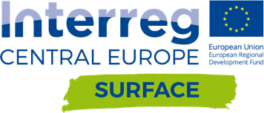
Press Release
SURFACE
Smart Urban Re-Use Flagship Alliances in Central Europe

Launch Event Kempten | 24.01.2018

Surface: Re-Use in practice

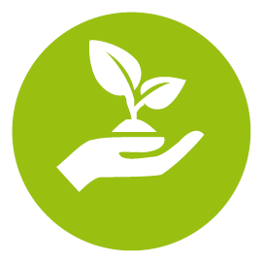
Our society consumes large volumes of goods and resources resulting in severe consequences for our environment due to increased waste generation. The best way to reduce waste is not to generate it in the first place which starts with extending the lifetime of products. In order to produce new goods energy is needed and raw materials must be excavated. Re-Use is therefore a viable way to reduce consumption and conserve natural resources. The SURFACE project, launched on 24 January 2018 in Kempten, brings together partners from nine European countries in order to open up possibilities for using our things wisely again instead of prematurely throwing them away. SURFACE aims to facilitate Re-Use practices in Central European countries starting in selected cities with the greater goal to establish the ideas in other partner cities.

The European waste management hierarchy clearly outlines the importance of waste prevention and Re-use which allow for saving resources without losing their quality. Recycling and energy recovery downgrades materials and not all resources can be exploited to the full extent. Disposal as the least favourable stage leads to a complete loss of the resources and should be only seen as the very last choice.

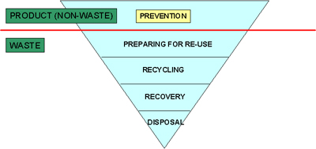
(Source: www: ec.europa.eu/environment/waste/framework)

The core concept of the SURFACE project is the formation of a Smart Re-Use Park in five pilot regions (IT, AT, DE, PL, HU) and preparing the implementation in the other four regions (IT, CZ, SI, HR). The Smart Re-Use Park will be a place where products, goods and materials will be given a new chance to get back into the product cycle instead of ending up as waste or as recycled material with a lower value. The Smart Re-Use Park is not solely a place where goods get reused or up-cycled, it also provides a space where people encounter each other and have the opportunity for exchange and knowledge transfer in the area of Re-Use. Courses and workshops will give leverage to reach new horizons in environment conservation. This will be accompanied by artistic activities of selected regional artist who will help disseminate the Re-Use idea through creative channels.
The Re-Use sector is full of promising initiatives, activities and innovative ideas. However in order to be better established it needs not only support from the national governments but also projects like SURFACE that create guidance for establishing Re-Use practices and inspire other urban areas to follow suit.

Contact: Please write here your contact details

www.interreg-central.eu/Content.Node/SURFACE.html

