Output fact sheet

Pilot actions (including investment, if applicable)

Version 3

Project index number and acronym | CE1352 S3HubsinCE
Output number and title | Output O.T2.2 Digital Innovation Hubs (DIH)
Investment number and title  (if applicable) | Not applicable
Responsible partner (PP name and number) | - Carinthia University of Applied Sciences (PP01)  - Forschung Burgenland Gmbh (PP02)  - Bwcon Gmbh (PP03)  - Fraunhofer Institute for Machine Tools and Forming Technology IWU (PP04)  - Intellimech (PP05)  - ECIPA – Training and Service Agency Limited Liability Consortium (PP06)  - Krakow Technology Park (PP07)  - Slovenian Tool and Die Development Center (PP08)  - Pannon Business Network Association (PP09)  - Croatian Chambers of Economy – Varazdin County Chamber (PP10)
Project website | https://www.interreg-central.eu/Content.Node/S3HubsinCE.html
Delivery date | 06/2021

Summary description of the pilot action (including investment, if applicable) explaining its experimental nature, demonstration character and transnational added value
The output is a collection of 60 pilot actions, specifically:
- 10 Pilot Hubs: formal strategic actions that each PP delivered in its region to better engage its chosen, regional Digital Innovation Hub within the S3HubsinCE project. The Action in each region has been considered complete when each PP generated a strong and sustainable link between itself and a regional DIH and has integrated RIS3 critical stakeholders.
- 20 mobility actions (2 for each PP: 1 transnational and 1 regional policy maker focused mobility). These mobility actions have been designed to train and align DIH operational staff with RIS3 excellent target group stakeholders and with policy makers, regionally and abroad; enhance awareness and promote collaborative engagement on the topic of RIS3 and Potential RIS3 Champions, with Policy-Making Relevant Stakeholders; identify & exchange with potential RIS3 Champions in each region. From a practical point of view: all Partners hosted one DIH-Exchange (Regional action), an exchange workshop/study tour in your region o “attend” one foreign DIH-Exchange (Transnational action), an exchange workshop/study tour outside of your region in one of the Partner’s region. Due to the pandemic crisis, all actions turned into online sessions / webinars; partners brough any stakeholders they wanted on the transnational mobility action; partners attending a regional mobility hosted by a partner, counted this mobility as their transnational.
- 30 transfer and cooperation actions (3 for each PP) consisting in concrete transnational market focused actions designed by thematically focused Navigation Crews. These actions had to 1) create evidence close to market initiatives enhancing the value-chain of and the value-added benefits to RIS3 Champions (i.e. organizations which are critical to regional RIS3) like, for instance, how a technology has been transferred from one region to another OR how a new product / service has been designed thanks to transregional cooperation; 2) showcase how a connected network of digital innovation hubs can be used to promote this close-to-market activity, and ultimately enhance RIS3 implementation; 3) test a method of promoting cooperation, engagement, and common development through the joint capitalization of proven success stories and use cases.

NUTS region(s) concerned by the pilot action (relevant NUTS level)
- CUAS – AT21, Kärnten (NUTS 2)
- FB – AT11, Burgenland (NUTS 2)
- Bwcon – DE11, Stuttgart (NUTS 2)
- Fraunhofer IWU – DED4, Chemnitz (NUTS 2)
- Intellimech – ITC4, Lombardia (NUTS 2)
- Ecipa – ITH3, Veneto (NUTS 2)
- KPT – PL21, Malopolskie (NUTS 2)
- TECOS – SI01, Vzhodna Slovenija (NUTS 2)
- PBN – HU22, Nyugat-Dunántúl (NUTS 2)
- Croatian Chamber of Economy – Varaždin- HR04, Kontinentalna Hrvatska (NUTS 2)

Investment costs (EUR), if applicable
Pilot Action did not include investments

Expected impact and benefits of the pilot action for the concerned territory and target groups and leverage of additional funds (if applicable)
All TCAs fulfilled have been positioned around a strategic matrix that has been created and used to analyze the strategic added value of each TCA around 4 dimensions: 1. Develop Infrastructures (includes all those Transfer and Cooperation Actions that aimed at planning, designing and setting up a facility (DIH or similar) which will host any of the listed possible actions), 2. Develop strategies (includes all those Transfer and Cooperation Actions that aimed at discussing, preparing, sharing or implementing strategies to share knowledge, transfer technology, raise awareness), 3. Support Close to Market activities (all those Transfer and Cooperation Actions that aimed at directly supporting beneficiaries in increasing the added value of their daily operations), 4. This category includes all those Transfer and Cooperation Actions that aimed at supporting involved DIHs in designing their overall long-term strategy and connecting to other DIHs.

Sustainability of the pilot action results and transferability to other territories and stakeholders
Most of the actions have been designed to give raise to long term strategies which will be supported by involved DIHs. Moreover, the involved DIHs – as permanent institutionalized structure – will continue to support their beneficiaries in the domains identified by the Navigation Crews. Additionally, the transnational cooperation structures which have been established will expand the opportunities and the accessible knowledge if compared to the initial situation.
The transferability to other territories is guaranteed by the synergic nature of all actions with the macroregional strategies. Detailed tables of these connections have been provided in deliverable DT2.3.4.
As in the case of OT2.1, the pandemic situation has made life difficult to those actions which were based on site exchanges and knowledge transfer. These were made possible by online meeting tools but there is the feeling that “physical and onsite action” would have been more effective.

If applicable, contribution to/ compliance with:
- relevant regulatory requirements
- sustainable development – environmental effects. In case of risk of negative effects, mitigation measures introduced
- horizontal principles such as equal opportunities and non-descrimination
No regulatory requirements had to be met.
Ideally, all actions may contribute to achieve sustainable development goals.
There is no risk of incurring into any negative environmental effect.
All actions have always considered to be open and provide equal opportunities and be nondiscriminatory.

References to relevant deliverables and web-links
If applicable, pictures or images to be provided as annex
Main relevant Project Deliverables:
- DT2.3.2: Pilot Action – Implement & connect CERIS3Action Plan to each Region DIH (PP5 / Imech)
- DT2.3.3: Support Action 1 - CERIS3 Training through Transnational & Policy-Relevant Mobility Actions (PP5 / Imech)
- DT2.3.4: Support Action 2 – CERIS3 Excellence Transfer & Cooperation Actions (PP5 / Imech)

Weblinks:
Project Newsletter 4: https://www.interreg-central.eu/Content.Node/S3HubsinCE/-4-S3HubsinCE-Newsletter.pdf

Images:
https://www.interreg-central.eu/Content.Node/S3HubsinCE/DIH-Poster.pdf

Brochure:
https://www.interreg-central.eu/Content.Node/S3HubsinCE/DIH-Brochure.pdf

DIGITAL INNOVATION HUB PILOT ACTIONS:
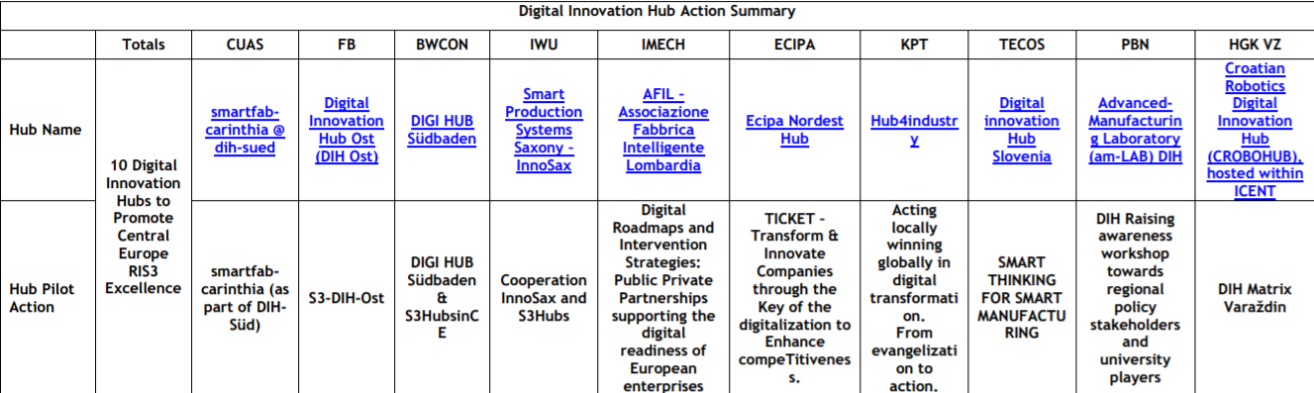

STRATEGIC MATRIX OF TCAs
