Output fact sheet

Pilot actions (including investment, if applicable)

Version 3

Project index number and acronym | CE1352 S3HubsinCE
Output number and title | O.T3.2 RIS3 Investment Forum
Investment number and title  (if applicable) | n.a
Responsible partner (PP name and number) | TECOS PP8 / bwcon PP3 / KPT PP7
Project website | https://www.interreg-central.eu/Content.Node/S3HubsinCE.html
Delivery date | November 2021 (DT3.4.2)

Summary description of the pilot action (including investment, if applicable) explaining its experimental nature, demonstration character and transnational added value
The RIS3 Investment Forum addresses the challenge at the heart of S3HubsinCE, encouraging the exploitation & bottom-up implementation of RIS3, in a territory where much of the transnational cooperation opportunities concerning focused R&I development remain unexploited. The RIS3 Investment Forum was designed as an exclusive knowledge & exchange event bringing together the partners (PPs), representatives of EU institutions, businesses, academia, & representatives of regional & national authorities. Through interactive panel discussions, keynote presentations & company pitches, the participants were to gain insightful knowledge on the role of Digital Innovation Hubs in boosting regional smart specializations, & learn about achievements of functional, cross-sectoral transnational network of technological excellence created withing project. The aim of the forum was to present recommendations for policies, including thematic priorities for transnational cooperation in the field of RIS3 & strengthening the sustainability of project results based on pilot implementations. TECOS (PP8), bwcon (PP3) & KPT (PP7) co-created RIS3 Investment Forum with input from all PPs. TECOS set thematic requirements in the work package guidelines. Bwcon built a detailed guidance which incorporated the needs, observations & inputs from other project activities towards a concept & event framework, meeting thematic requirements & encouraging R&I exchange. KPT built from this guidance document & established, implemented, moderated & reported on the event. PPs & participants from 9 countries were involved in the event, with transnational insights brought it at multiple points (panel discussions, company pitches). The experimental nature of the RIS3 Investment Forum was characterized by bridging Investment Forum style events (with expos & pitches) with strategic coordination & development associated to Research & Innovation, therefore bringing innovative actions closer to the market.

NUTS region(s) concerned by the pilot action (relevant NUTS level)
Please list the NUTS region(s) concerned by the pilot action.
CUAS – AT21, Kärnten (NUTS 2)
FB – AT11, Burgenland (NUTS 2)
Bwcon – DE11, Stuttgart (NUTS 2)
Fraunhofer IWU – DED4, Chemnitz (NUTS 2)
Intellimech – ITC4, Lombardia (NUTS 2)
Ecipa – ITH3, Veneto (NUTS 2)
KPT – PL21, Malopolskie (NUTS 2)
TECOS – SI01, Vzhodna Slovenija (NUTS 2)
PBN – HU22, Nyugat-Dunántúl (NUTS 2)
Croatian Chamber of Economy – Varaždin- HR04, Kontinentalna Hrvatska (NUTS 2)

Other Involved Territories
Slovakia (NUTS 0)
Czechia (NUTS 0)
Bulgaria (NUTS 0)

Investment costs (EUR), if applicable
N.A.

Expected impact and benefits of the pilot action for the concerned territory and target groups and leverage of additional funds (if applicable)
The expected result of the RIS3 Investment Forum was to establish and test a transnational methodology (in the form of an event), to bring innovation closer to the market. By creating a new, innovative format to entice a wider group of stakeholders to the table to build cross-collaboration on S3 topics, a model is presented which helps exploit key opportunities/lessons across the territory. The pilot action benefits target groups from across the innovation spectrum, from companies who directly benefitted from pitching in the transnational environment, to policy-makers who heard of how the tool of DIHs can be used to help foster technological innovation for different stakeholder types. BSOs, RTOs & other fundamental stakeholders in Digital Innovation Hub networks also benefitted from the pilot, because they could highlight their services & support across the Thematic Focus Areas, during the event (in the Expo). Six representatives from public authorities (primarily PL & IT) and many BSOs (across all 7 PP countries) who help manage & co-create RIS3 strategy at different territorial levels were involved in the RIS3 Investment Forum. What was especially clear were links to European DIH & next step initiatives to capitalize / leverage other investment to build more detailed innovation corridors between DIHs (circular economy, AI & automation).

Sustainability of the pilot action results and transferability to other territories and stakeholders
RIS3 Investment Forum is already being sustained & continued in other initiatives. For example, it influenced the Transnational Policy Learning Labs & Transnational RIS3 Round Tables (CEUP 2030, in Interreg Central Europe 4th Experimental Call), integrating new territories such as Upper Austria & Vienna (AT) & Genoa (IT), etc. Further, as described above, the RIS3 Investment Forum contained many references to new EDIH initiatives championed by members of the consortium. Finally, elements of RIS3 Investment Forum, i.e. public forums used to build cohesion on key tech/policy topics are integrated as a part of future consortium work plans (see Interreg Central Europe 1st Call, SMART CIRCUIT, Circular Industry Futures Conference Series; this integrates 2 new countries & numerous new territories into the methods started in S3HubsinCE). All DIHs eco-systems could take advantage of this output & the tested methodology to build cooperation & exchange on key topics that have a market & policy focus. Key lessons revolve around delivering hybrid events should be considered in case of future mobility challenges (pandemic/other issues), much planning was required to ensure this event could go ahead despite the pandemic’s autumn 2021 wave.

If applicable, contribution to/ compliance with:
- relevant regulatory requirements
- sustainable development – environmental effects. In case of risk of negative effects, mitigation measures introduced
- horizontal principles such as equal opportunities and non-descrimination
All relevant regulatory requirements have been complied with (including, changing measures across numerous countries, with regards to the Global Pandemic). There is no risk the pilot had negative environmental effects, in fact with the event in hybrid form, even PP individual travel was minimized which reduces the carbon footprint of the full project. Contribution in terms of Sustainable Development can be found with regards to the subject matter of focus within the Panels (and exchange on next step initiatives); topics that intersect technology and sustainability were core to the discussion (such as innovation in a circular economy), and the RIS3 Investment Forum brought to light a number of new initiatives championing sustainability across Central Europe (and in other territories). Finally, horizontal principles were respected in the design & implementation of the RIS3 Investment Forum, with no individual being discriminated against for gender, race, religion, sexual-orientation; all ideas were co-created by the partners and a balanced group of male & females were used to moderate & present in all panels & pitches.

References to relevant deliverables (e.g. pilot action report, studies), investment factsheet and web-links
If applicable, additional documentation, pictures or images to be provided as annex
D.T3.4.1 – Guidance & Process Documentation on the Planning of the RIS3 Investment Forum
D.T3.4.2 – Transnational RIS3 Investment Forum - https://www.interreg-central.eu/Content.Node/S3HubsinCE/DT3.4.2.Report-on-RIS3-Investment-Forum.pdf
D.C.3.4 – RIS3 Investment Forum Live Streaming, https://ris3forum.kpt.krakow.pl/ & https://www.youtube.com/watch?v=fg-Nf9P7GwI
D.C.5.5 – S3HubsinCE Final Conference alongside RIS3 Investment Forum

See below for images used to illustrate the output. They include images of the agenda, key speakers, key pitches from 10 RIS3 champions, and key panel discussions from the S3HubsinCE Community.
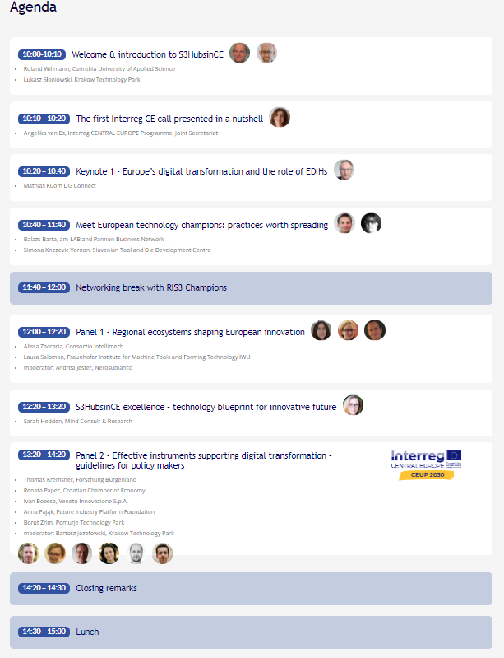
Figure 1 Agenda of the RIS3 Investment Forum (Source: S3HubsinCE, 2021)
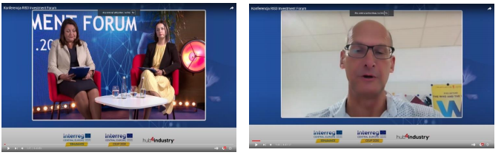
Figure 2 RIS3 Investment Forum - Introduction of Project by Hosting PP & LP (Source: S3HubsinCE, 2021)

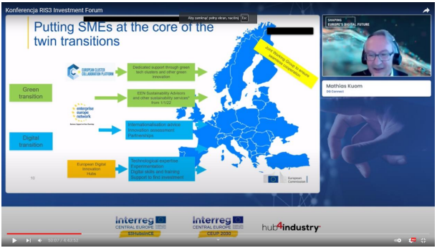
Figure 3 eDIH Presentation, Mathias Kuom - Linking S3HubsinCE to wider-EU Initiatives (Source: S3HubsinCE, 2021)

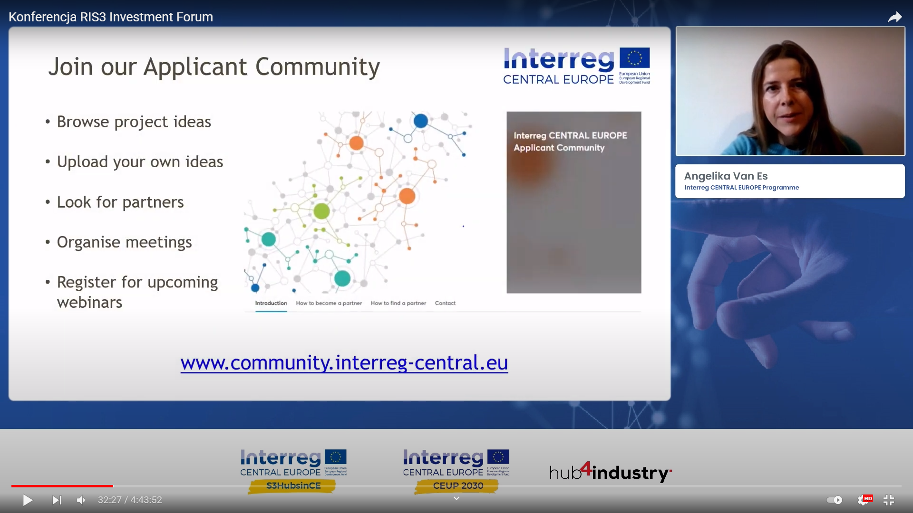
Figure 4 Presentation of the First Call of Interreg CE 2021 - 2027 (Source: S3HubsinCE, 2021 & Interreg Central Europe JS, 2021)
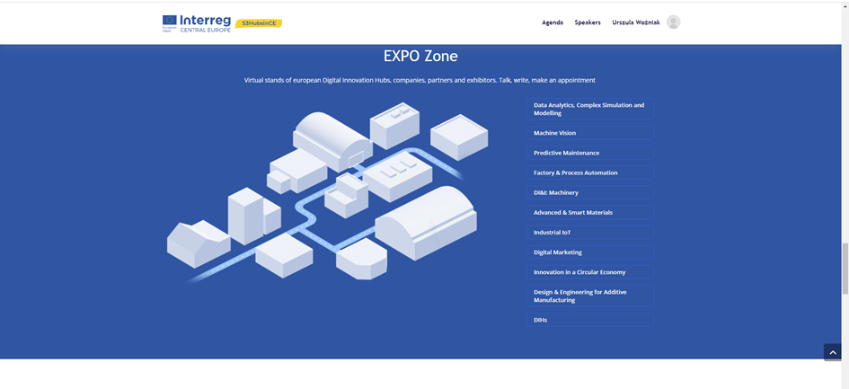
Figure 5 Virtual Expo Zone for the Navigation Crews and DIHs (Source: S3HubsinCE, 2021)

10 RIS3 Champion Pitches
- Nerosubianco
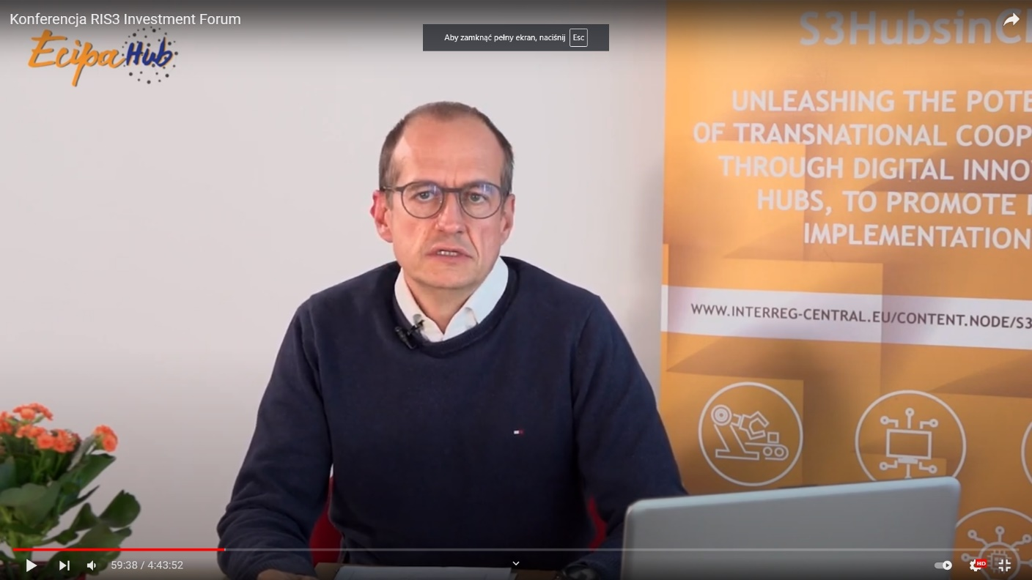

- Smart 3
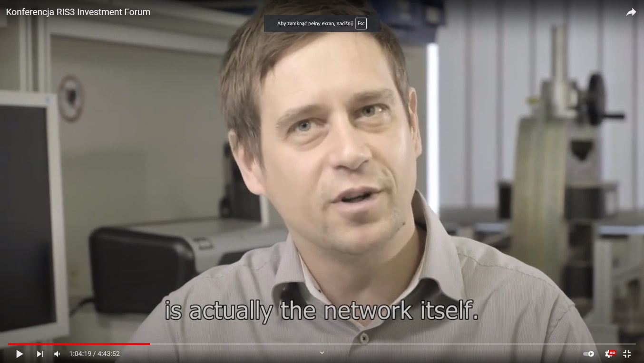

- Jozef Stefan Institute
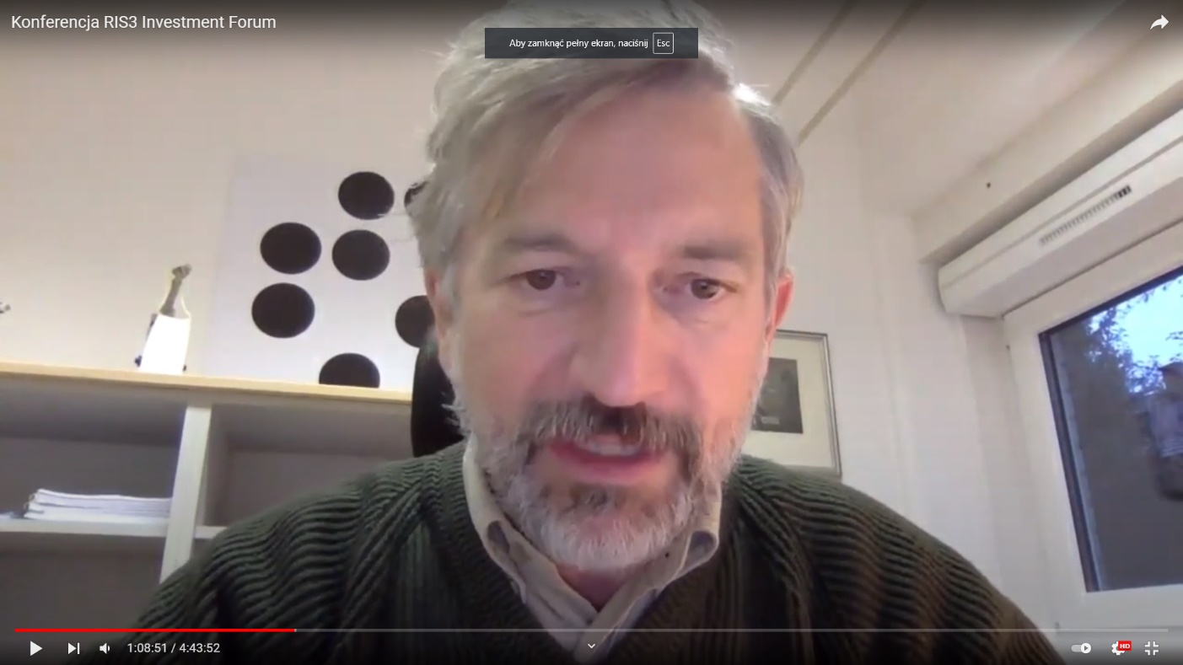

- Valtellina
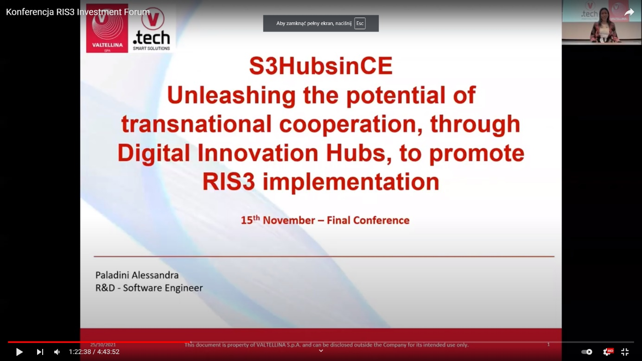

- Mobilisis
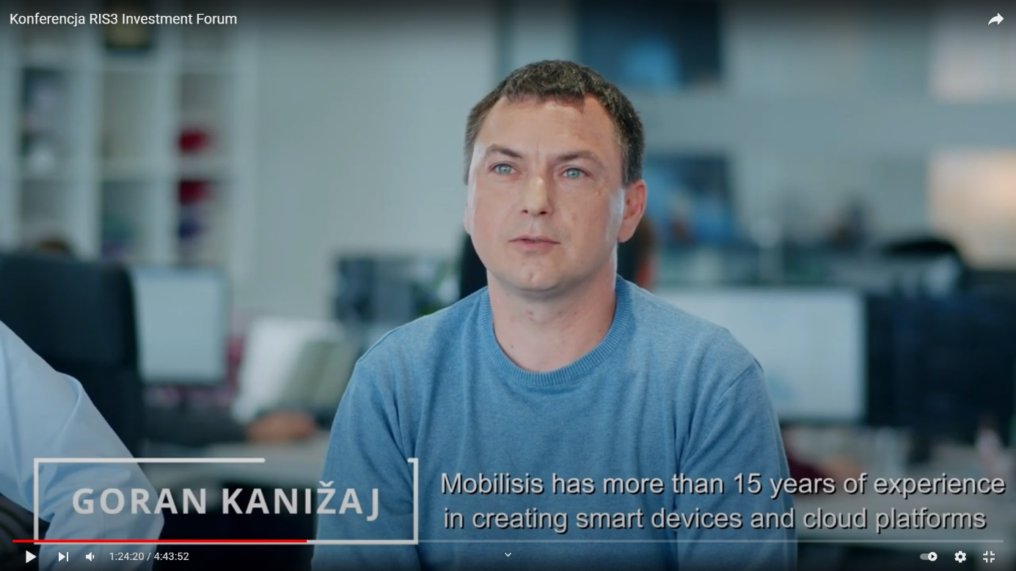

- Skyability
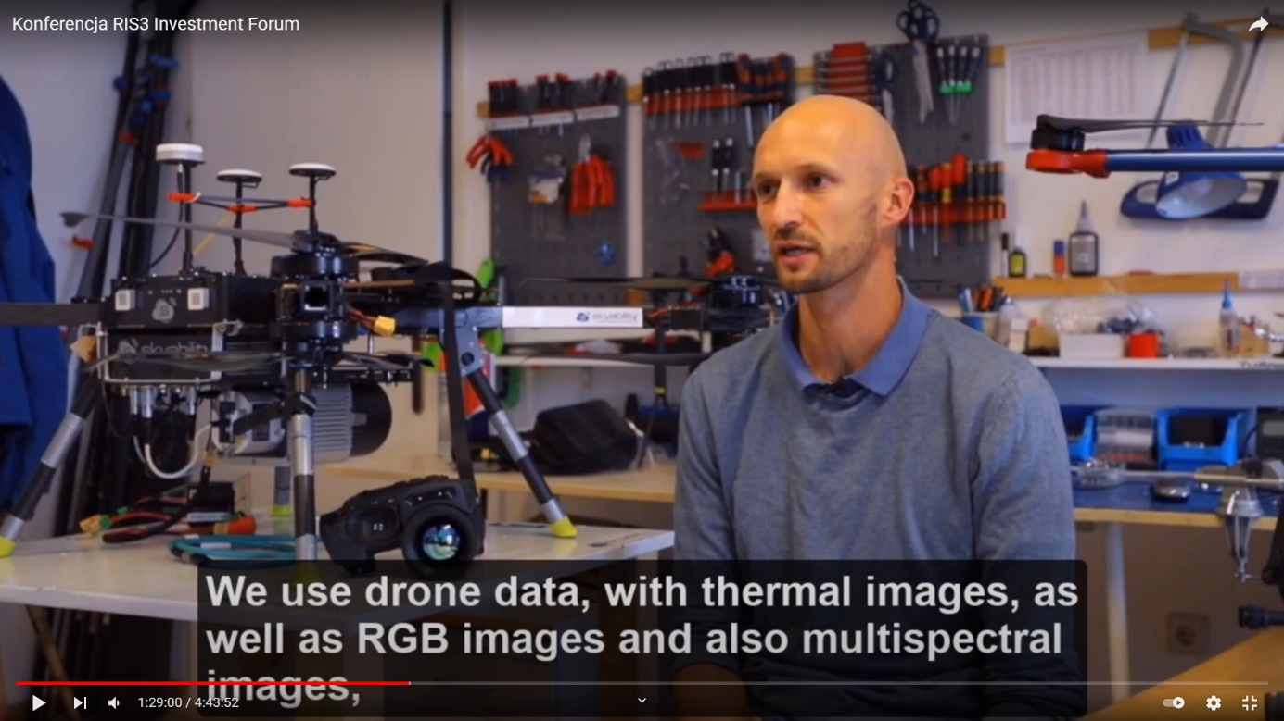

- Ivy Technology
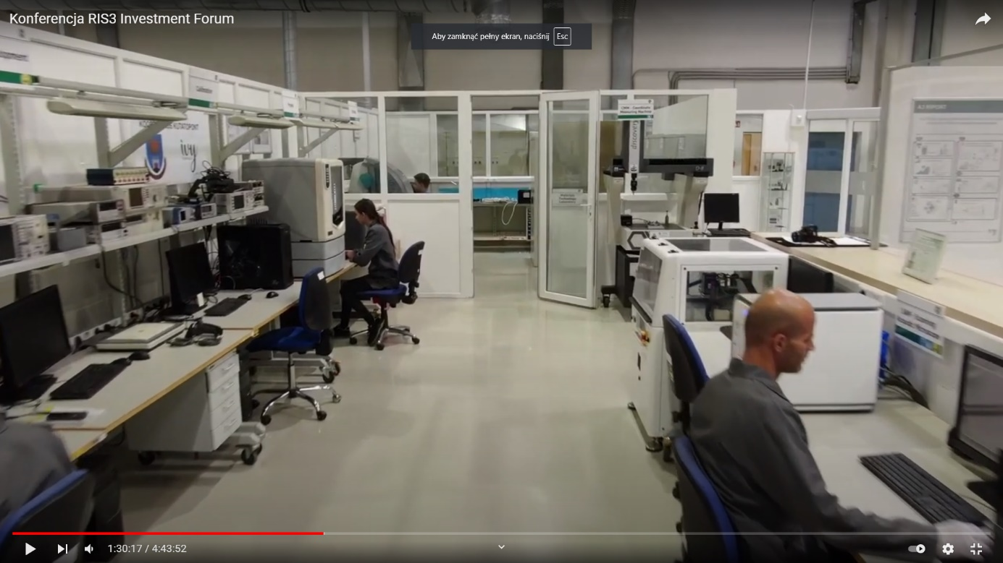

- Truphysics
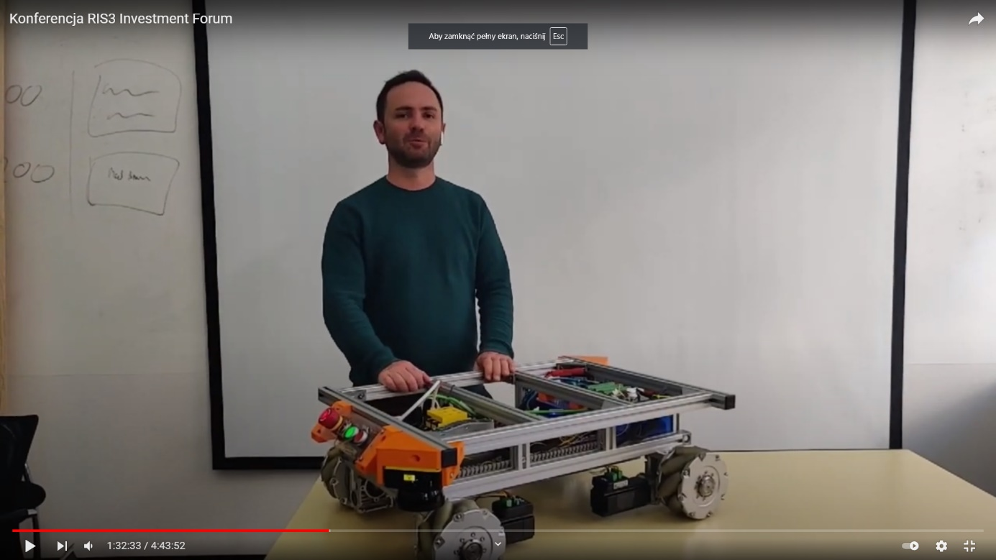

- Wild Hi Precision
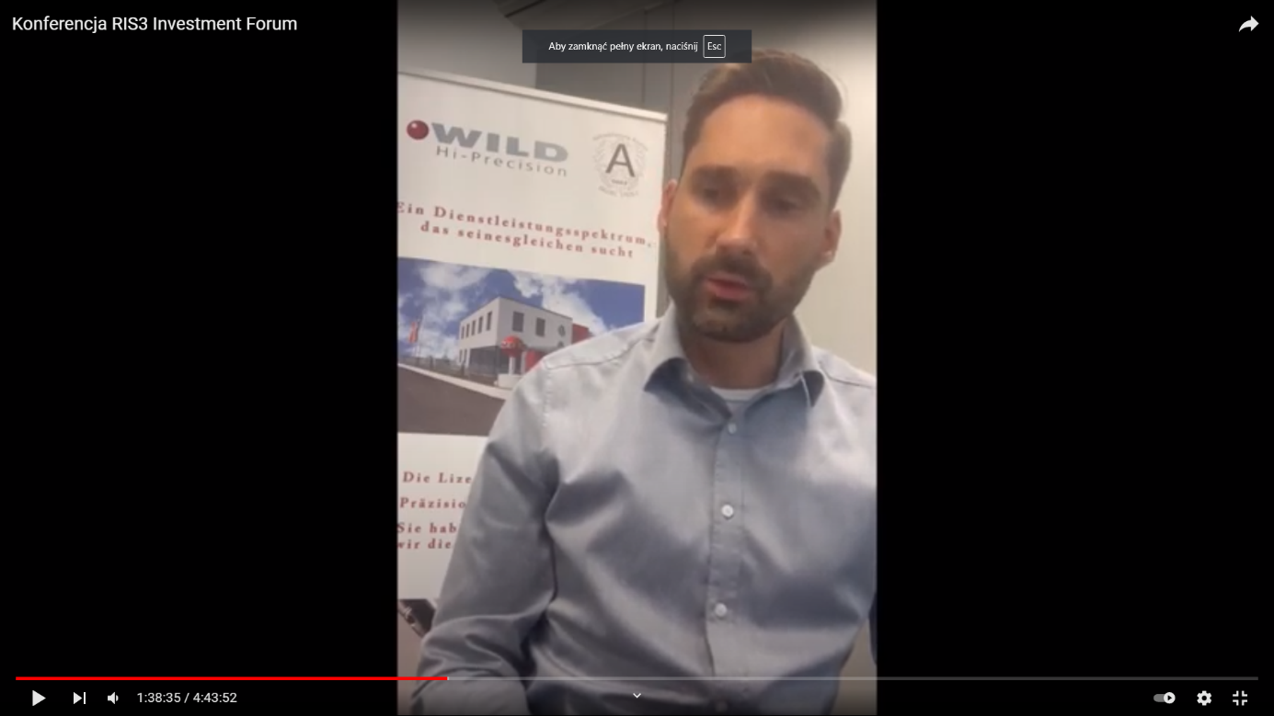

- Reliasol
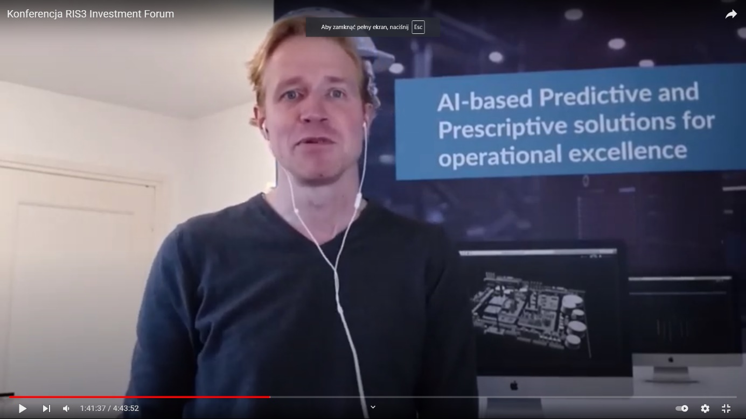

Three Moderated Panel Discussions
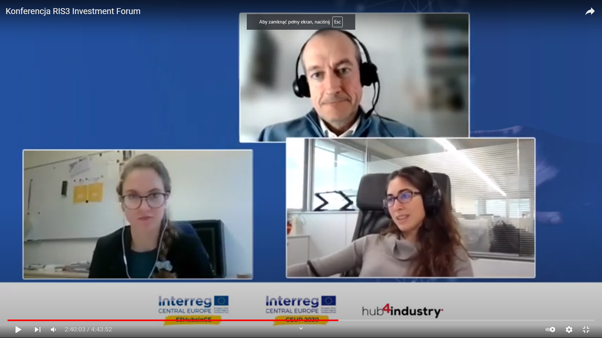
Figure 6 Panel on Regional Ecosystems Shaping European Innovation (Source: S3HubsinCE, 2021)

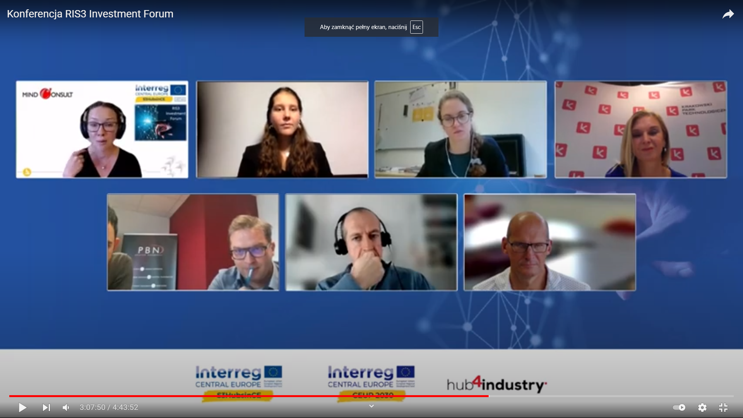
Figure 7 Panel on S3HubsinCE Excellence - Key Blueprint Results (Source: S3HubsinCE, 2021)

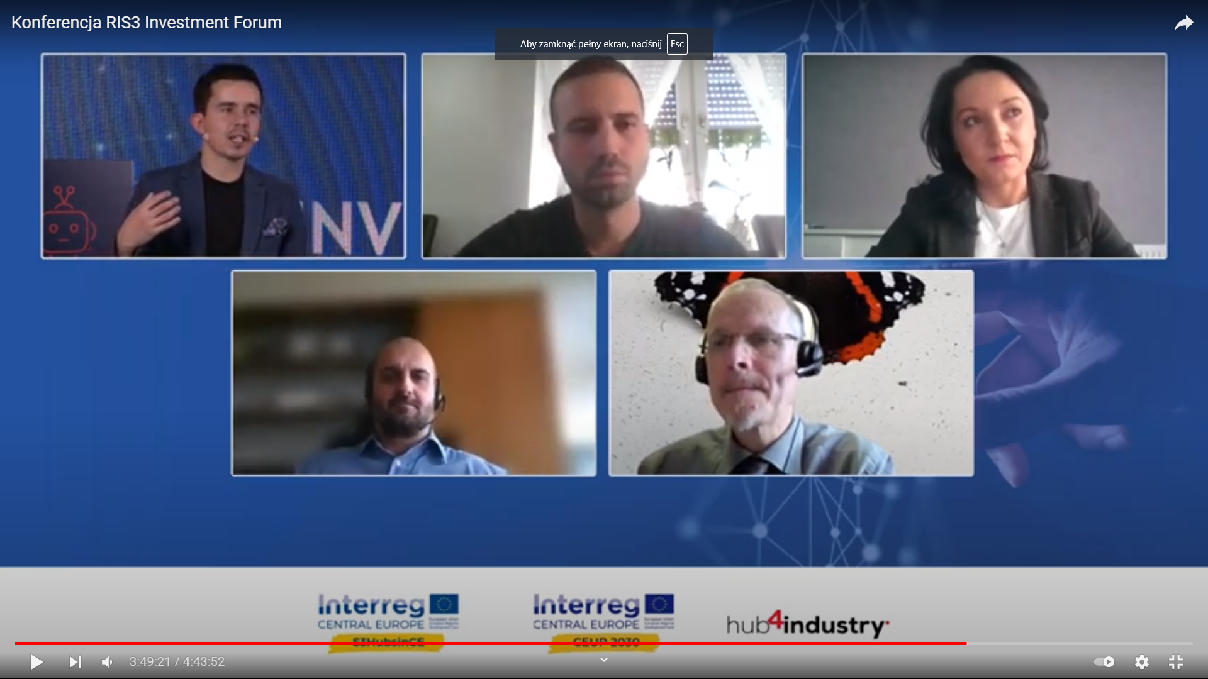
Figure 8 Panel on Effective Instruments Supporting Digital Transformation - Guidelines for Policy Makers (Source: S3HubsinCE, 2021 & CEUP 2030, 2021)

