Report on LSP workshop No. 5

|  |  |
| --- | --- |
| **Deliverable D.T2.2.1**  **Municipality of County-rank City of Szombathely** | **Version 1**  **23-01-2019** |



|  |  |  |  |
| --- | --- | --- | --- |
| **Date & time of the event:** | **23/01/2019** | **Location** | **Savaria Museum, Szombathely, Hungary** |
| **Number of invited guests** | **38** | **Number of attendees** | **11** |

|  |  |
| --- | --- |
| **Name of the event** | **Nr.5. meeting of the Szombathely Local Stakeholder Platform** |
| **Organized by** | **Szabolcs, Szakály, Ágnes Győrffy, Tibor Polgár, Andrea Csapláros** |
| **Contact person** | **Ágnes Győrffy** |

**1) Brief outline of the objective of the LSP events**

The events were – as usual - open to all LSP members: altogether 38 organisations and private persons received the invitation, partly by phone calls. The leaders of the LSP were involved in the previous negotiations about structuring the event.

The events were facilitated this time by the Municipality, as the main points of the meeting were to give a picture of the project’s development, and prepare for the two Mini-workshops.

**2) Key messages, outcomes, recommendations**

The main point of the meeting was that Szombathely as project partner had to decide about how to continue the project after the not-too-successful Idea Contest. The LSP members stated that probably the focus of the Call for ideas was too narrow, and required too high IT skills – thus it definitely should not be repeated. Instead, based upon the ideas emerging through the project implementation, plus ideas developed at the Mini workshop Nr. 1., the Mini workshops should be used for partly idea development (WS Nr1), partly for roll-out and implementation details (WS Nr1+2). The LSP accepted Mr. Károly Balogh as moderator of the workshops. The LSP members present also participated in the workshops.

**3) Communication and other technical information**

The invitation was sent to each organization by email, in some cases personally or per telephone.

The venue was again a small-size event room of the Museum as it appeared to be suitable many times earlier. (However, the venue is a bit tight when groupwork is planned – to be changed when planning the next meeting.)

As this event was mainly a preparation for the Mini workshop and the future of the idea development process, the management did not find it relevant to communicate the event independently.

**4) Evaluation of the event and future steps**

The meeting met the initial objectives, and was successful, as the planned agenda of the workshops worked well.

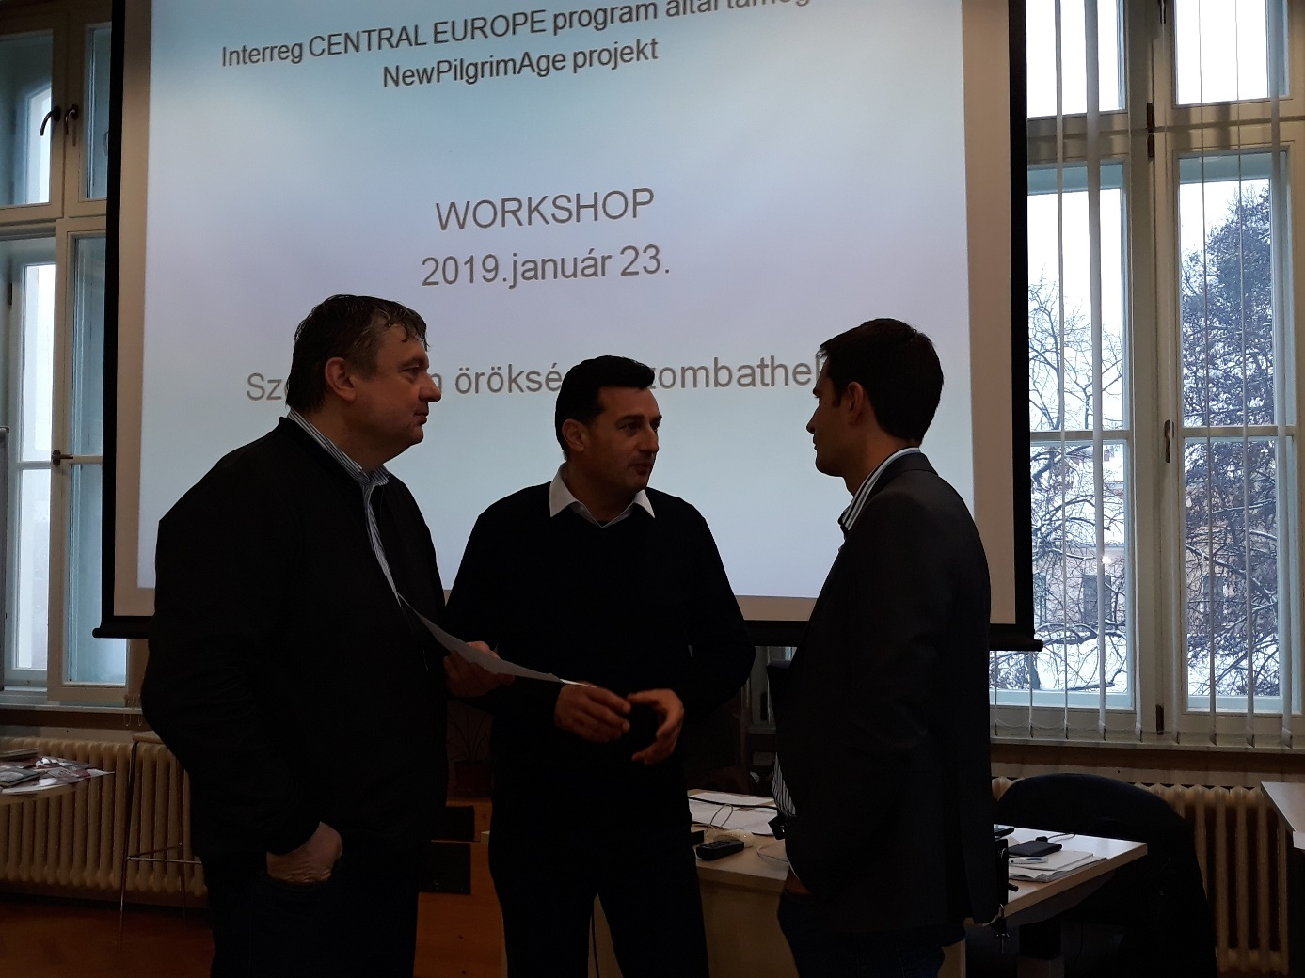

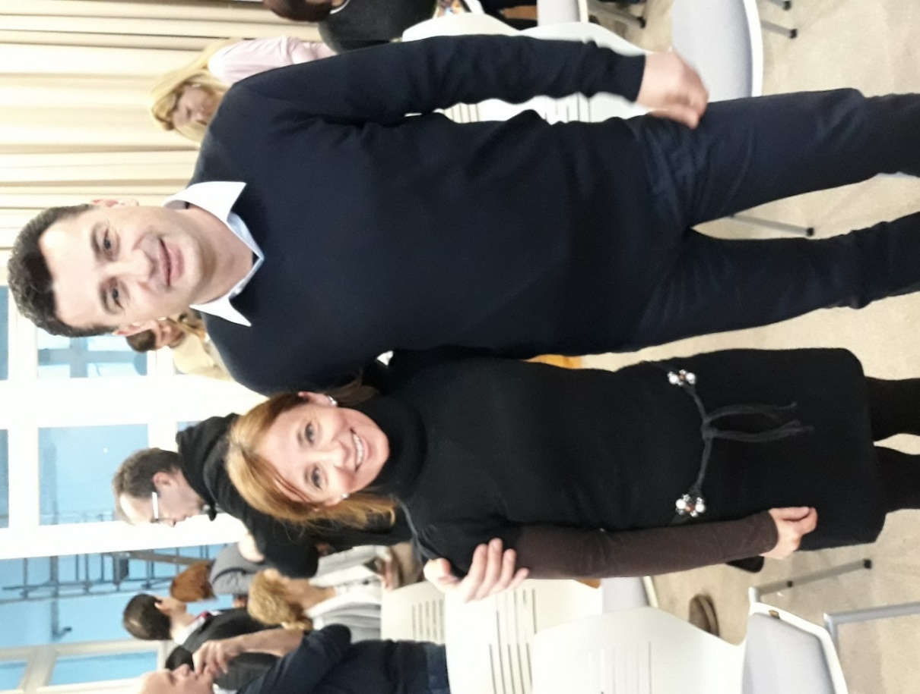

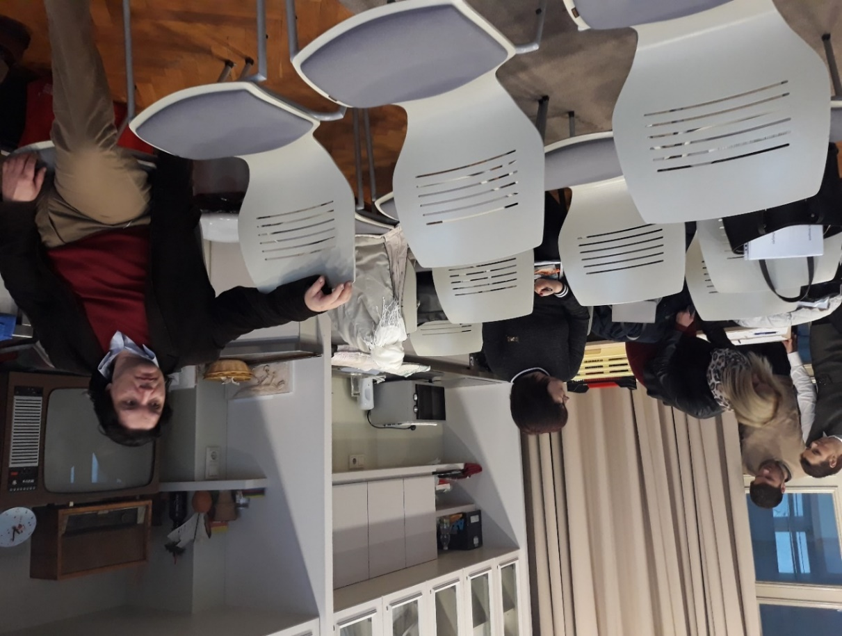

Report on LSP workshop (No.5)

|  |  |
| --- | --- |
| **Deliverable D.T.3.1.1**  **Municipality of Maribor** | **Version 1**  **15.2.2019** |



|  |  |  |  |
| --- | --- | --- | --- |
| **Date & time of the event:** | 12/2/2019  from 11:00 to 13:00 | **Location** | the Old Vine House  Maribor, Slovenia |
| **Number of invited guests** | 15 | **Number of attendees** | 14 |

|  |  |
| --- | --- |
| **Name of the event** | 5th Local Stakeholder Platform Workshop  Presentation of the project’s progress "NewPilgrimAge" (Intrerreg Central Europe Program) and discussion of possible roll-out of smart valorisation concepts. |
| **Organized by** | **Municipality of Maribor** |
| **Contact person** | **Alenka Likar Mastnak, Project Manager** |

**1) Brief outline of the objective of the LSP event**

Among main objectives of the 5th LSP workshop was informing participants about the project’s progress so far: Idea contest, 3rd TEM in Albenga, PR campaign, newsletter, poster and leaflet, capsule stories, selected valorisation fields, 2 workshops about the Compendium of local valorisation concept, where we rewarded ideas through a series of workshops based on priority fields (raising awareness of the population, youth, etc.).

The main objective was the discussion on the introduction of smart valorisation concepts in connection to the Interactive map app (the winning idea) - an interactive presentation of the cultural Route of St. Martin. The idea was proposed and discussed more closely, how this could be done and how each participant of the workshop could participate in it.

Participants of the LSP Workshop No.5:

* Alenka Likar Mastnak, NPA project manager, Municipality of Maribor
* Karina Šenveter, NPA project assistant, Municipality of Maribor
* Uroš Vidovič, i.e. NPA Change Driver, Cultural society European Cultural Center St. Martin Tourski – Slovenia
* Tina Heinrich, head of the Old Vine House, Maribor-Pohorje Tourist Board
* Simona Pinterič, Maribor-Pohorje Tourist Board
* Katja Raušl, the Old Vine House, Maribor-Pohorje Tourist Board
* Darja Viher, director of ARTmijeMAR, souvenir shop
* Simona Martinšek, head of the program at Pika.Day center - Day center for children and youth Maribor, Centre for Social Work Maribor
* Lara Žnidarič - a volunteer at the Pika.Day Center
* Darja Ivanuša Kline – managing director of the INUK Institute
* Dušan Vrban - Kainoto, author of the application ARTOUR (application that help users explore the European cultural heritage in cemeteries) and manager of the European Cemeteries Route, which is the same as the Route of St. Martin included in the list of European cultural routes
* Barbara Izlakar, representative of the project Maribor is the future
* Aljaž Brodnjak, Foundation Prizma
* Franc Kopič, cameraman, author of the video about the Old Vine and the Old Vine House

**2) Key messages, outcomes, recommendations**

At the 5th LSP Workshop participants were briefed about the project’s progress. They were also shown the video of Mr. Kopič about the Old Vine and its wine and about the Old Vine House. The video will be sent to the project partners to get acquainted with the Old Vine.

Possible roll-out (i.e. launching, making public, putting into the market) of valorisation concepts were discussed: the Interactive map (Interactive presentation of St. Martin’s cultural Route), preparing and promoting St. Martin's dish, establishment of the Information points of St. Martin, promotion of St. Martin’s day as a day of solidarity and charity, the Old Vine quiz.

In case of the Interactive map, Mr. Dušan Vrban recommends to think first of having different partners on the ground and also different users. One route is being considered but it should be just a cohesive thread, because we could offer different routes to different target groups. Young people are interested in something other than religious pilgrims, for example. At the same time, it is important to connect everything to the common point. In the European Cemeteries Route they made it so, that each member can put on the app his own route through a certain cemetery. The main route connects many versions of routes that can be offered to different users. It is necessary to find substantially good content solutions to make the routes attractive to the visitors and at the same times attached to the basic values ​​- this is a key challenge (e.g. stamp in the Old Vine House, at Tourist farms). Other providers along the Route should also consider what is the added value for them to cooperate.

Uroš Vidovič explained that one direct route was demanded by Hungarians to which the route through city of Maribor is connected. Two routes combined covers the city of Maribor and its surroundings. The first marked hiking trail in Maribor was wine road. In the years since the St. Martin's Route has been marked, local organizers of the surrounding events have joined this Route. Uroš Vidovič suggest that the local community could use this fact to prepare the events where they invite residents from outside of the city.

In discussion it was suggested that Martin’s dish can be connected with the Institute of Culture, the castle Slovenska Bistrica. In the castle they made Martin's kitchen and they learn how to prepare dishes.

Participants listed where St. Martin’s information points could have been.

The Old Vine quiz will be an application included in the Interactive map app. It would attract young people to visit the Old Vine House and understand why. Lara Žnidarič propose different difficulty levels of the quiz.

Promoting St. Martin's day as a day of goodwill, solidarity, hospitality. For this purpose, a hike would be organized, charity societies would be introduced and thus promoted.

In the continuation of the workshop, each participant expressed how he could participate. Change Driver Uroš Vidovič will guide hikes along the St. Martin’s Route. He expressed importance of the collaborative effort to achieve the goal, guidance, information on the Route with a list of heritage, offerings.

Barbara Izlakar offers guidance in part of the Route or the whole, organization of hikes, integration of products, tourist promotion through promotional channels they have, help with photo & video production.

Pika.Day center could be one of the Information points, they cooperate with 300 children and many parents annually. They are already activating youth for solidarity and charity. They encourage children and youth to cooperate, through projects like this they teach them, i.e. how to take an invitation to workshops as a gift. In their kitchen young people can prepare together some dishes. They offer to help also with some suggestions for app, their children and youth could help create an interesting quiz for young people.

Franc Kopič will promote the activities through video production.

The Old Vine House, Maribor-Pohorje Tourist Board offers to be the Information point and with TIC they will be involved in providing information and making a quiz.

Dušan Vrban will help to create, connect and promote digital content from their rich experiences. They also have quizzes, each route has its own quiz - they can offer a lot of ideas, help, links that they have created; he sees the connection of messages and symbols of St. Martin’s Route with their routes. The solutions for cooperation can be found in soft contents e.g. sharing (food, beverage) and other in a way that every stakeholder participating has something from it. They can make booklets from digital content with our content included - they are mainly interested in linking.

Darja Viher says they are promoting Maribor-Pohorje and all the rest, if they decide to promote this project, they need a complex story and are looking forward to this map app. They will produce some souvenirs on this topic. She suggests to encourage and regularly motivate people who will work at the Information points, because the offer will be available to visitors all year long. People working at Info points need to be informed and educated. She recommends to present them a wider path, taken as a study tour to see how it looks, so they will get the impulse to motivate visitors for the whole year. She also suggests that instead of posters, there should be something innovative at these Info points.

INUK Institute will participate by preparing teachers how to use ICT in teaching, how to prepare Treasure hunt, which can also be organized inside the Old Vine House.

**3) Communication and other technical information**

A narrower group of local stakeholders, active participants of the previous LSP workshops, were invited via E-mail and personally. Participants were shown the video of Mr. Kopič about the Old Vine, its wine and about the Old Vine House. The video will be sent to the project partners to get acquainted with the Old Vine.

**4) Evaluation of the event and future steps**

Participants working in various fields expressed willingness to contribute and cooperate together to protect and preserve the heritage of St. Martin so that the Route of St. Martin will become an important generator of tourism and entrepreneurship in the city.

For the next workshop we plan a hike for participants along the St. Martin’s Route.

**Attachments**

* Invitation
* Attendance sheet
* Presentation
* Photos

PP5 – UNPLI VENETO

5th LOCAL STAKEHOLDER PLATFORM



|  |  |
| --- | --- |
| **Deliverable D.T3.3.1** | **Version 0** |
| Prepared by: Unpli team | **February 2019** |

**5th LOCAL STAKEHOLDER PLATFORM MEETING**

|  |  |  |  |
| --- | --- | --- | --- |
| **Date & time of**  **the event:** | 19/01/2019  from 14.30 to 17:00 | **Location** | Marcon **(Venezia)** |
| **Number of**  **invited guests** | 20 | **Number of**  **attendees** | 10 |

# **Brief outline of the objective of the LSP event**

The 5th LSP meeting aims was to discuss about possible development of the valorisation concepts expressed by the Call for Ideas and through the mini-workshops. Together with the LSP members we met 2 external consultants which helped the group in the discussion: Mrs. Erica Scoppel as turist expert and Mr.Alberto Ferri, who organized and leaded the mini-workshops.

In particular we would like to deepen the discussion on possible scenarios in our territory, if our valorisation concepts will be concretized and which support work or initiatives could help them to be sustainable on long term perspective.

# **Key messages, outcomes, recommendations**

* + LSP members agreed on the valorization concepts to sustain and to increase the territorial network
  + LSP asked Unpli Veneto to support the work with the Regional Government and to express NPA plans to the Regional Minister. Unpli confirmed their availability
  + LSP confirms the collateral work with Eu partners for the development of Via Sancti Martini

# **Communication and other technical information**

The meeting was host by Unpli Veneto at Antony Palace Hotel in Marcon (VE) during a General Assembly in which LSP members were already attending, in order to do not duplicate efforts.

# **Evaluation of the event and future steps**

The meeting confirmed the choices made via the mini-workshops and that the core part of the LSP meeting is close. Unpli Veneto will continue their parallel work with the Regional Government and the Cultural Centres responsible for the Via Sancti Martini, in order to find new possibilities of development.

# **Attachments**

* + Slides
  + Signature list

PP6 – MUNICIPALITY OF ALBENGA LOCAL STAKEHOLDER PLATFORM – WORKSHOP 5

|  |
| --- |
| **Version 1**  **February 2019** |

|  |  |  |  |
| --- | --- | --- | --- |
| **Date & time of the event** | 02.02.2019 09:45 – 17:00 | **Location** | Palazzo Scotto Niccolari, Albenga |
| **No. of invited guests** | 15 | **No. of attendees** | 10 |
| **Name of the event** | D.T3.1.1 – Discussion of possible roll-out of smart valorisation concepts | | |
| **Contact Person** | Davide Geddo, Michela Vecchia, Dario Zunino (ChD) | | |

**The report provides an overview of the activities undertaken during the Workshop aimed at discussing the valorisation concepts and developing a shared Pilot Action Plan. The choice of the Municipality of Albenga, in fact, was to deeply involve the local community (also based on the results of the NPA Idea Contest) in the planning of a Pilot Action Plan able to increase the proactive involvement of the local community, so that the ownership of any future action/strategy to be implemented would be accrued.**

**1. Brief Outline of the Objective of the Workshop**

The workshop was intended to develop a Pilot Action Plan with the active involvement of the local community, as well as of the Idea Holders. As Albenga has few tangible traces of Saint Martin’s presence in its cultural heritage and/or traditions, the Municipality considers that a proactive participation of the local community in the implementation of the NPA Project-related activities is essential in order to develop ownership and give sustainability to the actions to be implemented within the framework of the transnational project and the long-lasting results to be achieved. Participants were thus invited to reflect on the ideas resulting from the NPA Idea Contest and to adapt them in order to develop a synergic set of activities/products/services able to be transformed in long-lasting services/products for both the community and the tourists visiting the city, thus becoming essential elements of the overall NPA participative local development strategy.

**2. The Methodology**

After a brief introduction on the state-of-the-art of NPA Project development, participants were required to work in group and to analyse the existing ideas (treasure hunt, pilgrimage from Szombathely to Albenga along the Via Sancti Martini and the organisation of an international multidisciplinary conference on Saint Martin) and to propose eventual activities/services/products to enrich the Pilot Action Plan.

The brainstorming phase was facilitated by the NPA team and the Change Driver supported by an ICT specialist having the role of supporting the working group in the choice of the more suitable ICT-based tools for valorising the local cultural heritage and any other action to be implemented.

The discussion resulted in three distinct actions having clear links one to the other and showing the potential for developing ICT-based services and products.

The group came out with three final ideas, that are briefly described below:

**Action I - Treasure Hunt. A Look Toward the Other: The Mantle of Saint Martin**

The initiative has the goal of valorising the spiritual legacy of Saint Martin among the youngest. The values of sharing with the others and of solidarity will be spread to the young generation, and it will be the starting point for establishing an international network of ‘Saint Martin’s Schools’ thanks to which children/young teenagers will share ideas and initiatives for a new inclusive community. The work to be done by children/young teenagers at school will guide them in the discovery of local history (including the presence of Saint Martin on the Gallinaria Island) and of the tangible cultural heritage shaping the historical centre of the city and its surroundings. The young generation will thus start valuing the local history and cultural heritage, and will for sure develop a proactive interest in their protection and valorisation. The final result will be a Treasure Hunt to be organised live during Saint Martin’s Week and to be then virtually replicated – any time – thanks to ICT-based tools (QR codes for visualising questions, quiz, videos, etc.). The Treasure Hunt will be an amusing way for young students visiting Albenga during school trips for discovering traditions, the local cultural heritage and the Saint Martin’s spiritual legacy.

**Action II - Saint Martin International Conference**

The conference will be focused on Saint Martin and the monastery of the Gallinaria Island, that had a great influence in Albenga’s history. The international conference, to be held in Albenga, will involve well-known international scholars in the fields of history, patrology, art and other disciplines in ad-hoc multidisciplinary studies. The International Conference will contribute to highlight the Saint’s deed and spirituality, his influence on the Albenga’s territory and in all those territories having had exchanges with the Gallinaria Island Monastery. Thanks to the Conference, Albenga should become the centre of a new wave of studies on Saint Martin and cultural heritage, thus making it an international reference city in the field, and encouraging meantime the development of cultural tourism. Parallel to the organisation of the conference (that will probably not be held during the NPA project lifecycle), the identification of a number of itineraries in the historical city centre and in the near hinterland to valorise the tangible cultural heritage is to be carried out. Interactive maps and QR codes scattered across the historical centre could be the ICT-based tools/products to be developed.

**Action III - The XXI century pilgrim and the Via Sancti Martini’**

The initiative has the goal of strengthening the links between Albenga and the Via Sancti Martini, that could represent a powerful driver for tourism development, especially considering the increasing success of slow tourism, and the peculiar climate of Albenga, where outdoor activities can take place throughout the year thanks to the mild weather. Additionally, churches dedicated to Saint Martin are spread in the immediate hinterland and a huge number of archaeological and historical remains (including from the Roman period) are scattered around the historical centre, thus making of Albenga an interesting and relevant cultural and religious tourism destination. The Albenga’s pilgrim will undertake the entire Via Sancti Martini from Szombathely back to Albenga with the values of sharing and solidarity informing his journey. This experience will be shared by the pilgrim with Albenga’s local community, as well as with the pupils/students of the local schools (the pilgrim will act as ambassador with schools located along the Via Sancti Martini), thus revitalising the spiritual legacy of Saint Martin. The marking out of the leg of the journey between Pavia and Albenga will formalise the link between Albenga and the Via Sancti Martini, with a view to enhancing religious tourism and the cooperation with Saint Martin’s Cultural Centres and the local research institute on local history and culture. Interactive maps, QR codes and the implementation of a Saint Martin’s section in the Gallinaria Island Multimedia Centre will be the set of services targeted at tourists capable of reinforcing the identity of Albenga as a cultural tourism destination.

Report on workshop nr 5 Discussion of possible roll-out of smart valorisation concepts

|  |  |
| --- | --- |
| **Deliverable D.T3.1.1**  **The town of Dugo Selo** | **Version 1**  **02 2019** |

|  |  |  |  |
| --- | --- | --- | --- |
| **Date & time of the event:** | 13/02/2019  from 09:00 to 13:30 | **Location** | City Hall of Dugo Selo, Dugo Selo, Zagreb county, Croatia |
| **Number of invited guests** | 12 | **Number of attendees** | 11 |

|  |  |
| --- | --- |
| **Name of the event** | Workshop with thema: discussion of possible roll-out of smart valorization concepts – reconstruction of the old church of Saint Martin in Dugo Selo |
| **Organized by** | **The town of Dugo Selo ( municipality of Dugo Selo) , project manager for NPA** |
| **Contact person** | **Zvjezdana Budor Klarić, project manager** |

**1) Brief outline of the objective of the LSP event**

General purpose of the meeting was to make consensus with the reperesentatives of the church and Ministry of Culture of Republic of Croatia about reconstruction of the old church of Saint Martin in Dugo Selo on Martin’s Hill.

Reconstruction of the church will be one of the most important action in development of Saint Martin‘s heritage in Dugo Selo and one of the biggest project.

On the meeting we invited a representative of Zagreb Arcbishopic in charge of investments, vicar of the parish church, representatives of Ministry of culture of Republic of Croatia in charge for reconstruction of cultural heritage and designer-architect who make design of the reconstruction of the church. The local authority ( mayor and his advisors was the invitator.

Actuale attendees ( from attendance sheet):

1. Ana Matanić – Ministry of culture Republic of Croatia, Conservation Department in Zagreb, architect advisor for the protection of cultural goods
2. Amelio Vekić - Ministry of culture Republic of Croatia, Conservation Department in Zagreb, Head of Department
3. Slavko Kresonja – vicar of the parish church of Saint Martin
4. Nedjeljko Pintarić - representative of Zagreb Arcbishopic in charge of investments
5. Damir Foretić – architect from Foretić and soons company ( in the name of the local church
6. Ivan Foretić – author of the model of the reconstruction of the church ( in the name of town of Dugo Selo) Daniela
7. Zvjezdana Budor Klarić, project manager for NPA , Head of Department for economy of town of Dugo Selo
8. Marijo Vinko, project assistant for NPA, Head of Department for urbanization and construction of town of Dugo Selo)
9. Jasminka Kokot Bambić – deputy mayor of the town of Dugo Selo
10. Nenad Panian – mayor of town of Dugo Selo
11. Ana- Marija Šprihal – journalist from local newspaper “Dugoselska kronika”

**2) Key messages, outcomes, recommendations (maximum 5 bullet points)**

Representatives of the town of Dugo Selo, Ministry of culture and churc made consensus about reconstruction of the old church of Saint Martin on Martin’s Hill in Dugo Selo.

After meeting the town of Dugo Selo received written consents from Ministry of culture and Zagreb Arcbishopic about support to the project of the reconstruction of the church ( in the attachment of this report).

That is a big step in development of Saint Martin’s heritage in Dugo Selo and precondition for reconstruction of the church – which is the most important and most valuable monument in Dugo Selo.

**3) Communication and other technical information**

We invite all participants with e-mail and by post.

We have organized lunch, after 2 hours of meeting, to get better and comfortable atmosphere for discussion.

We invited journalist from local newspaper Dugoselska kronika, and the article about meeting was published on web page of Dugo Selo.

**4) Evaluation of the event and future steps**

The meeting was very successful. The initial objectives are realized.

We get consensus for reconstruction of the old church of Saint Martin on Martin’s Hill in Dugo Selo. The reconstruction will be in new innovative way.

Next step is signing of the agreement between town, church and Ministry of Culture. After that the town of Dugo Selo will finance the development of project documentation with all permits. Then the project will apply for fundings from EU funds.

**Attachments**

Invitation to meeting with evidence of sent by Post

List of Participants

Photos

Written consents

Article about the meeting published on web page of Dugo Selo (www.dugoselo.hr)