Newsletter nr. 3
Stimulating CCI in mid-sized urban centres to
boost competitiveness

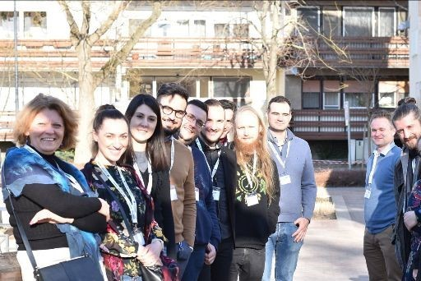

Final conference
The Final Conference was organized on 1st of March 2022, in Jászberény (HU). It was part of the final project events which also included the final partner meeting on the 28th of February. The conference was held in Lehel Cinema and besides the project partnership and stakeholders attracted attendees from the local cultural organisations and networks of creatives. After thematic presentations addressing varied fields in CCI, all the five partner cities and external thematic experts presented their final results, best practices, and the evolving effects of the project cooperation and knowledge exchange on CCI experienced during the project implementation. The meeting was organized in a »hybrid« meeting form, and it was interpreted. All project partners and the majority of their stakeholders attended the meeting either in person or on-line. The event had extensive coverage in the local and regional press. In the end, we can say, it was a successful ending to our project

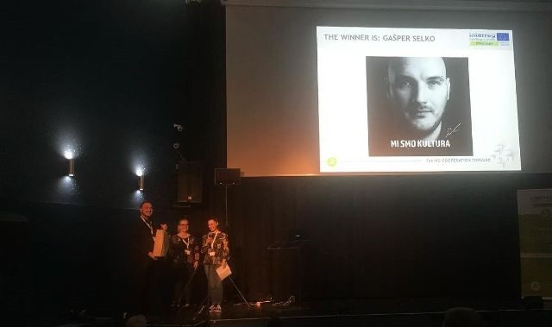

StimulartAward
The 3 rounds of the STIMULART Award were carried out by the end of the project. From the three winners of each partner city one was selected locally to be nominated for the title of the ultimate Stimulart Award winner. The project Steering Group members woted for the ultimate winner at the last partner meeting, in Jászberény (28th of February). The final winner was Gasper Selko (Kamnik, SI), who won the award with his outstanding idea of “Implemeting infrastructure for digtal execution of events, workshops and meetings,” where different interested stakeholders could use the infrastructure of Youth centre Kotlovnica to continue their activities during the restrictions of the Covid-19 pandemic to allow continuity and even enhance some cultural experiences. The prize was handed over at the Final Conference as Gaspar was present at the event in person.

5th partner meeting in Kamnik
After a lenghty delay due to Covid-19 restritrction, finally almost all the partners could meet in person in the host city, Kamink, in october 2021. Partners had discussion regarding the actual management issues, the CCI Repository Handbook and had a long session to give an account on the actual status of their Pilot Projects too. All participants had the opportunity to discover Kamnik on a walking tour and to visit the “Gunpowder factory”, discovering the field of the pilot project of the Slovenian partners.

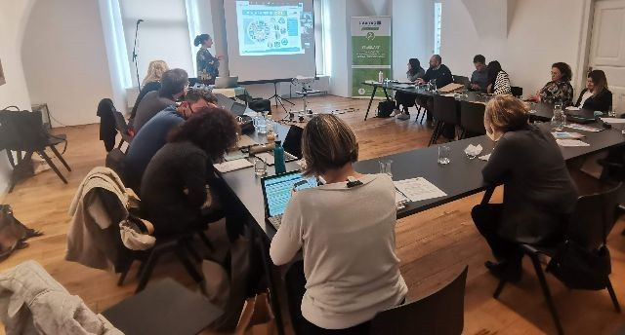

StimulArt e-News
Project partners had a lot of catching up to do during
peer-review visits

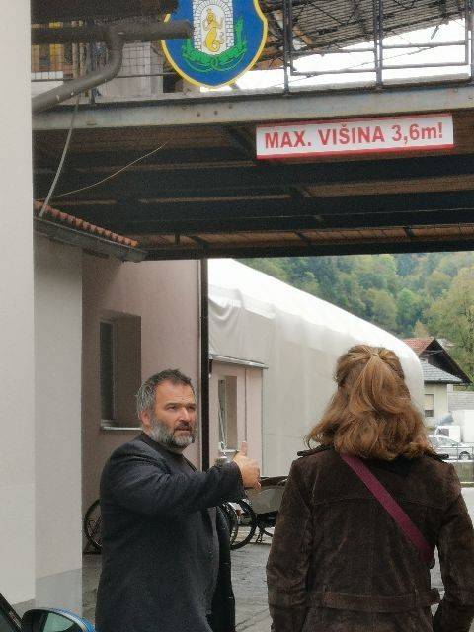

Naumburg to Kamnik
The Naumburg „team“ visited the Kamnik team in advance of our 5th Partner Meeting. After dinner with colleagues at Repnik on Thursday, the Kamnik team organized an individual tour on the industrial heritage trail on Friday.

Amberg to Jaszbereny
The Amberg team visited Jászberény in the framework of the pilot implementation peer-review visit. This was an amazing opportunity for the Jászberény and Amberg team to discuss pilot concepts, most recent cultural projects and for the Amberg team to visit some of the most interesting CCI venues in Jászberény, such as the Lehel Movie, which is the major cultural venue in Jászberény or a local CCI company, the Perlaki Reklám Ltd. (a creative enterprise)

The main event of the visit was the opening ceremony of Jászberény’s pilot, Roomli-the creative hub, where the Amberg team could not only talk with the creative team behind the pilot, but they could also check out all the CCI products already in place.

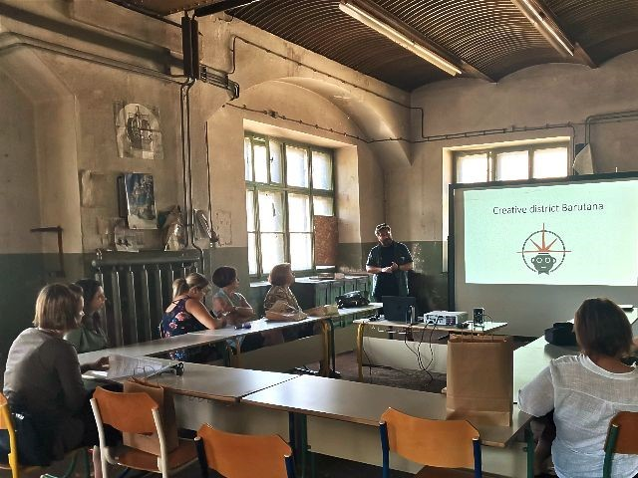
Jaszbereny to Kamnik
The Jászberény and Kamnik team discussed the outcomes of the Stimulart strategy-making process. Additionally, they shared their experience and ideas regarding the preparations for the pilot actions. The location of the meeting was in the former factory hall now the event hall of Barutana, where presentations on the strategy, the new cultural venue, and other CCI topics of local concern were delivered. The Jászberény PPs also visited the Kikstarter (home to start-up innovative enterprises) and the Cultural House located on the same former industrial site. The second day of the visit was centered around tourism attractions, the achievements of the local tourism sector, and its link to CCI activities.
On the third day, the Jászberény team traveled to Skofja Loka to visit the pilot (the Creative HUB) of Interreg Central Europe, IndoCult project as well. This was also of high interest for Jászberény due to its similar ambitions in Stimulart (Roomli the Creative hub).

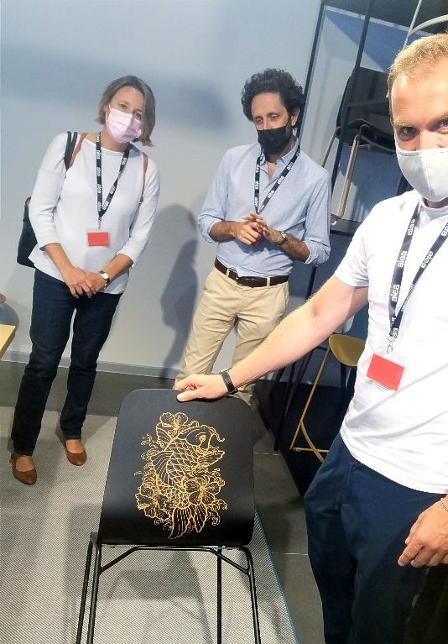

Kamnik and Jászberény to Vittorio Veneto
The Kamnik team visited Vittorio Veneto on 29th and 30th September 2021 and Jászberény on 1st and 2nd October 2021 in order to strengthen mutual partnerships and share experiences, gained during the implementation of the project and the pilot. The main topic of the visit was related to the preparation of the Strategy for cultural and creative industries in the included cities, furthermore, partners shared their experiences and ideas regarding the preparations of pilot actions.
During the visit, several successful local entrepreneurs were introduced to the partners, especially in the fields of furniture design (M.arte design, Varaschin S.p.A). They presented their work and their stories, from the beginning, when they had just started their businesses and went through many obstacles, until now, when they are more experienced and have become important local entrepreneurs, renowned all over the world.
The delegation also visited a company named EMO design, which is present in a field of industrial design. They are very successful in developing many creative ideas for varied companies worldwide. The Kamnik delegation was especially interested as to how such a successful company in CCI was established in a mid- sized city.

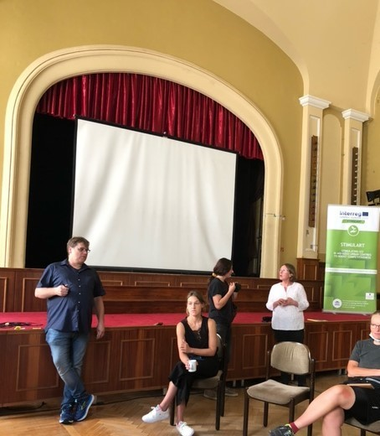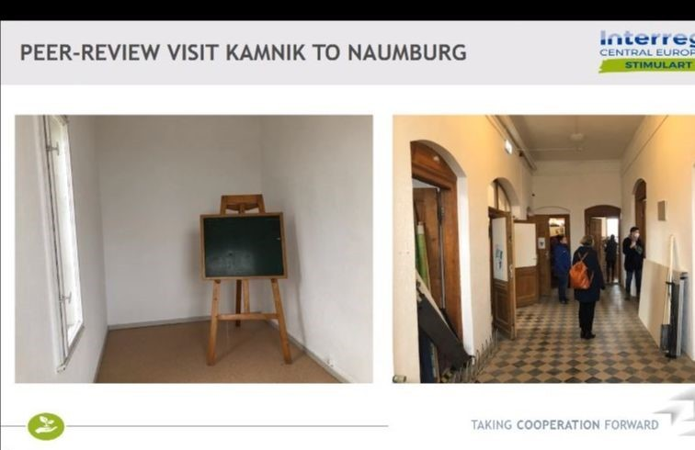

Amberg to Naumburg
In this excange the Amberg delegation got to know the local CCI in Naumburg, and considered how to incorporate them into local strategy. There was an emphasis in finding similarities between Amberg and Naumburg. Seeing how Naumburg dealt with the COVID pandemic The delegation visited the open-air theatre and attended the play "Elling". They also visited individual artists at their work, the city of Naumburg and we attended the meeting of the strategy development working group on the topic of the pilot project Pop-Up Festival "Naumburg Kreativ".

Kamnik to Naumburg
Because the Kamnik delegation was unable to visit Naumburg in 2021 and the time constraints in 2022, the peer review visit was organized online. The Kamnik delegation learned about the creative scene in Naumburg and the Pop-up- festival. They learned about a local artist Eva Kindler who works with paper mache. Anna Eckert and Martina Kiepe presented their plans for the creative house, which was in part inspired by the presentation of the pilot project in Kamnik. The teams concluded there were a lot of similarities between the cities and agreed to keep in touch for the potential cooperation opportunities in the future.

Vittorio Veneto to Amberg
The VVEN to Amberg peer review visit was also organized online. The VVEN delegation learned about the CCI potentials and lacks in Amberg. They discussed about their future plans for CCI by the presentation of the pilot project.

Copyright © StimulArt. All rights reserved.

"This project is supported by the Interreg CENTRAL EUROPE Programme funded under the European Regional Development Fund."

Official project e-mail:
stimulart@jaszbereny.hu

Official project website:
https://www.interreg-central.eu/Content.Node/STIMULART.html

Want to change how you receive these emails?
You can u pdate your preferences or u nsubscribe from this list.

This email was sent to anej.ivanusa@domkulture.org

w hy did I get this?
u nsubscribe from this list
u pdate subscription preferences

Jászberény Municipality · Lehel vezér tér 18. · Jaszbereny, JNSZM 5100 · Hungary

