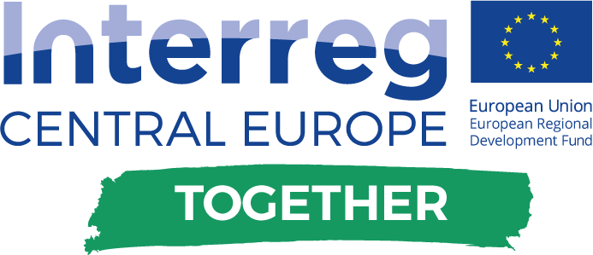



**On Thursday, 19th October 2017, the Faculty of Energy Technology of the University of Maribor together with the Local Energy Agency Dolenjska-Posavje-Bela Krajina (LEAD) and the Municipality of Krško organized an international conference titled "Rethinking Energy Efficiency in Buildings and Energy Planning Education”. Around 100 participants attended the conference - from the University of Maribor, energy agencies and Slovenian municipalities, as well as foreign students from the Faculty of Electrical Engineering and Faculty of Mechanical Engineering, University of Zagreb.**

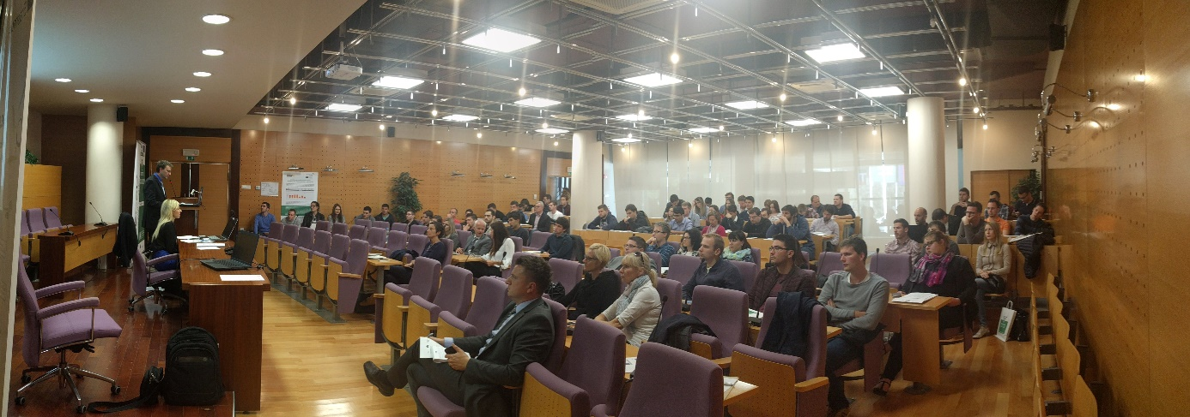

The conference took place in the framework of two international projects: E-resplan – Innovative Educational Tools for Energy Planning – financed by Erasmus + programme and project Together – TOwards a Goal of Efficiency THrough Energy Reduction – co-financed by Interreg Central Europe programme.

The content was related to energy efficiency in public buildings and energy education of building users. The main purpose of the conference was to familiarize stakeholders with the activities that take place within these projects and their results. Significant emphasis was placed on organizational measures, their implementation and the main obstacles that we can encounter in raising awareness of energy efficiency among users of public buildings.

The first part of the conference was held in the premises of the Municipality of Krško, while the second part was in Vrbina, where the Institute of Energy Technology, as an example of good practice, was presented.

Conference papers were summarized in Book of Abstracts, which can be found here:

https://www.scribd.com/document/361968421/r2epe-Book-of-Abstracts

More about projects can be found on their websites:

<http://www.interreg-central.eu/Content.Node/TOGETHER.html>

<http://www.eresplan.eu/>