

**D.T2.2.3, D.T2.2.4 – Individual Final Pilot Report**



|  |  |
| --- | --- |
| Milan Airports Pilot on low carbon mobility management - testing car-pooling platforms and implement public awareness campaigns | Version 2  08 2020 |

**Content**

1. Introduction 2

2. Specifications of pilot 3

3. Awareness raising campaign 5

4. Insights on developments of KPIs 9

5. Insights on qualitative survey results 12

6. Lessons learnt 12

6.1. Success factors 12

6.2. Failure factors 12

7. Conclusions 13

1. Introduction

The aim of the LAirA project is to raise the competences of public sector entities in the field of planning and implementing low-carbon solutions for landside accessibility to airports, which are important traffic generators in Functional Urban Areas (FUAs). The airports involved in the LAirA employee pilot test in Milan are Malpensa and Linate.

The pilot project’s main goal is to develop low-emission solutions that will improve employees’ access to airports. The total number of employees at Milan Airports is about 27,000. The sites are very large and there are employees at different entities (employers) and with different roles, who work in various areas at the airports, sometimes far from each other; the car-pooling application aims at helping employees finding colleagues who have the most compatible home-work trip pattern and getting to know each other to share trips.

SEA Milan Airports is committed to improve Malpensa and Linate surface access, and one of the instruments that has been chosen by SEA to change travel behaviours of Milan Airports’ employees is a car-pooling platform. Jojob Carpooling is an innovative service for corporate carpooling and its objective is to allow employees to share their trips from home to the workplace.

The objective of the application is to encourage employees currently commuting individually by their own cars and going to the same destination to share cars with colleagues, and consequently reduce car traffic. The objective is fostering behavioral change by employees and creating environmental benefits for the Airports’ FUA.

1. Specifications of pilot

As already reported in the previous reports, SEA awarded the car-pooling service provision to Jojob according to procurement rules. The award procedure was based on:

* a preliminary analysis of car-pooling operators in Italy, aimed at identifying operators to engage in the LAirA pilot project, as a first basis to contact them and set-up the subsequent selection procedure;
* the evaluation of the offers received, aimed at selecting the best provider.

In particular SEA preliminary collected information on operators’ service scope and benefits, on how users could join and use the service, on prices, and on terms and conditions. After this preliminary phase, the public procurement documentation was prepared by SEA and on 2nd May 2019 the tender for the provision of the car-pooling service was published, with deadline for offer submission by 14th May 2019.

The subject of the contract was:

* the implementation of and access to a car-pooling web site and mobile application;
* the provision of the service maintenance;
* the presentation of the application at Milan Airports;
* the provision of reports on the application use.

The corporate car-pooling platform has the following functionalities:

* landing page and company code for creating a user account with an e-mail address and badge number;
* uploading itinerary form home to work (collecting information like departure and arrival address, type of vehicle used daily to get to work, working time, including with the possibility of registering work shifts);
* providing information on how much money the user would spend travelling alone and how much he/she saves by car-pooling;
* searching for best travel companions for the itinerary (drivers and passengers) with percentage compatibility index focussed on routes;
* sending or receiving friendship requests from other users to connect each other;
* calculating the estimated cost of a shared ride;
* providing a customer care service in the “Help section”;
* including an administration section in which the user can see statistics about the registration process and trips certification.

The web site and the application will be available to Milan Airport’s employees for one year starting from 03/07/2019.

The following figures show respectively the carpooling landing web page and app.

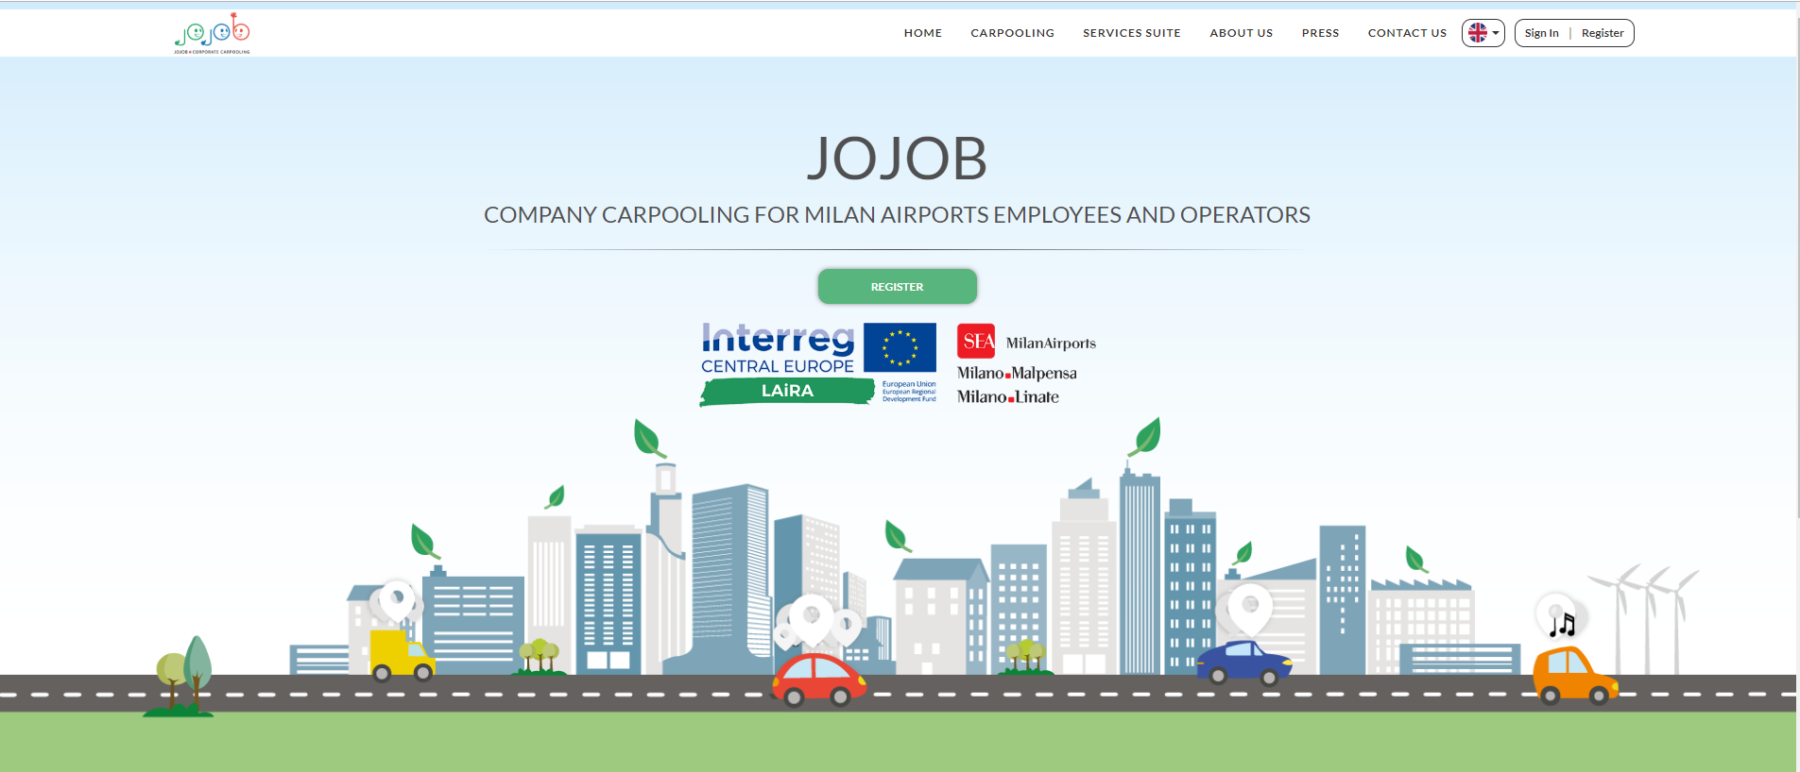

Figure 1. Jojob web site landing page for Milan Airports in the LAirA project

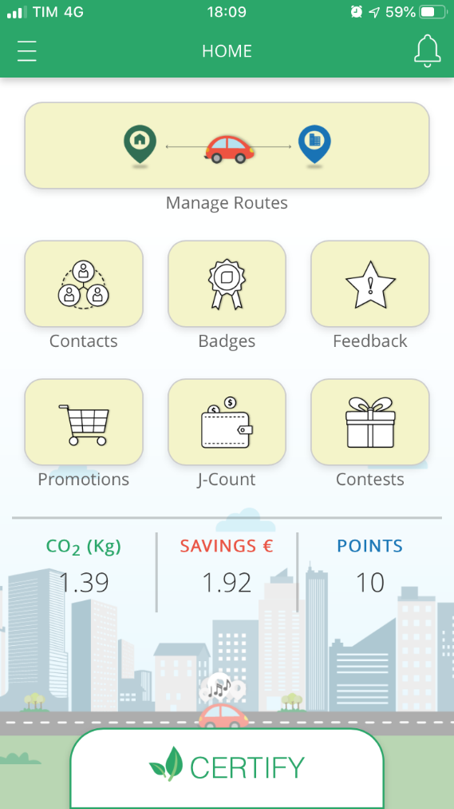 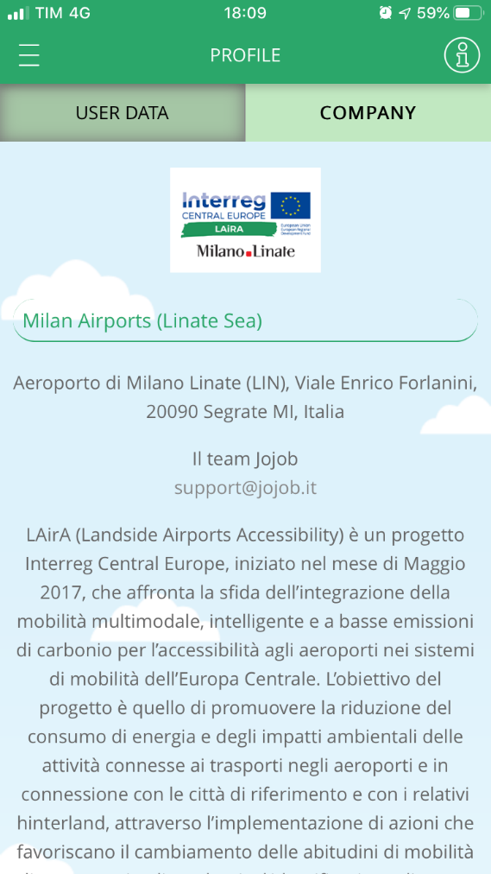

Figure 2. Jojob car-pooling mobile app with a description of the LAirA project

1. Awareness raising campaign

The Jojob Carpooling platform started to work after a three-days campaign delivered in July 2019 at both Milan Airports (one day at Linate, one day at Malpensa Terminal 1, and one day at Malpensa Terminal 2), during which training activities were organised by SEA to inform airport employees about the new service. The communication campaign included digital materials and a video tutorial disseminated through SEA internal communication channels with the aim of:

* supporting employees in registering in the platform;
* setting-up travel preferences and home-to-work itineraries;
* explaining how to certificate carpooling trips using the Jojob Carpooling app.

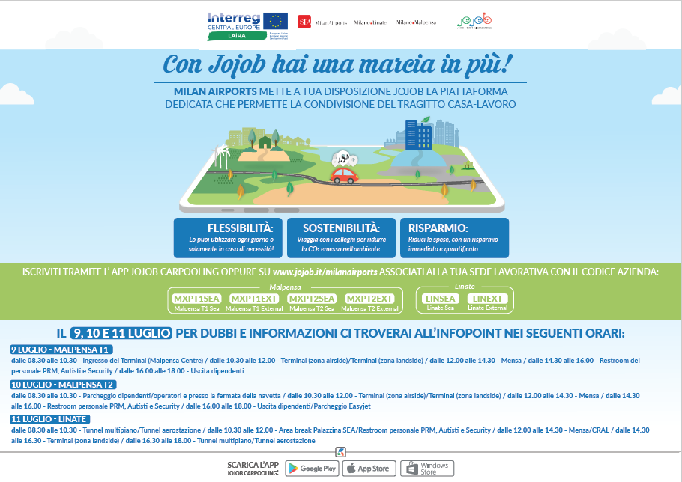

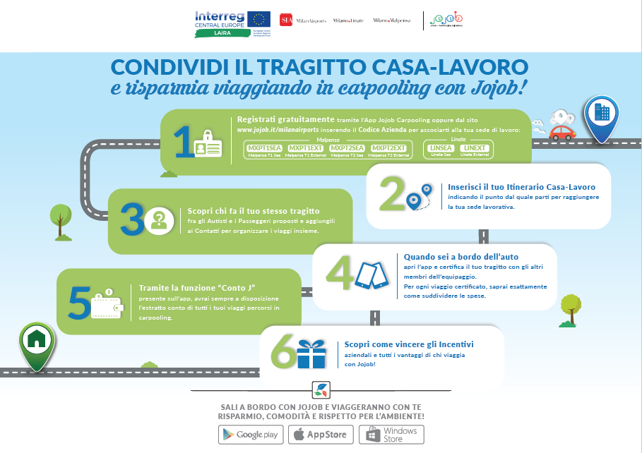

Figure 3. Communication material distributed to employees

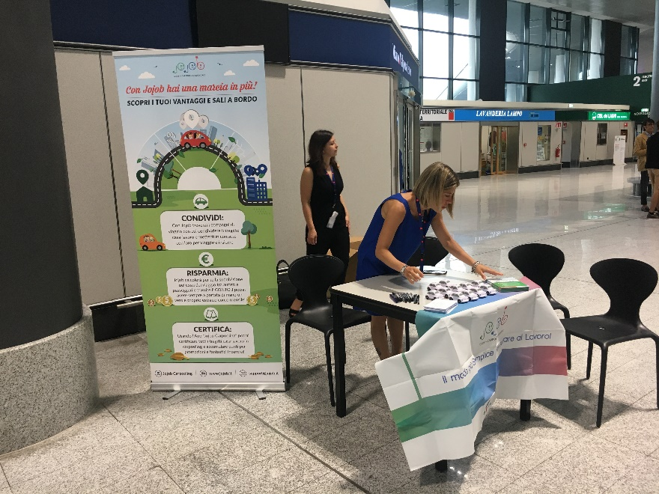

Figure 4. Jojob staff at Milan Malpensa T1

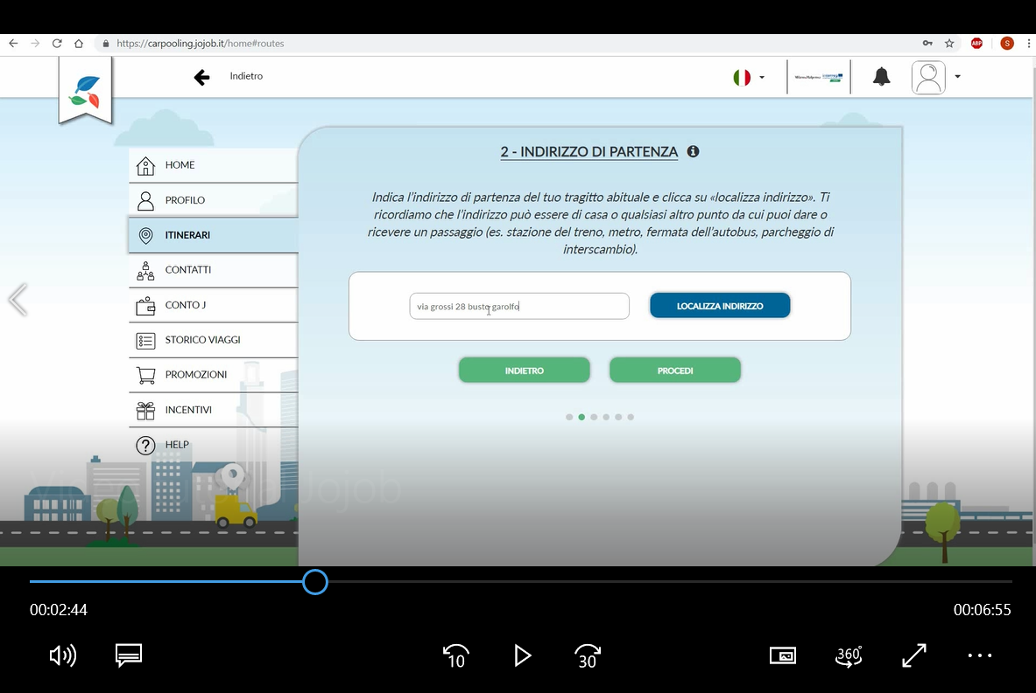 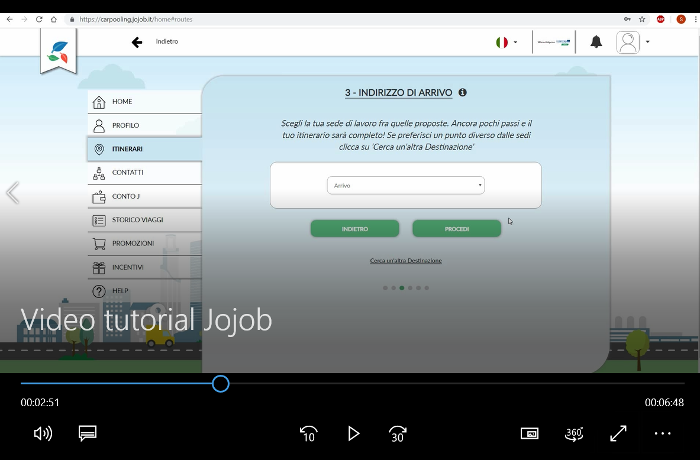

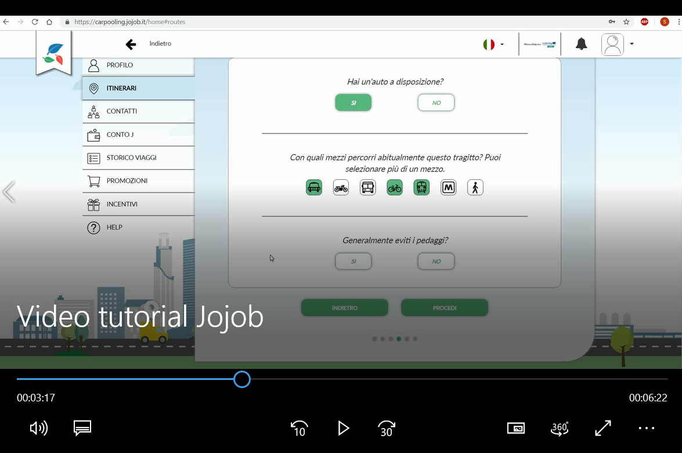 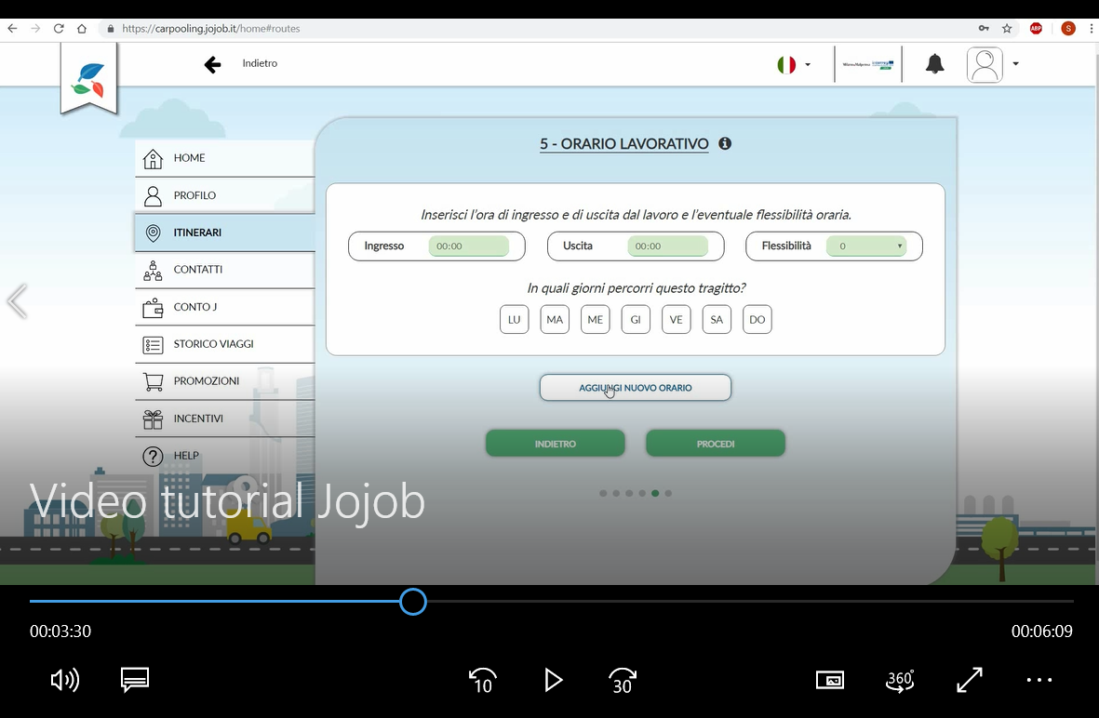

Figure 5. Video tutorial printscreen: how to set up the platform

The communication campaign implemented by SEA in cooperation with Jojob includes not only the on-site days at Linate and Malpensa, but also news and information spread through the company’s internal communication channels, such as e-mail and intranet. The following figures report communication products developed by SEA to launch the carpooling service.

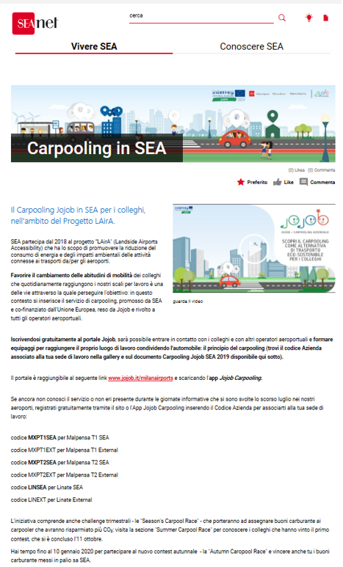

Figure 6. News on the LAirA car-pooling project published on SEA Milan Airports intranet

SEA Milan Airports launched periodic incentive plans, the “Season's Carpool Race”, in order to encourage airport employees to share rides. These are three-month competitions dedicated to airport employees who certify their shared home-to-work trips. At the end of each competition, the best car-poolers (those sharing the most rides) are awarded with fuel vouchers; we note that vouchers are paid by SEA Milan Airports and are not refunded by the Interreg Central Europe Programme. The first periodic competition was the “Summer Carpool Race” from 15/07/2019 to 11/10/2019. On 14/10/2019 the “Autumn Carpool Race” has started and it will end on 10/01/2020.

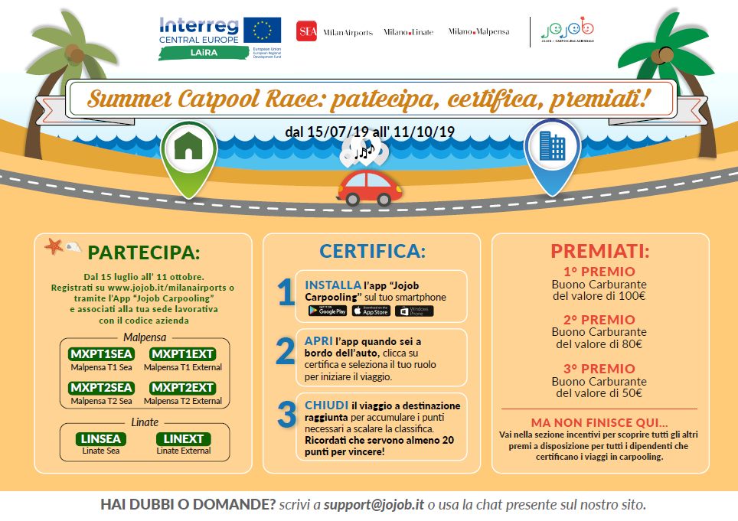

Figure 7. Leaflet on Summer Carpool Race founded by SEA Milan Airports

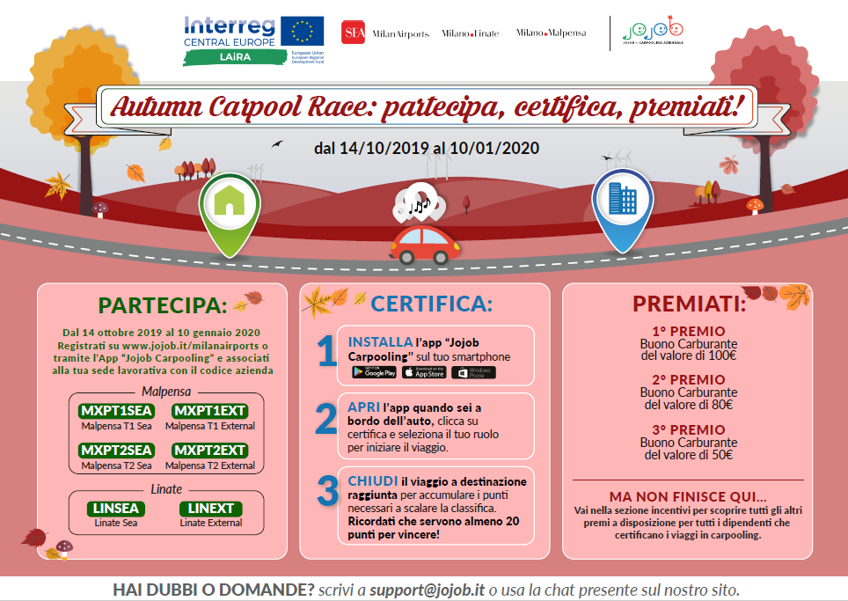

Figure 8. Leaflet on Autumn Carpool Race founded by SEA Milan Airports

1. Insights on developments of KPIs

The table below shows Key Performance Indicators (KPI) values ​​on the use of the Jojob Carpooling service by employees of Milan Airports updated to 06 December 2019 (cumulative values for both Milan Linate and Milan Malpensa Airports).

|  |  |  |  |  |  |  |  |
| --- | --- | --- | --- | --- | --- | --- | --- |
| **KPI** | **Jul-19** | **Aug-19** | **Sep-19** | **Oct-19** | **Nov-19** | **6 Dic-19** | **TOTAL** |
| Registered users (n.) | 259 | 5 | 8 | 2 | 2 | 1 | 277 |
| Active users (n.) | 11 | 8 | 10 | 9 | 9 | 8 | 18 |
| Matched rides to/from the airports (n. trips) | 50 | 34 | 68 | 76 | 66 | 24 | 318 |
| Vehicle occupancy rate (n. passengers) | 2 | 2 | 2 | 2 | 2 | 2 | 2 |
| CO2 savings (kg) | 74,32 | 58,14 | 100,56 | 117,74 | 98,32 | 35,14 | 484,22 |
| Parking spaces saved (n.) | 25 | 17 | 35 | 38 | 33 | 12 | 160 |

Table 1**.** Main KPI on carpooling use at 06 December 2019

Vehicle occupancy refers to the number of employees (driver and passengers) who share the ride.

CO2 savings was calculated by multiplying the savings in kilometres travelled by the average value for CO2 emissions equal to 130 g/km (avarage value based on type of engine and year of manifacture, according to data collected by the European Environment Agency).

The number of parking spaces saved was calculated taking into account the number of employees who shared rides as passengers, instead of using their own car.

The highest number of registered users (259) is in July 2019 because employees registered during or soon after the on-site days held at both airports, during which 2 Jojob staff members informed airport employees about the carpooling service and supported the registration process. We observed a decline in the number of new registrations per month in the following months.

Since the pilot project started in July 2019 until the middle of October 2019, 18 car-poolers certified 318 trips shared with colleagues to/from the airports. These home-to-work trips have an average crew of 2 car-poolers.

In the concerned period, trips shared and certified by Milan Airports’ employees generated savings in CO2 emissions equal to 484.22 kg and in parking spaces equal to 160.

The tables below show the results at each Airport and at each terminal for Malpensa Airport.

**Milan Linate**

|  |  |  |  |  |  |  |  |
| --- | --- | --- | --- | --- | --- | --- | --- |
| **KPI** | **Jul-19** | **Aug-19** | **Sep-19** | **Oct-19** | **Nov-19** | **6 Dic-19** | **TOTAL** |
| Registered users (n.) | 108 | 0 | 4 | 0 | 0 | 1 | 113 |
| Active users (n.) | 0 | 0 | 0 | 2 | 0 | 0 | 2 |
| Matched rides to/from the airports (n. trips) | 0 | 0 | 0 | 2 | 0 | 0 | 2 |
| Vehicle occupancy rate (n. passengers) | 0 | 0 | 0 | 2 | 0 | 0 | 2 |
| CO2 savings (kg) | 0 | 0 | 0 | 0,52 | 0 | 0 | 0,52 |
| Parking spaces saved (n.) | 0 | 0 | 0 | 1 | 0 | 0 | 1 |

Table 2. Milan Linate Airport - main KPI on carpooling use at 06 December 2019

**Milan Malpensa Terminal 1**

|  |  |  |  |  |  |  |  |
| --- | --- | --- | --- | --- | --- | --- | --- |
| **KPI** | **Jul-19** | **Aug-19** | **Sep-19** | **Oct-19** | **Nov-19** | **6 Dic-19** | **TOTAL** |
| Registered users (n.) | 91 | 5 | 3 | 1 | 2 | 0 | 102 |
| Active users (n.) | 3 | 2 | 3 | 2 | 4 | 4 | 6 |
| Matched rides to/from the airports (n. trips) | 14 | 12 | 44 | 24 | 48 | 14 | 156 |
| Vehicle occupancy rate (n. passengers) | 2 | 2 | 2 | 2 | 2 | 2 | 2 |
| CO2 savings (kg) | 15,56 | 16,96 | 61,8 | 33,66 | 62,8 | 18,34 | 209,12 |
| Parking spaces saved (n.) | 7 | 6 | 23 | 12 | 24 | 7 | 79 |

Table 3. Milan Malpensa Airport Terminal 1 - main KPI on carpooling use at 06 December 2019

**Malpensa Terminal 2**

|  |  |  |  |  |  |  |  |
| --- | --- | --- | --- | --- | --- | --- | --- |
| **KPI** | **Jul-19** | **Aug-19** | **Sep-19** | **Oct-19** | **Nov-19** | **6 Dic-19** | **TOTAL** |
| Registered users (n.) | 60 | 0 | 1 | 1 | 0 | 0 | 62 |
| Active users (n.) | 8 | 6 | 7 | 5 | 5 | 4 | 10 |
| Matched rides to/from the airports (n. trips) | 36 | 22 | 24 | 50 | 18 | 10 | 160 |
| Vehicle occupancy rate (n. passengers) | 2 | 2 | 2 | 2 | 2 | 2 | 2 |
| CO2 savings (kg) | 58,76 | 41,18 | 38,76 | 83,56 | 35,52 | 16,8 | 274,58 |
| Parking spaces saved (n.) | 18 | 11 | 12 | 25 | 9 | 5 | 80 |

Table 4. Milan Malpensa Airport Terminal 2 - main KPI on carpooling use at 06 December 2019

Even though Milan Linate had the highest number of registrations to the carpooling platform, employees did not use the carpooling tool in the concerned period. This could be explained by the fact that Linate is a city airport located in the urban context and public transport is used more frequently than car. Another reason could be that most of airport employees are used to travel alone (as resulted from the LAirA survey on employees’ mobility needs and behaviour conducted last year at Milan Airports) and the big challenge is to change their habits.

The highest number of “active users” (i.e. airport employees who use the carpooling tool and certify their shared trips) is registered at Milan Malpensa. The reason could be that car is the preferred transport mode of employees working at Malpensa; in fact, the Airport is located out of the urban context and is not well connected by public transport, except for the Malpensa Express train to/from the city of Milan and very few local buses with low frequencies.

Finally, we note that all the car-poolers are SEA’s employees: a very low number of employees employed by companies other than SEA have joined the platform, but these are not active users.

Figure 9. Active users and matched rides

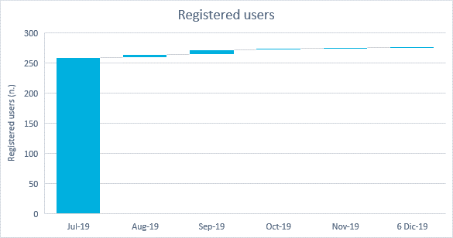

Figure 10. Registered users

1. Insights on qualitative survey results

In September 2019 SEA delivered a questionnaire to all the platform registered users to have feedback on their experience with the carpooling service. The results are included in the previous intermediate report.

SEA decided to deliver a new questionnaire next March, when the pilot project will have completed more than half of the path and when the new bike race will have started, in order to investigate employees’ impressions and feedbacks.

1. Lessons learnt

These first five months of carpooling-scheme implementation have been extremely useful to think over the success and failure factors of the pilot project and to better understand the current employees’ mobility behaviours at both Milan Airports, especially for those who commute by car, and their real inclination to change their mobility habits.

During these months of platform operations, no specific claims have been collected from company’s department, but a suggestion came directly from employees who commute by bicycle: in addition to the periodic contest launched every four months (the “Season’s Carpool Races” which has monetary incentives paid by SEA to encourage employees to commute by carpooling), some employees working at Milan Linate suggest to set up also a “Bike Race”, in order to reward those employees who commute with a transport mode that is more sustainable than car and allows zero carbon emissions.

Therefore, SEA decided to launch this new competition, with the collaboration of Jojob, from next January 2020 until the end of the pilot project. As for the “Season’s races” dedicated to carpooling, incentives will be paid by SEA and will be not refunded by the Interreg Central Europe Programme.

As reported below about the failure factors, it was not easy to implement the Jojob carpooling service because it was very difficult to reach and engage a critical mass of airport employees. For this reason, at the moment SEA decided not to organise the two remaining on-site days in September as originally planned, but to try other approaches to involve as many employees as possible in the carpooling community. In particular Jojob suggested to:

* train via webinar colleagues working in different company areas as “Jojob ambassadors”, in order to create a “Jojob team” that could help other colleagues using the tool and being aware of benefits and opportunities offered by the carpooling scheme; and
* train small groups of colleagues in short training lessons.
  1. Success factors

A great success factor is determined by the active participation of the company representatives in the project, who were totally available to try to better implement the service both in terms of internal communication and support given to Jojob resources during the days carried out at company offices and at the Airport terminals. The “Summer Carpool Race” guaranteed a continuity of travel certification in these months and the best car-poolers for this first competition have already been awarded.

* 1. Failure factors

It was not easy to implement the Jojob carpooling service in terms of number of subscriptions and, as a consequence, of active users: airports as workplaces are very wide and complex, and it is difficult to reach all employees, especially those who haven’t a corporate e-mail or do not belong to a company with a company’s intranet on which news are sponsored and advertised. Furthermore, Info-Point activities did not allow investigating the reasons why many employees think that the app is not useful for those who work on shifts.

Furthermore, we had evidence, directly from employees, that many of them give up sharing the trips with other colleagues because they don’t want to risk not to find someone to go back home with, if their carpool mate has an unexpected trouble and has to leave before than the agreed time. For this reason, the improvement of the critical mass of users is key. This target can be achieved building a wider community of carpool users, involving also other companies located in the same area, but also giving more benefits to carpoolers: shopping and/or fuel vouchers are not enough to engage people.

1. Conclusions

According to the data collected in the first five months of platform operations, the number of carpooling active users is very low and limited to Milan Malpensa Airport. This could be due to the fact that the Milan Airports’ locations are different in terms of proximity to Milan urban area and this may influence travel behaviours: most of Malpensa employees commute from many small-medium urban centres around the airports (mainly in Varese and Milan provinces), while most of Linate employees start their journey from the Municipality of Milan. The availability of transport services is different at the two airports, in fact the use of public transport by Milan Linate employees is more frequent. Another reason to explain the low number of users could be found in the period the service has been launched, near the summer holidays. Next months will be fundamental to further test the project.

In these months the difficulty in reaching a large population of users and involving as many employees as possible in this low-carbon mobility project was definitely confirmed. In order to further enhance the pilot project and collect new adhesions, some activities are already being planned to increase the “Jojobber” community at the Milan airports.

Finally, it emerged from the user questionnaire that the scarce training and information on how to use Jojob and on what the platform offers led to erroneous beliefs, for example that it is not a useful tool for those who work on shifts.